  Health Promoting School  Awarded 2011 | 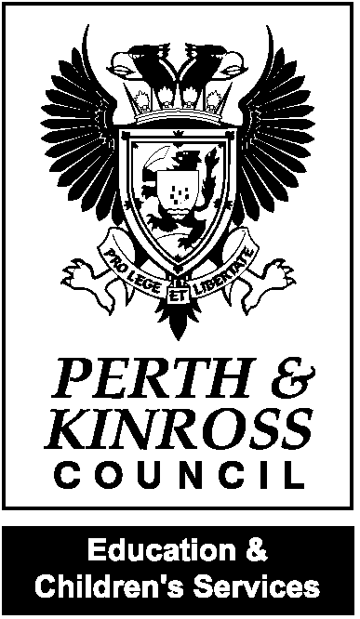 |   2016  Kettins Primary School  School Road, Kettins  BLAIRGOWRIE PH13 9JL  Tel 01250 871410  Email kettins@pkc.gov.uk
Kettins ‘Return to school’ Newsletter

Dear Parent/ Carer,

I hope our families have managed to have a good summer break and enjoyed some nice weather and the more recent easing of lockdown. As you know, school resumes for pupils next week and this newsletter will provide you with some updated information. We know some parents and pupils may be anxious about the return to school. We will do our best to support all the children at this time. You may also wish to support your children by sharing some of the content of this newsletter in preparation.

We are all really looking forward to welcoming the children back to school and settling back into school routines. We are not returning to ‘normal’. Some things will be very different but I want to reassure you all that different can be okay and in some instances; better.

Rachel Cross
Headteacher

CONTACT DETAILS!

There will be a lot of information to share with you in the coming weeks. Please ensure your Parentpay account and your phone numbers are all up-to-date. We will also use our school app to share information. Please make sure that you are still able to access this. Email or call the school to provide us with any new contact numbers. You can find our contact details at the top of this newsletter.

We are asking at this time that parents do not come into the school building. This is very hard as you know we operate an open-door policy and we are always keen to see parents in school. However, in line with guidance, this ensures less contact and keeps everyone safer. DO NOT COME TO THE SCHOOL BUILDING, UNLESS ASKED TO DO SO BY A MEMBER OF STAFF.

ARRANGEMENTS FOR NEXT WEEK

Monday 10 August- INSET DAY
Tuesday 11 August- INSET DAY
Wednesday 12 August- Group A pupils in school.
Thursday 13 August- Group B pupils in school.
Friday 14 August- ALL children in school.
Monday 17 August- ALL children in school for full return.

We ask that parents do not enter the playground (with the exception of P1 parents). Adults are still required to respect social distancing. Pupils can enter the playground from 8.50am. P1-P3 pupils should line up at the usual area around the side of the playground and P4-P7 pupils should line up at the main entrance.

CHANGES TO GUIDANCE SINCE JUNE

Children do not need to socially distance from one another. Children are not required to wear face masks.
Adults need to stay 2m from children and from other adults. Adults are not required to wear facemasks but will wear a face covering in certain situations like administering first aid.
Some pupils and some staff members may wish to wear a face mask. This will be respected as personal choice.

Children will wash their hands when they come into the classroom or use hand sanitizer.
We have had a delivery of extra cleaning materials, hand sanitizer and PPE.
Tayside Contracts will provide us with 2 hours of extra cleaning during the school day.

SCHOOL UNIFORM

School uniform will be relaxed for Term 1. Pupils can wear polo shirts or plain t-shirts and school sweatshirts with self-coloured leggings or joggers and sensible footwear. Clothes need to be changed and washed daily when we start back in August, for infection control, so if easier to wear casual clothes for cleaning, please do so.

Children do need to bring a jumper and a coat to school every day. Pupils will be involved in outdoor learning in the playground and the windows in the classrooms will be open all day to keep the school building well ventilated.

Children will not be changing for PE initially, so something practical that they can run around in for outdoor PE will be useful. PE will be outside for the foreseeable future.

BELONGINGS

We will provide a pencil case and stationery for each child. Pupils are not required to bring a school bag, book bag or pencil case.
Pupils will only need to bring a coat, snack, water bottle and lunch box (if this is their lunch choice).

PLAYTIMES AND LUNCHES

Breaks and lunches will take place at the usual time and will be supervised by staff. Pupils will be asked to play in ‘zones’ to reduce mixing with too many children. Support staff will encourage and organise games. Lunches will be served in the classrooms to provide more space
A cold school lunch option is available until October. P1-3 continue to have free lunches and also those who are entitled to a free lunch. Packed lunches may also be brought to school.

CURRICULUM

In term 1, we will focus on Literacy, Numeracy and Health & Wellbeing. We will support children to settle back to school routines and the new routines.
It will be important for children to reconnect with each other and their teachers.
We will provide homework and reading books and once books come back to school they will be quarantined for 72 hours before anyone else uses them and wiped down.
There will be no trips or excursions planned for term 1.
There will be no visitors to the school in term 1.

CHILD’S PLANS

If your child has an IEP, or Child’s Plan we will still hold meetings, but these will be via Teams or over the phone for the foreseeable future.

HEALTH

Please do not send your child to school if they display any of the following symptoms-

- a high temperature – this means you feel hot to touch on your chest or back (you do not need to measure your temperature)
- a new, continuous cough – this means coughing a lot for more than an hour, or 3 or more coughing episodes in 24 hours
- a loss or change to your sense of smell or taste – this means you've noticed you cannot smell or taste anything, or things smell or taste different to normal.

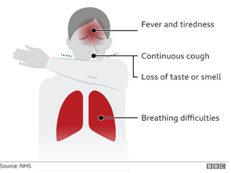

Please encourage your child to report to their teacher if during class time, or to support staff if they start to develop symptoms. An initial assessment will be carried out by first aider. A separate isolation medical room has been set up to be used in the case of suspected symptoms.

If a pupil becomes unwell at school:
- Parents/carers will be contacted and asked to make arrangements to pick the young person from school immediately and to follow the national guidance for households with possible COVID-19 infection including testing and self-isolation.
- after leaving the school, minimise contact with others where possible, eg use a private vehicle to go home. If it is not possible to use private transport, then the advice is to return home quickly and directly, and if possible, wear a face covering in line with Scottish Government guidance. If using public transport, the advice is to try to keep away from other people and catch coughs and sneezes in a tissue/crook of arm.
- Should a member of staff or pupil be confirmed as having coronavirus, then Test and Protect procedures will be followed. Schools are considered complex settings and cases will be prioritised and escalated to specialist Health Protection Teams. (HPT)

We will follow procedures and guidance from HPT at all times and parents will be alerted as per guidance.

Please do reassure your child about the return to school. Whilst most of our pupils are very resilient, no one has ever been in such a situation before and 5 months away from school may have had a significant impact on some. Our staff are equipped and ready to give support as necessary.
As you will be aware; we are making every effort to make the return to school as safe as possible.

Thank you for taking the time to read this newsletter.

Kind regards,

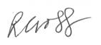

Headteacher Meigle and Kettins Primary Schools

