
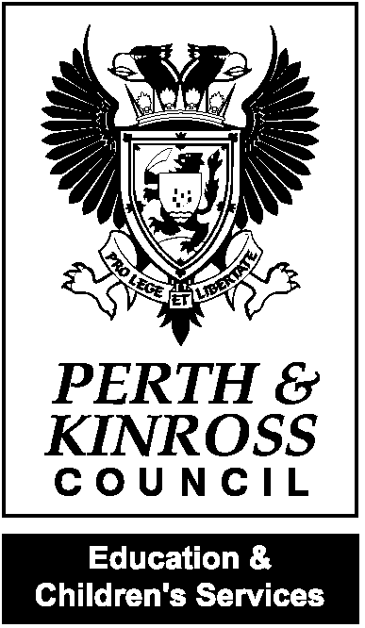


Health Promoting School
Awarded 2011

Rachel Cross
Headteacher

Meigle Primary School
Dundee Road
Meigle
BLAIRGOWRIE
PH12 8SD
Tel 01250 871415
Email: meigle@pkc.gov.uk

28 August 2020

Dear Parent/Carer,

New National Guidance on the Use of Face Coverings
Following an announcement by the Deputy First Minister on Tuesday 25 August 2020, the national guidance for the return to schools has been updated and now recommends the use of face coverings in secondary schools for pupils and staff with effect from Monday 31 August 2020.
From this date, face coverings should be worn by staff and pupils when:
- adults and young people in secondary schools (including special schools) are moving about the school in corridors and confined communal areas (including toilets), where physical distancing is particularly difficult to maintain; and
- adults and children and young people aged 5 and over are travelling on dedicated school transport.
This guidance will apply across Tayside, and Angus, Dundee City and Perth & Kinross Councils are now revising local guidance to reflect this update. Young people, many of whom already wear face coverings in shops and on public transport, will be encouraged to extend their use as outlined above, and your support in reinforcing this message would be greatly appreciated.
The Council’s Public Transport Unit will be contacting all school transport operators, including taxis, to share the update to the guidance with their drivers and escorts. Pupils, drivers and escorts travelling in taxis, private hire vehicles and minibuses have been requested to wear face coverings since 12 August 2020.
Staff and pupils should ensure they:
- bring their own face coverings to school;
- store these safely in a washable, sealable bag or container when not in use;
- wash reusable face coverings in hot water at the end of each day; and
- safely and hygienically dispose of disposable face coverings after use.
Please remember that a face covering can be as simple as a scarf, snood or other piece of cloth which covers the nose and mouth.
It is understood that there are some staff and children and young people who cannot wear a face covering for good reasons and that position will be respected.
Arrangements will be made for a supply of face coverings to be available in school for pupils and staff in the case of forgotten or lost face coverings. If you think you may have difficulty in sourcing a face covering, or if you feel that your child or young person should be exempt, please contact the school directly.
Further information on face coverings is available on the Scottish Government’s website as follows:
https://www.gov.scot/publications/coronavirus-covid-19-phase-3-staying-safe-and-protecting-others/pages/face-coverings/
The full return to school guidance, including the updated guidance on face coverings is also available on the Scottish Government’s website as follows:
http://www.gov.scot/publications/coronavirus-covid-19-guidance-preparing-start-new-school-term-august-2020-version-2/

Thank you for continuing to support our school to keep it safe and open.

Yours sincerely,

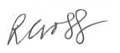

Headteacher Meigle and Kettins Primary Schools

