



Health Promoting School
Awarded 2011

Rachel Cross
Headteacher

Meigle Primary School
Dundee Road
Meigle
BLAIRGOWRIE
PH12 8SD
Tel 01250 871415
Email: meigle@pkc.gov.uk

Dear Parent/Carer,

As we approach the end of the term, I would like to thank you for your support during these different and challenging times for our school.

The pupils have coped very well with their different routines and the way the school is required to operate since we reopened.

As the October holidays approach, you may be thinking of taking your family abroad. If you are, I would appreciate if you could advise the school which country you are planning to visit and the dates of travel to and from the country. I would respectfully remind you that if you return from or travel through a country which is on the quarantine list, you should not send your child(ren) back to school until they have completed the required 14 days quarantine period. Home learning and remote support will not be provided by the school over the period of quarantine.

Further information is available at:

https://www.nhsinform.scot/illnesses-and-conditions/infections-and-poisoning/coronavirus-covid-19

https://www.gov.scot/coronavirus-covid-19/

www.pkc.gov.uk/coronavirus/schools

I look forward to welcoming all pupils back after the holidays.

Yours sincerely

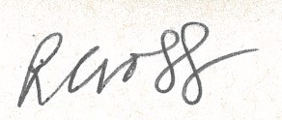

Rachel Cross
Headteacher

