Help us share the magic of reading with children across the world. Every donation will help us to reach children who have little, or no, access to books and reading. Every £2 we raise will mean a book sent to a child.

Help us share the magic of reading with children across the world. Every donation will help us to reach children who have little, or no, access to books and reading. Every £2 we raise will mean a book sent to a child.

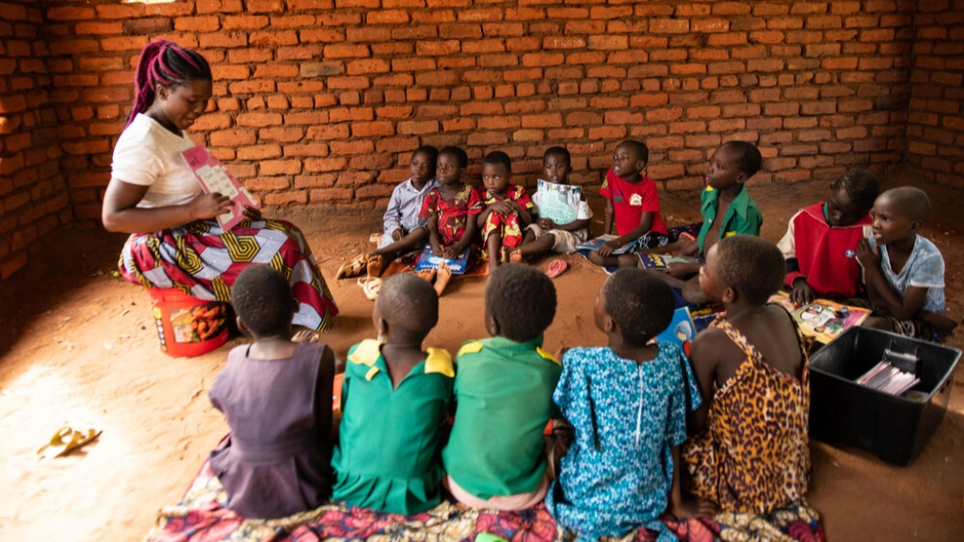

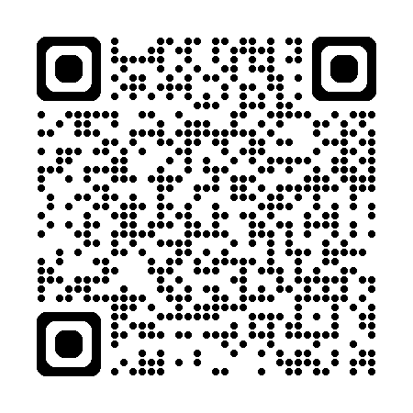

Scan the QR code to donate to Book Aid International on the Meigle Just Giving page. **Thank you!**

Scan the QR code to donate to Book Aid International on the Meigle Just Giving page. **Thank you!**