

MEIGLE PRIMARY SCHOOL
“Getting it Right for Your Child”

In Meigle Primary School our vision is to provide a safe, happy,
inclusive, secure and stimulating learning environment where,
in partnership with all stakeholders
we enable every child to achieve his/her potential.

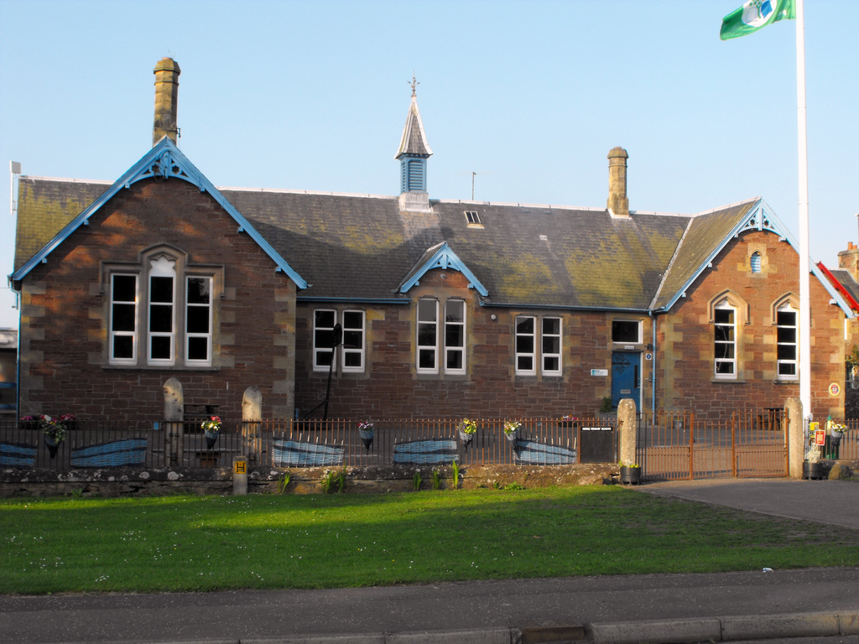

Standards and Quality Report
2019-2020

The purpose of this report is to share information on the impact that school improvement actions have had on pupils’ learning and progress over the course of this session. Using “How Good is Our School 4?” (Education Scotland 2015) our self-evaluation grades for key quality indicators are shown below.

Quality Indicator |  | Evaluation
1.3, Leadership of Change | Very Good
2.3 Learning, Teaching and Assessment: | Good
3.1 Ensuring Wellbeing, Equality and Inclusion | Very Good
3.2 Raising Attainment and Achievement: | Good

These evaluations derive from a range of ongoing evaluative processes which we carry out over the school year with parents, pupils and staff. This report was compiled using the evidence from the aforementioned evaluations.

Progress on Priorities 2019 – 2020

Our priority areas were Vision, Values and Aims, Progress in learning and Health and Wellbeing. There has been good progress made in meeting most of the actions from 2019-2020 priorities. There is a solid base for progression and development in place, which is based on evidence from a range of areas. Due to the Covid19 school closures, actions which are still to be fulfilled will be incorporated into the priorities for next academic session.

Miss Rachel Cross (Acting Headteacher)
12.6.20

LEADERSHIP

The Acting Head Teacher and Principal Teacher are committed to the school and its community. They work effectively together as a senior leadership team; the fresh thinking of the Acting Head Teacher and the in-house experience of the Principal Teacher, being very complementary. Together, they have the highest expectations for all children at Meigle Primary School. These high aspirations for all are effectively reinforced by the work and efforts of a strong staff team. Relationships are strong and the senior leadership team has worked hard to develop effective partnerships with all staff, partners and stakeholders. Staff have been encouraged to take on leadership roles relating to the school improvement plan and show commitment to take forward projects to help achieve improvements. Staff also play an active role in self-evaluation to identify strengths of the school and areas for improvement. Staff participate effectively in high level professional dialogue.

The school has made progress to achieve the developments set out in the 2019- 2020 School Improvement Plan. Staff meetings and in-service days have been planned to develop staff skills and knowledge. Changes that have been implemented have been realistic and achievable but suitably challenging. Staff continue to work towards the aims of the 5-year strategy plan of the Blairgowrie High School Local Management; to improve sleep, physical activity, mental health and engagement and communication. Teaching staff participated in moderation events across the LMG to ensure consistency in approaches. This session, staff have also taken part in practitioner enquiry into quality feedback, through Dundee University.

The staff team have worked hard to raise pupil awareness of the school improvement journey. The plan is visible for pupils to see and some pupils can talk about the areas for improvement. All children in the school have access to a variety of regular opportunities to develop their leadership skills. The Pupil Council allows children the chance to lead school improvement, making decisions about things that are important to them and their peers. P7 pupils have the opportunity to become Prefects and House Captains. All pupils are encouraged to use the newly implemented ‘Tools for Talking’ system which was introduced by the Principal Teacher and supports learners to reflect and comment of the progress they are making. Pupils feel more empowered to talk about their learning. For the first time, pupils have led a popular lunch time drama club.

Parents have had the opportunity to provide feedback at parent contact sessions, school events and through questionnaires. Partnerships with parents continue to be very good. Our Parent Council continues to work extremely hard to support our school. Their continued enthusiasm and involvement has had a positive impact on the school.

Our progress in Leadership of Change this year is very good.

ATTENDANCE

Arriving on time and attending school is essential for pupil learning and progress. Below is a review of attendance across the school for the last three years.

 | June 2018 | June 2019 | June 2020
Attendance | 96.8% | 95.9% | 98.4%

ATTAINMENT

When tracking the progress that children make, we use CFE levels. Typically, Early Level covers Nursery and P1, First Level will cover P2 – P4, and Second Level will be P5-P7. We currently record attainment levels for Literacy and Numeracy. When considering the statistics, it is important to remember that the figures reported refer to a stage and the specific group of children who make up that stage.
It is also significant to consider the impact that the Covid19 school closure will have on achievement of a level this session. Many pupils will be assessed on return to school.

In Primary 1 the majority of pupils are on track to achieve Early Level in Literacy and Numeracy.
In Primary 4 the majority of the pupils are on track to achieve First Level in Literacy and Numeracy.
In Primary 7, the majority of our pupils are on track to achieve Second Level in Literacy and Numeracy.

All being 100% Almost All being 91-99% Most being 76-90%
Majority being 51-75% Less (or fewer) than half being 16-50% A few being up to 15%

We have identified 40% of our pupils as requiring additional help in some areas of the curriculum. All pupils who have received targeted support have made good or very good progress in their supported areas. Learners with Additional Support Needs are very well supported by classroom teachers, our Pupil Support Teacher and Pupil Support Assistants. Learning experiences are carefully differentiated to ensure that all learners are progressing appropriately and experiencing success in their learning.

ACHIEVEMENT

We are very proud of the achievements of all children at Meigle Primary School. We believe that every pupil in the school should have the opportunity to experience success and celebrate personal achievement and so aim to provide a variety of stimulating experiences. This session, pupils worked with Martin Brady from Urbanfit and Josh Henderson from Saints in the Community. We used our pupil equity to fund to invite these visitors into school to boost self-esteem and resilience in learners. Pupils had the opportunity to set short term goals and celebrate the success of reaching them.
There have been numerous individual, group and class achievements this session, both within and out with school, and these are celebrated in a variety of ways. They are showcased on our wider achievement board in the school foyer, at assemblies and in our monthly school newsletter. We tailored our assembly certificates this session to correspond with our school improvement priorities. This helped to raise the profile of our priorities and make pupils feel like part of the progress. We also introduced a system to track achievement through the pupil’s primary years, ensuring that opportunities for a variety of experiences are being monitored and recorded.
Some of our most notable achievements this year include participation in the Rotary Quiz, Flower and Food Festival, World Book Day and The Big Art Project. Pupils feel proud to have registered for the Rights Respecting School Award this session.

Our progress in Raising Attainment and Achievement has been good this session.

Our progress in Ensuring wellbeing, equity and inclusion was very good this session. Positive outcomes for children have been achieved.

LEARNING

A quality assurance programme is in place to monitor learning and teaching. Learning and teaching was monitored in all classes by SLT to ensure appropriate pace and challenge for all learners. Sampling pupils’ work and tracking pupils’ attainment over time ensures progress, pace and challenge in learning. Staff use various assessments including national assessments to ensure that their judgements are consistent, evidence based and in line with National Benchmarks. Teachers took part in moderation sessions with all primary schools in the Blairgowrie High School Local Management Group and shared good practice in how to plan for learning effectively. At February Inset, staff participated in the Learning and Teaching Festival at Blairgowrie High School and enjoyed high level messages from key note speaker Ross McGill. This impacted on the practice of teaching staff who have trialled some new ways to revisit learning with pupils. All classes and children have begun to use ‘Learning Ladders’ as a tool to reflect on learning in a single lesson or across a school week. These are bright and colourful and include pupil friendly statements like “I’m getting there” and “I owned it!”. This is reinforced by the ‘Tools for Talking’ system that we also introduced this year. Pupils are actively encouraged in robust conversations with adults and peers to talk about their progress.
Outdoor learning continues to be an integral part of the Meigle curriculum.

Our progress in Learning, teaching and assessment was good this session.

Learning and Achievement Visit

During December, we had a positive Learning and Achievement Visit (LAV) conducted by the Local Authority.

The identified strengths of the school are as follows:
• The ethos and environment are welcoming, warm and nurturing.
• Every member of staff has a shared goal- to help get the best for the children.
• The staff team values each other’s contributions.
• Pupils shared that they felt safe and healthy and get good opportunities.

Improvement Priorities for 2020-2021

The outcomes that we will be focusing on achieving in the next academic year are:

• Recovery - provide a connected and compassionate ethos for the return of pupils after the Covid19 school closure.
- Health and Wellbeing – continue to develop learners’ understanding of the importance of growth mindset and emotional regulation. This will be of particular importance as pupils return to school after the Covid19 school closure.
- School Vision, Values and Aims – continue to build on the work completed this session to establish a clear, consistent and shared vision for the school and community.
- Science- this is the second year of a Local Management Group priority whereby staff across the LMG will continue to work and learn together to improve the science attainment of our learners.

These school priorities are in line with the National Priorities as outlined in the National Improvement Framework. The full School Improvement Plan is available on request at the school office from 11 August 2020. This report has been completed in consultation with staff, parents and pupils.

