

MEIGLE PRIMARY SCHOOL

“Our goal is to provide the knowledge, skills and mindset to succeed, thrive and then take on the world.”




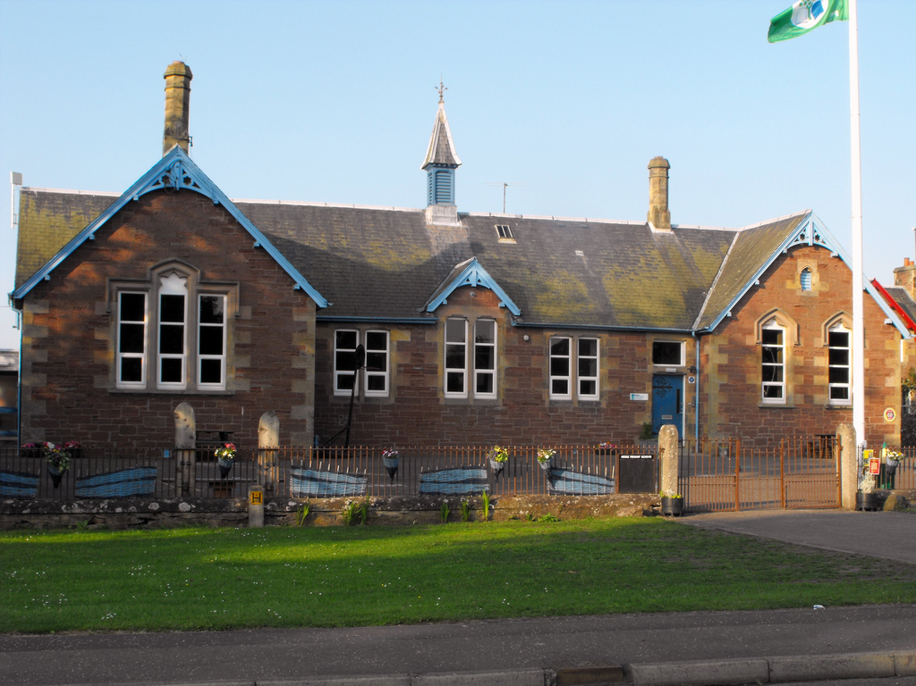

Standards and Quality Report 2023-2024

The purpose of this report is to share information on the impact that school improvement actions have had on pupils’ learning and progress over the course of this session. Using “How Good is Our School 4?” (Education Scotland 2015) our self-evaluation grades for key quality indicators are shown below.

Quality Indicator |  | Evaluation
1.3 Leadership of Change | Very Good
2.3 Learning, Teaching and Assessment: | Very Good
3.1 Ensuring Wellbeing, Equality and Inclusion | Very Good
3.2 Raising Attainment and Achievement: | Good

Progress on Priorities

Our priority areas for session 23-24 were to raise attainment in writing, enhance learning through digital technology and to review our curriculum rationale. Good progress has been made towards our overall aims. Our progress against these priorities will help inform next session’s Quality Improvement Plan. This report is evaluative and reflective of the various educational experiences over the last academic session and was produced in consultation with staff, parents and pupils.

Miss Rachel Cross (Headteacher)
1 June 2024

LEADERSHIP

The Head Teacher and Principal Teacher work effectively together as a Senior Leadership Team (SLT) with the Principal Teacher spending one day per week out of class to support strategic development. Together, the SLT are united in their vision that any change in school must result in a positive impact on learners. Leadership at Meigle is underpinned by our aspirational vision that all pupils have the knowledge, skills and mindset to thrive and then take on the world. Our school values are very well embedded and are collectively labelled; ‘The Meigle Promise’. Regular reference to our values has ensured these are a prominent within our school community, known by pupils, families and staff alike. A number of community projects have celebrated the school values. All staff are committed to the school and its community, sharing consistently high expectations for all learners. At school level, leadership of change is values based with all stakeholders involved in decision-making processes.

Collegiate sessions are purposeful and are focused on meeting our improvement priorities. Teaching staff regularly reflect on and show commitment to their professional values, as embedded in the GTCS standards. All staff embrace leadership roles explicitly linked to our Quality Improvement Plan, engaging in both local and national training. The ‘National Improving Writing Programme’ was attended by our P4-P7 teacher and had significant impact on learners this session. The Local Management Group in Blairgowrie have organised and taken part in French training sessions in order to collegiately ensure a smooth transition from primary to secondary school Modern Languages. Our PSA team benefited from PKC training in Self-Regulation.

This session our pupils have worked across four committees, now named ‘teams’, connected by their mutual interest in the Global Goals. Through involvement in their teams, children make decisions about things that are important to them and their peers. Pupils from P1-P7 planned, organised and delivered a MacMillan Afternoon Tea and invited our families to attend. This was a huge success. We introduced ‘Digital Champions’ this session, with pupils from P3 and P6 taking on additional responsibilities for our devices. Through an application process to the SLT, we have invited pupils from P6 and P7 to lead on clubs this session. House Challenges have allowed pupils the opportunity to develop leadership skills like delegation, communication and self-awareness.

Partnerships with families continue to be excellent. Our active Parent Council supports the school in hosting regular termly meetings. The Parent Council have been the driving force for successful fundraising and social events this year. Families provide positive feedback on our ‘Sharing the learning’ updates with jotters and evidence of learning going home termly. The response to our Family Survey in the month of November was extremely positive. Parents contributed well to our recent homework survey which will inform changes to our policy and practice.
Our progress in Leadership of Change this year is very good.

ATTENDANCE

Arriving on time and attending school is essential for pupil learning and progress. Below is a review of attendance across the school for the last three years.

 | June 2022 | June 2023 | June 2024
Attendance | 94.5% | 94.4% | 93.0%

ATTAINMENT

When tracking the progress that children make, we use CFE levels. Typically, Early Level covers Nursery and P1, First Level will cover P2 – P4, and Second Level will be P5-P7. We currently record attainment levels for Literacy and Numeracy. When considering the statistics, it is important to remember that the figures reported refer to a stage and the specific group of children who make up that stage.

In Primary 1 all pupils are on track to achieve Early Level in Literacy and Numeracy.
In Primary 4 the majority of the pupils are on track to achieve First Level in Literacy and Numeracy.
In Primary 7, the majority of our pupils are on track to achieve Second Level in Literacy and most are on track to achieve Second Level in Numeracy.

All being 100% Almost All being 91-99% Most being 76-90%
Majority being 51-75% Less (or fewer) than half being 16-50% A few being up to 15%

All pupils who have received targeted support have made good progress in their supported areas. Learners with Additional Support Needs are very well supported by classroom teachers, our Primary Pupil Support Teacher and Pupil Support Assistants. Pupil Equity Funding has allowed us to staff and resource a daily Nurture Group which has had positive outcomes for all those who participated.

ACHIEVEMENT
In March 2024, we were awarded the Digital Schools Award. Our report acknowledged the “rich and vibrant relationship that the pupils have with digital technology”. All classrooms are mature digital learning and teaching environments, where teachers and learners demonstrate the motivational capacity of digital technologies. In May 2024, we achieved the Bronze Sport Scotland Award. This recognises our commitment to continuous improvement in school sport and physical activity.
We are proud of the opportunities for success and achievement that we create for our pupils. At Meigle Primary School, we track wider achievements from P1 to P7 to ensure that pupils take part in a variety of opportunities and events throughout their primary years. A selection of pupils from P3 and P4 represented the school in a tennis tournament. P5 and P6s competed in a cricket festival at Victory Park in Meigle. P6s pupils competed in the PKC Euro Quiz and P7s attended the Rotary Quiz. In addition to this, individual pupils placed in the Mathematical Challenge this session and in the Cross-Country Event at Scone Racecourse.

As a school community, working together, we received £250.00 from ‘Pounds for Primaries’. We have continued success this session in organising shared events with our sister school, Kettins Primary School that celebrate our mutual school values. We had a fantastic joint Carol Service with Kettins and a shared Sports Day at Victory Park which was supported by Active Schools and our Community Link Worker.

Our progress in Raising Attainment and Achievement has been good this session.

Our progress in Ensuring Wellbeing, Equality and Inclusion was very good this session.

LEARNING

Our curriculum rationale is designed around the four contexts for learning; the life and ethos of the school, subjects and areas, interdisciplinary learning, and opportunities for achievement.

Learning and teaching at Meigle Primary School is underpinned by our vision, values and aims. The ethos and culture of our school reflects a commitment to positive relationships and children’s rights. Most pupils are eager and active participants in their learning who are engaged, resilient and motivated. Learning is enriched and supported by our effective use of digital technologies. Skilful questioning and engagement promote curiosity, independence and confidence and regularly enables higher-order thinking skills in all learners. Lessons are highly differentiated to provide both support and challenge for all our learners. Experiences are varied and matched to the needs and interests of pupils. Outdoor learning continues to be an integral part of the Meigle curriculum given our surroundings.

A quality assurance programme is in place to monitor learning and teaching across subject areas. Class visits this session have monitored appropriate pace and challenge in Literacy and Numeracy and the planned learning experiences within Digital Literacy. Sampling work and tracking pupils’ attainment over time ensures progress is celebrated.

Both classes enjoyed visits from the Scottish Deer Centre, SSPCA, RHET and Professor Potato which enhanced interdisciplinary learning topics across the terms. P4-P7 participated in Generation Science workshops on electricity and Saints in the Community workshops about racism. The whole school joined in Tartan Tuesday which celebrated our love for Scots language. Poetry winners included pupils from both classes. During ‘Values Fortnight’, all pupils enjoyed a visit from PC Blackhall and Traffic Control Officers who delivered a valuable input on road safety. In developing skills for life, our P6 pupils have embraced an intergenerational project visiting Meigle care home on a weekly basis in term four. Members of the Community council delivered a themed day to celebrate the history of the bowling club and all learners from P1 to P7 participated.
Pupils are actively involved in areas of planning their learning and in considering opportunities for achievement. Pupils are encouraged and empowered to express their views on how they are progressing using our ‘Learning Ladder’ as a supportive tool. The Learning Ladder has been shared with families this session to support discussion about learning at home.

Improvement Priorities for 2024-2025

The outcomes that we will be focusing on achieving in the next academic year are:

- Reading- build a culture of reading through participation in the Reading Schools Award
- Numeracy- focus on high quality learning, teaching and assessment in numeracy.
- LMG priority- A 3-year focus on sharing good practice in the moderation of Learning, Teaching and Assessment. In 2024-25, all relevant staff across the LMG will share practice and undertake moderation activity with a particular focus on literacy or numeracy.

These school priorities are in line with the National Priorities as outlined in the National Improvement Framework. The full Quality Improvement Plan is available on request at the school office from 14 August 2024.

