
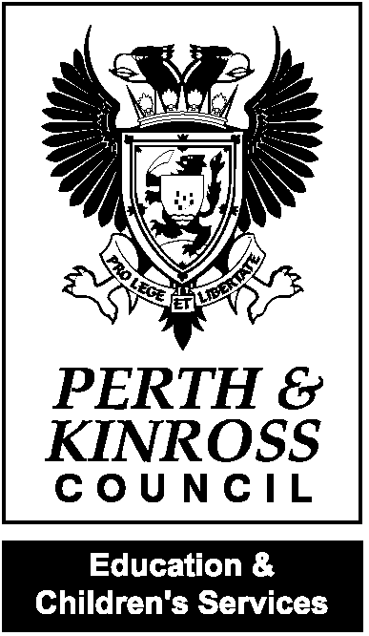



Health Promoting School
Awarded 2011


Rachel Cross
Headteacher

Meigle Primary School
Dundee Road
Meigle
BLAIRGOWRIE
PH12 8SD
Tel 01250 871415
Email: meigle@pkc.gov.uk

Dear Parent/Carer
Industrial Action – 21 October to 1 November inclusive

I am writing to update you on the impact of industrial action in our school. There are national strike days planned 21 October to 1 November, inclusive. This involves support staff in all schools in Perth and Kinross.

As you will be aware we closed today on the first day of industrial action. This was due to the numbers of union members potentially involved in strike action and the need for an assessment to be undertaken as to whether we can open the school safely. It was not possible to complete this during the October holidays. These assessments were completed today and the information available to me at present indicates that our school will be closed to pupils.

For schools who are closed to pupils, remote learning will be available. Further information regarding the provision of remote learning will follow.

As the industrial action is expected to last two weeks, it may be the circumstances of our school could change day to day.

We will keep you informed via the School App.

Please also follow the Council’s social media accounts on Facebook and X (Twitter) @PerthandKinross for further updates.

Yours sincerely,

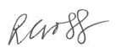
Headteacher Meigle and Kettins Primary Schools

