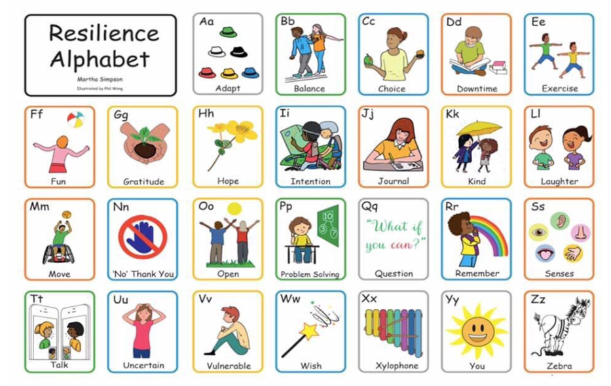A Play Process Which Helps to Build Resilience in Children

This behaviour, I believe is a strong example of how children show resilience and how they build that quality into their experience.

Two children, Primary 1 and Primary 2 entered into an elaborate, all day role play event. They took one one of their puppets which they call Squeak, it is a Sooty puppet, and they said it had got “norovirus” mispronouncing it.
These are some of their comments:

P1 child:
“ Squeak got norovirus and almost died
We gave him medicine and air to help him live”

P2 child:
“We gave him medicine and air and put him in the bed
We kept him warm and we were gentle with him”

Mum said they looked after him all day. They wrapped him up in Child 1’s jacket and took him outside to go down their new slide. At night time he was included in their treats, when they gave him a malteser, a chocolate egg, a rolo and a rainbow sweet.

Mum reported that part of the play did also include a moment when Squeak did not survive and they role played a little funeral for him by putting him in a box they found and picking flowers from the garden and putting them in the box. They didn’t bury it though. They said they thought he wasn’t dead after all and he recovered.

Asked how they knew he needed medicine and air they didn’t seem to be able to answer that question. It’s not clear if they got that information from mum or if they had seen some news.

It’s the kind of play which needs a sensible and measured response from adults. It should be understood as easily within the normal spectrum of play when a child has heard about illness and dying. If a child finds a dead bird lying on the ground he or she will often create a ritual for a funeral or burying the animal. This of course is the experience of many children when a family pet has died.

When the school returns this may well be the play and drawings of many friends as they get the opportunity to act out their experiences during lockdown. It may be a real loss in a family. However, it may also be a necessary part of processing the new normal for children.

