To book your place on one of the workshops below call the relevant number:

Tuesday 24th March 2020 12.30 – 2.30

ARCH, Reid St, Burnbank, Hamilton ML3 0RQ Call **01355 597452**

Wednesday 13th May 2020 1.30 -3.00

Carluke Health Centre, (Health Education Room) 40 Chapel St, Carluke ML8 4BA Call **01555 667158**

Wednesday 27TH May 2020 9.30-11.30

GREENHILLS HEALTH CENTRE (HEALTH EDUCATION ROOM) EAST KILBRIDE G75 8TT Call **01355 597452**

**What Other Users Think..........**

‘It helped me break situations down so I could explain them to my child and show him how to handle things better.’

‘The discussion time with other parents and teachers was useful.’

‘Working through real examples was helpful.’



**EK, Hamilton, Camglen and Clydesdale**

**Speech and Language Therapy Department**

**Social Stories Workshop**

[](https://www.google.co.uk/imgres?imgurl=https://cdn.skim.gs/image/upload/ar_1.91,c_fit,f_auto,fl_lossy,h_600,q_auto/v1/msi/rdbrivyf6z8ct63ippbt&imgrefurl=https://www.sheknows.com/parenting/articles/1005561/how-to-encourage-good-study-habits-without-nagging&docid=ZnC5K9c0xqHPzM&tbnid=fia3BXdSXi7hXM:&vet=10ahUKEwiugo_j6v3cAhWHLFAKHT8GDn8QMwiKAShaMFo..i&w=480&h=600&bih=851&biw=1280&q=NON%20COPYRIGHT%20images%20of%20adult%20and%20child%20writing%20together&ved=0ahUKEwiugo_j6v3cAhWHLFAKHT8GDn8QMwiKAShaMFo&iact=mrc&uact=8)

**Practical Solutions for Real life Problems**

Children & adults with Autism Spectrum Disorder often struggle to spot, understand and adapt to social signals in the world around them.

A social story is one tool to help with problems that occur repeatedly or to prepare people for a problem that is going to arise. It can be used with people aged 3 and upwards. Each story is personal to the individual and is written in a simple, structured way, supporting the individual to know what to expect.

The course explains:

* Why social stories are helpful
* The structure of a social story and how to write and personalise one
* Ways to adapt stories for different abilities and age groups
* Where, when and how often to read stories

**Here’s an example.**

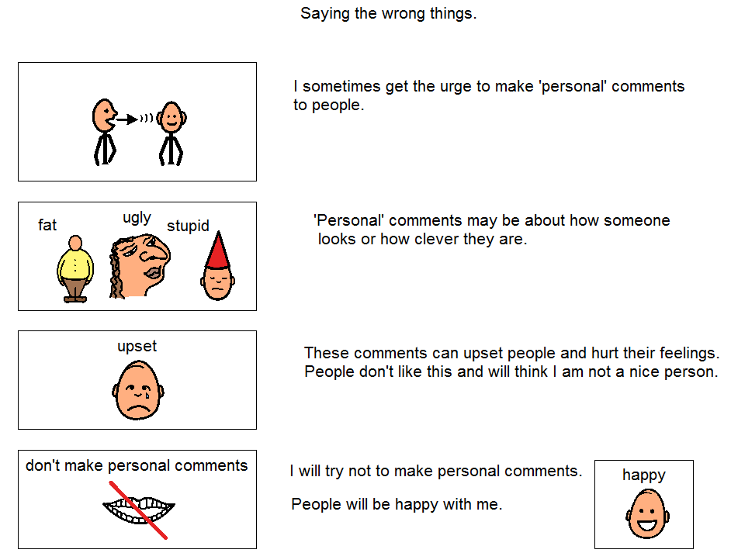

Course format:

* The course is for parents, carers, teachers and other professionals, to learn to write stories. It is **NOT** for children to attend
* A short presentation describes what the stories can do and how to write them
* Participants will get the chance to have a go writing a Social Story with help and support from the group and SLTs.