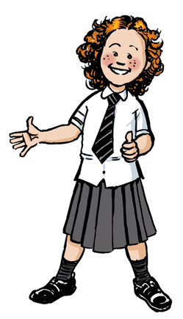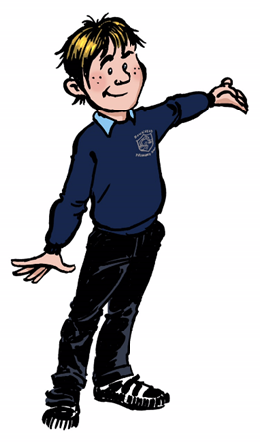

Returning to School in August 2020

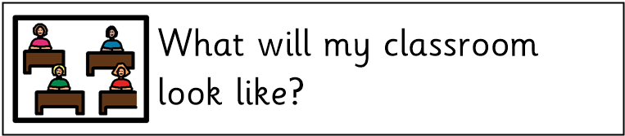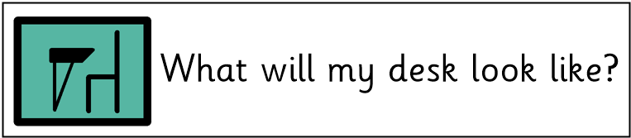

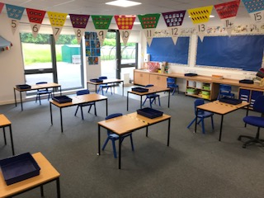

You will only sit at one side of the desk. The tape and stickers will show you which side of the desk you should sit on.

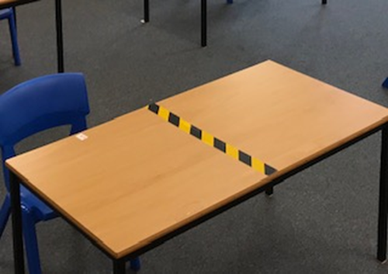

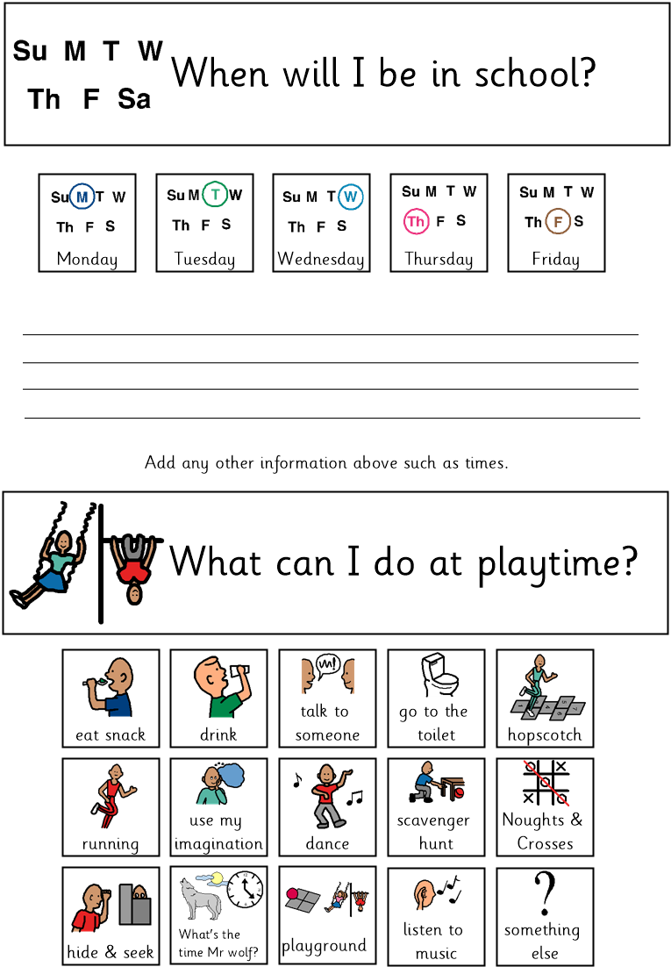

Tick applicable boxes

**You will be in school**

**from 9.10am till 3.10pm**

**You will be in school**

**from 9.00am till 3.00pm**

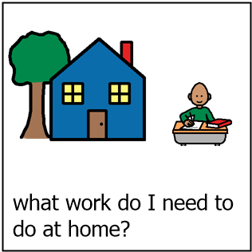

Your teacher will provide you with work to do on the days that you won’t be in school.

You will be able to do some work on paper or in jotters.

At home, you will be able to go onto Google Classroom and do some work that the teacher will set for you.

The teacher will show you how to do this on the days you are in school.

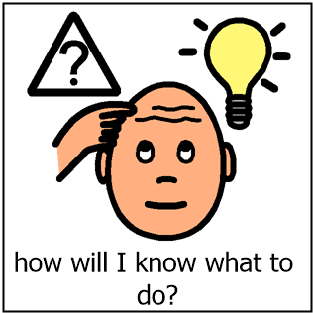

You can ask your grown-ups at home to help you.

Your teacher will show you what to do when you are in school.

If you are worried or stuck you can put a message on Google Classroom and an adult from school will try to help you.

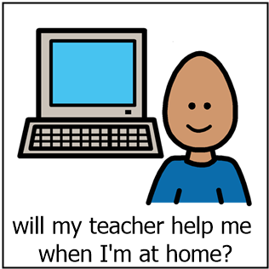

An adult from school will be able to help you when you are at home. It may not be your teacher but another adult. It may be Mr Hamill, Mrs Easton or Mrs Yardley.

Your teacher will help you to understand what you have to do when you are in school.

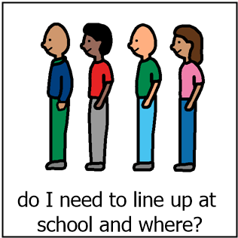

Rooms 1-5 will line up outside their classrooms.

Rooms 6 and GP will line up at the posts in the infant playground.

Rooms 7, 8, 9, 10 and 11 will line up at the posts in the top playground.

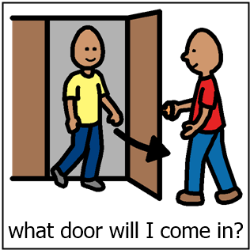

Rooms 1-5 on the ground floor will come in through their own classroom doors.

Rooms 6 and GP will come in through the doors beside P1 and the Nursery.

Room 7, 8, 9, 10 and 11 will come in through the doors at the top of the playground.

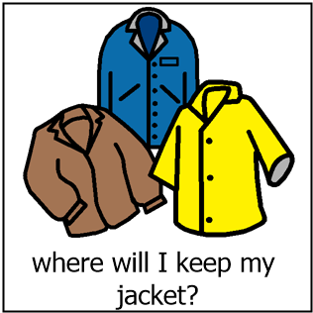

You can hang your coat and bag on the back of your chair.

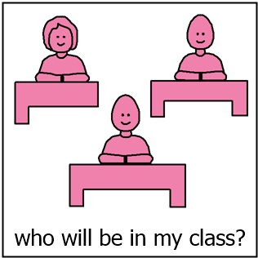

Some of the children who were in your class last year.

You may have some new children in your class.

You will only have a small number of children in your class.

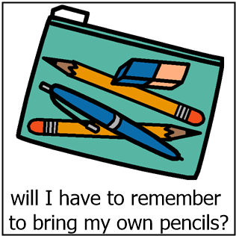



No, you will be given your own pencils and other resources to keep in your own tray.

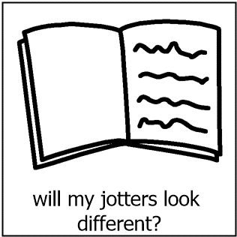

No, all your jotters and books will look the same.

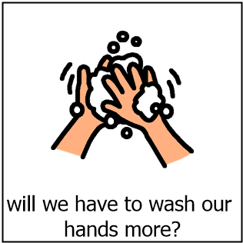

You will have to wash your hands when you arrive in school and at regular intervals throughout the day.

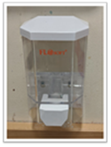 

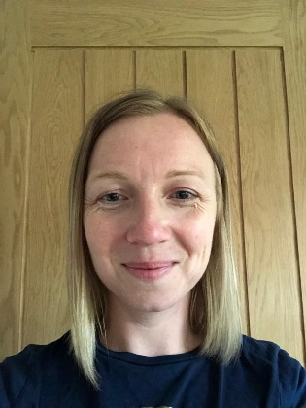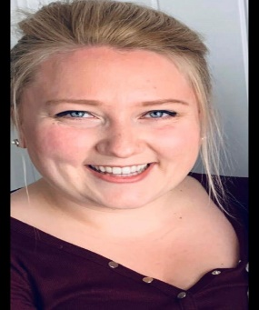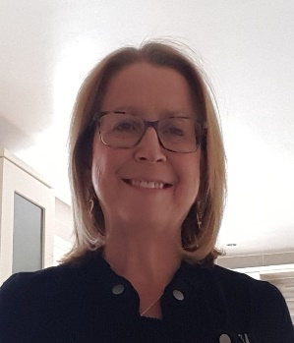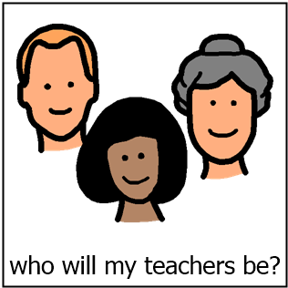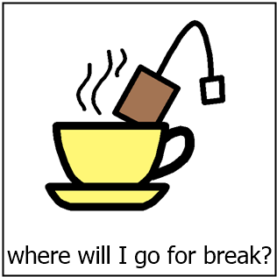

Primary 1

Mrs McCarthy Mrs Murray Mrs Stevenson Mrs Alexander

Gym Hall Room 1 Mon/Tue Room 1 Thu/Fri P1/2 - Room 2

You will play in the playground as normal. Your class will have their own section to play in.

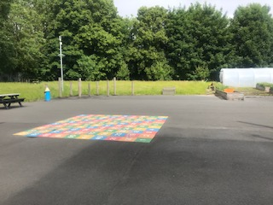

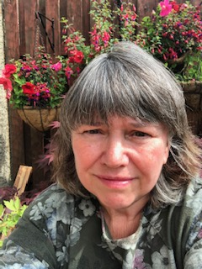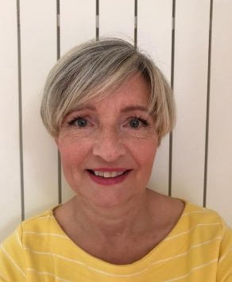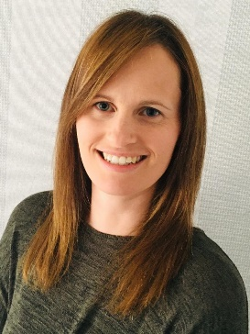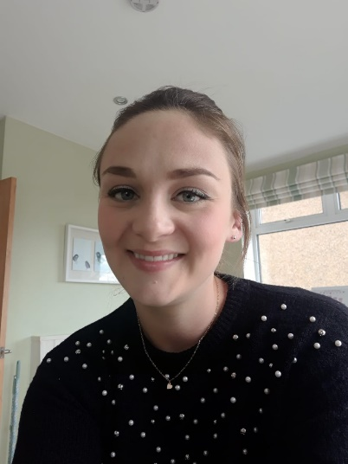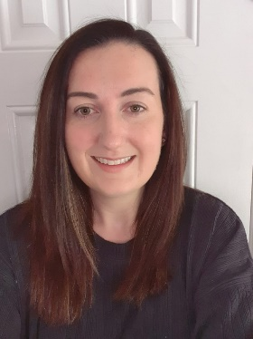

Primary 2 and 3

Mrs Disley Mrs Donald Mrs Jolly Ms. Bestel Mrs Chase Room 3 – Mon/Tue Room 3 – Thu/Fri Room 4 Mon/Tue Room 4 – Thu/Fri Room 5

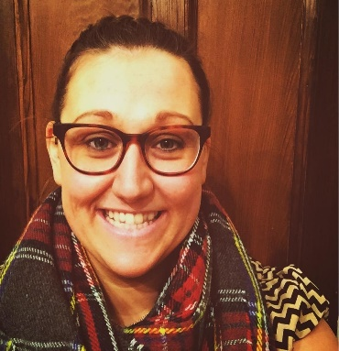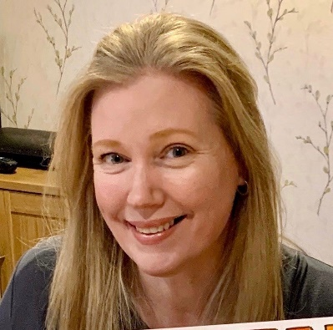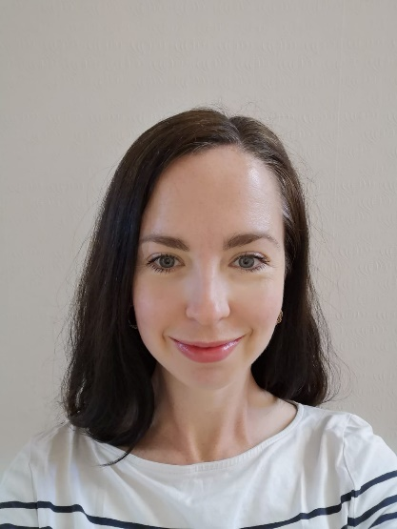

Primary 4 and 5

Mrs Muir Mrs Baird Miss Young Miss Fillingham

Room 6 Mon/Tue Room 6 Thu/Fri GP Room Room 7

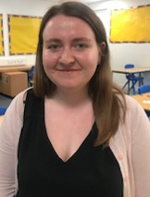

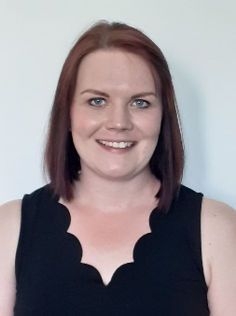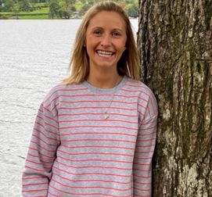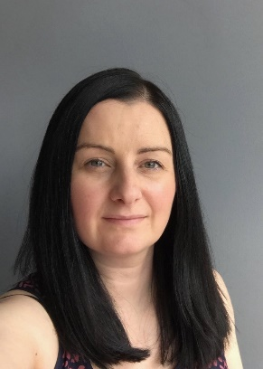

Primary 5, 6 and 7

Mrs Urquhart Mrs McIntyre Miss Jack Miss McVey Miss Boyd

Room 8 Mon/Tue Room 8 Thu/Fri Room 9 Room 10 Room 11

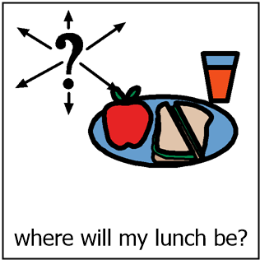

If you have a packed lunch you will eat your lunch in the classroom.

If you have a school lunch you will go to the cafeteria.

You can choose a seat that have the Bankhead boy and girl stickers.

There are tables in the gym hall that you can also sit at.

You will still clear you plates and trays in the same way.

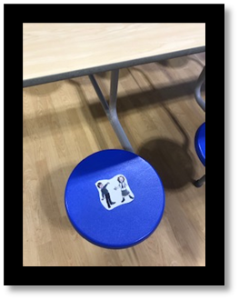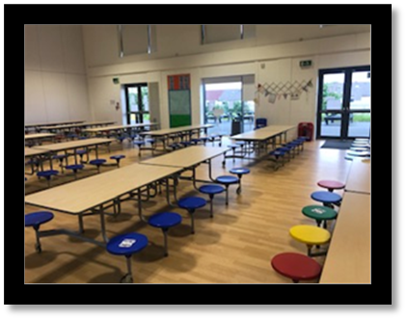

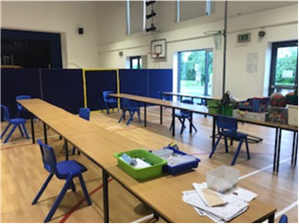

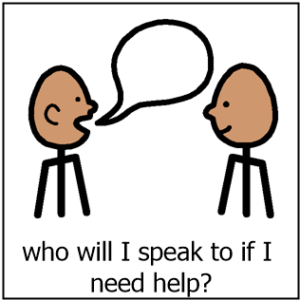

You can speak to any adults in school.

You can always speak to Mr Hamill, Mrs Easton or Mrs Yardley.

There are adults in the playground or the janitors.

You can get help from the office too.

You can always speak to your teacher.

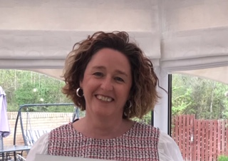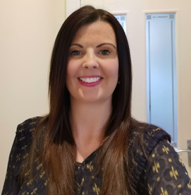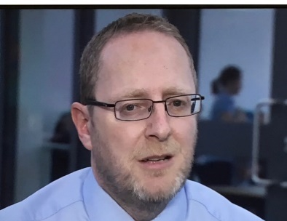

Mr Hamill Mrs Easton Mrs Yardley

Head Teacher DHT Acting DHT

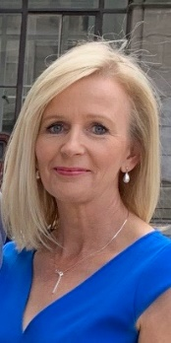

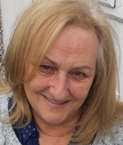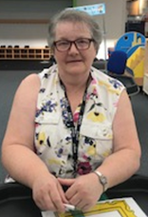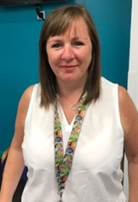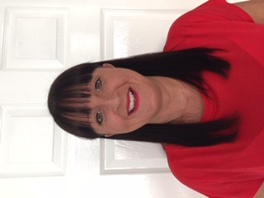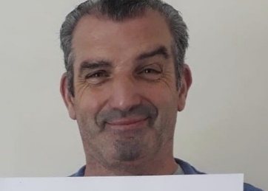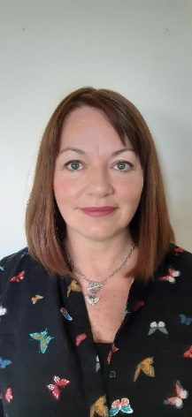

Mrs Foy Mrs Blue Mrs Doyle Miss McCord Mrs Duffy Mrs Higgins Mrs Gardner Mr McAulay

Office Support Assistants Janitors

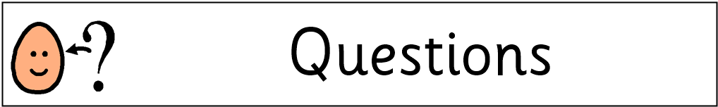

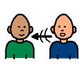



There are lots of questions that we all have. We have tried to answer as many as we can, but if you have any more then make a list for us and we can try to answer them.

 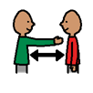

Some questions you may have, we might have too. We may not be able to answer all of your questions, but we can find the answers together.

  

You might feel nervous or excited about coming back to school. We feel that way too. We are nervous about what will be different. That is only natural. But more so, we are excited to see you all again. We have missed you!