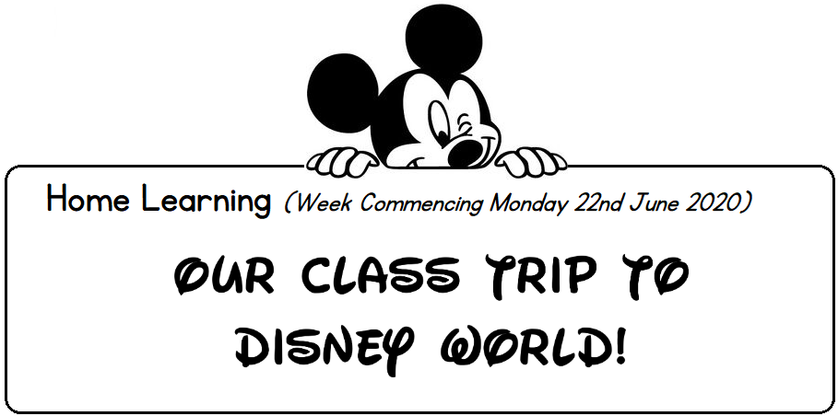
Room 5 Home Learning – Virtual Trip to Disney World!
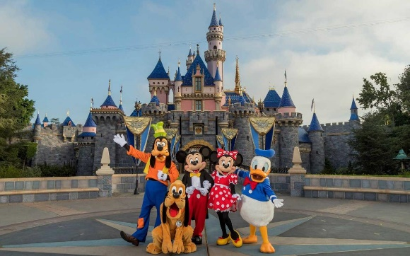

For our last week of term, we are going to be planning a trip to Disney World in Florida!
You can pick and choose which tasks you would like to do over Monday, Tuesday and Wednesday!
Here are a range of activities you could do at home with your child.

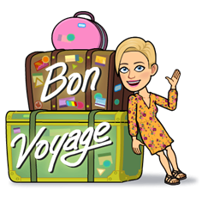
Task 1: Let's get to Disney World

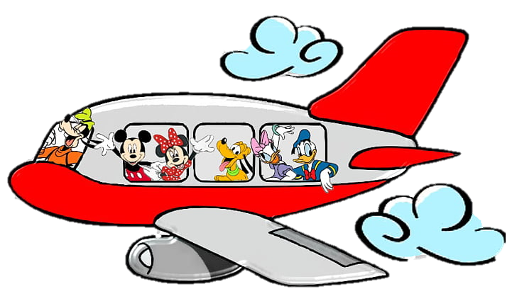
Flight Prices.
Glasgow to Orlando | One way
Seat | £450
Children under 2 | £30

Orlando to Glasgow | One way
Seat | £350
Children under 2 | £20

How much to get your whole family there AND back again? Everyone will have different answers as you do not all have the same family members. You might want to write down all the flight prices you need before you add them up. You could also check your answer by using the calculator on a phone.

Task 2: Design your dream hotel room
Draw a picture of your dream hotel room and label it to show what you would like in your room. You might want a jacuzzi, a mini fridge full of snacks or even slides and a climbing frame! Here are a few hotel pictures to help you if you are stuck for ideas.

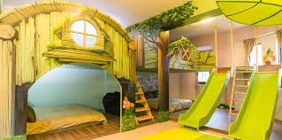
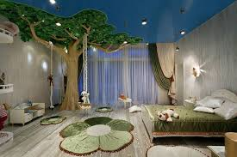
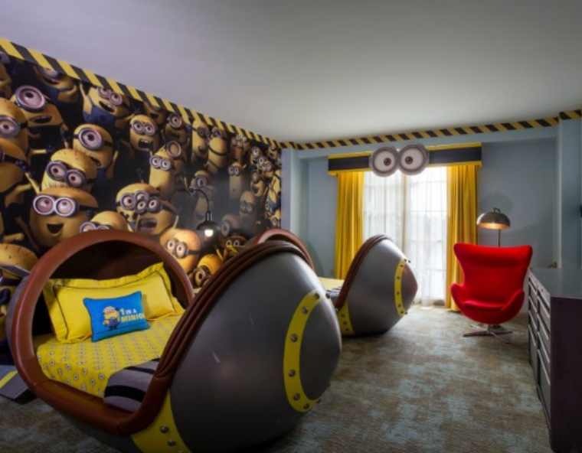
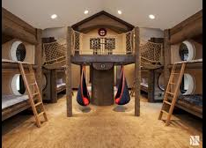

Task 3: Disney World ticket problem solving
Daily Pass
Family ticket (2 adults and 4 children) | £50
Adult ticket | £30
child ticket (under 16) | £20

How much would it cost for your family to go to Disney World for the day? Again, Everyone will have different answers as you do not all have the same family members. You might need to work it out in 2 different ways to see which way is cheaper- depending on how many adults and children there are in your family!

Task 4: Design a Disney themed ticket, which you would have to show at the gates to get into Disney World.

If you are stuck for ideas, you could use this template to help you, or look up some images for theme park tickets on the internet.

Remember to include:
- The words ‘Disney World Ticket’.
- The price of the ticket.
- The date the ticket is valid for (Monday 22nd June 2020 – Wednesday 24th June 2020).
- Colours and illustrations.

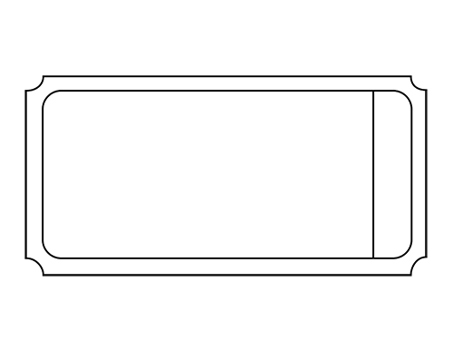

Task 5: WE HAVE ARRIVED AT DISNEY WORLD…have a look around by clicking on the link below:

https://www.youtube.com/watch?v=_iIxfFZW-NE

Task 6: Design your own Disney ride
Design a new ride or build a model ride for Disney World. Use this checklist below to help you.

To do | tick
Decide on a Disney theme, e.g, Frozen, Toy Story.
Think about ways you can make your model show your theme. ( Maybe you have someone in the house who likes to dress up in a Disney costume and could become the character?)
Who will use your ride? You? An action figure or doll?
Where are you going to build your ride? Inside with the furniture? Outside with what’s in your garden? Junk model? Construction toys, e.g Lego or Scalextric.
What kind of ride is it going to be? Will it be a roller coaster or Big Wheel or a ride through attractions? Will there be water? Will the riders get wet or scared or even made to ride upside down?
Sketch out your plan in pencil.
Build your ride.

This template might help you get started.
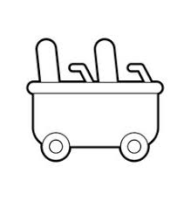

Task 7: Disney Games
You have been very busy exploring Disney World. Now take some time to relax and play any of these Disney games by clicking on the link below:
https://lol.disney.com/games

I hope you enjoyed our virtual school trip to Disney World, boys and girls! Please remember to post any work to our Google Classroom of anything you have done this week!

Mrs Chase

