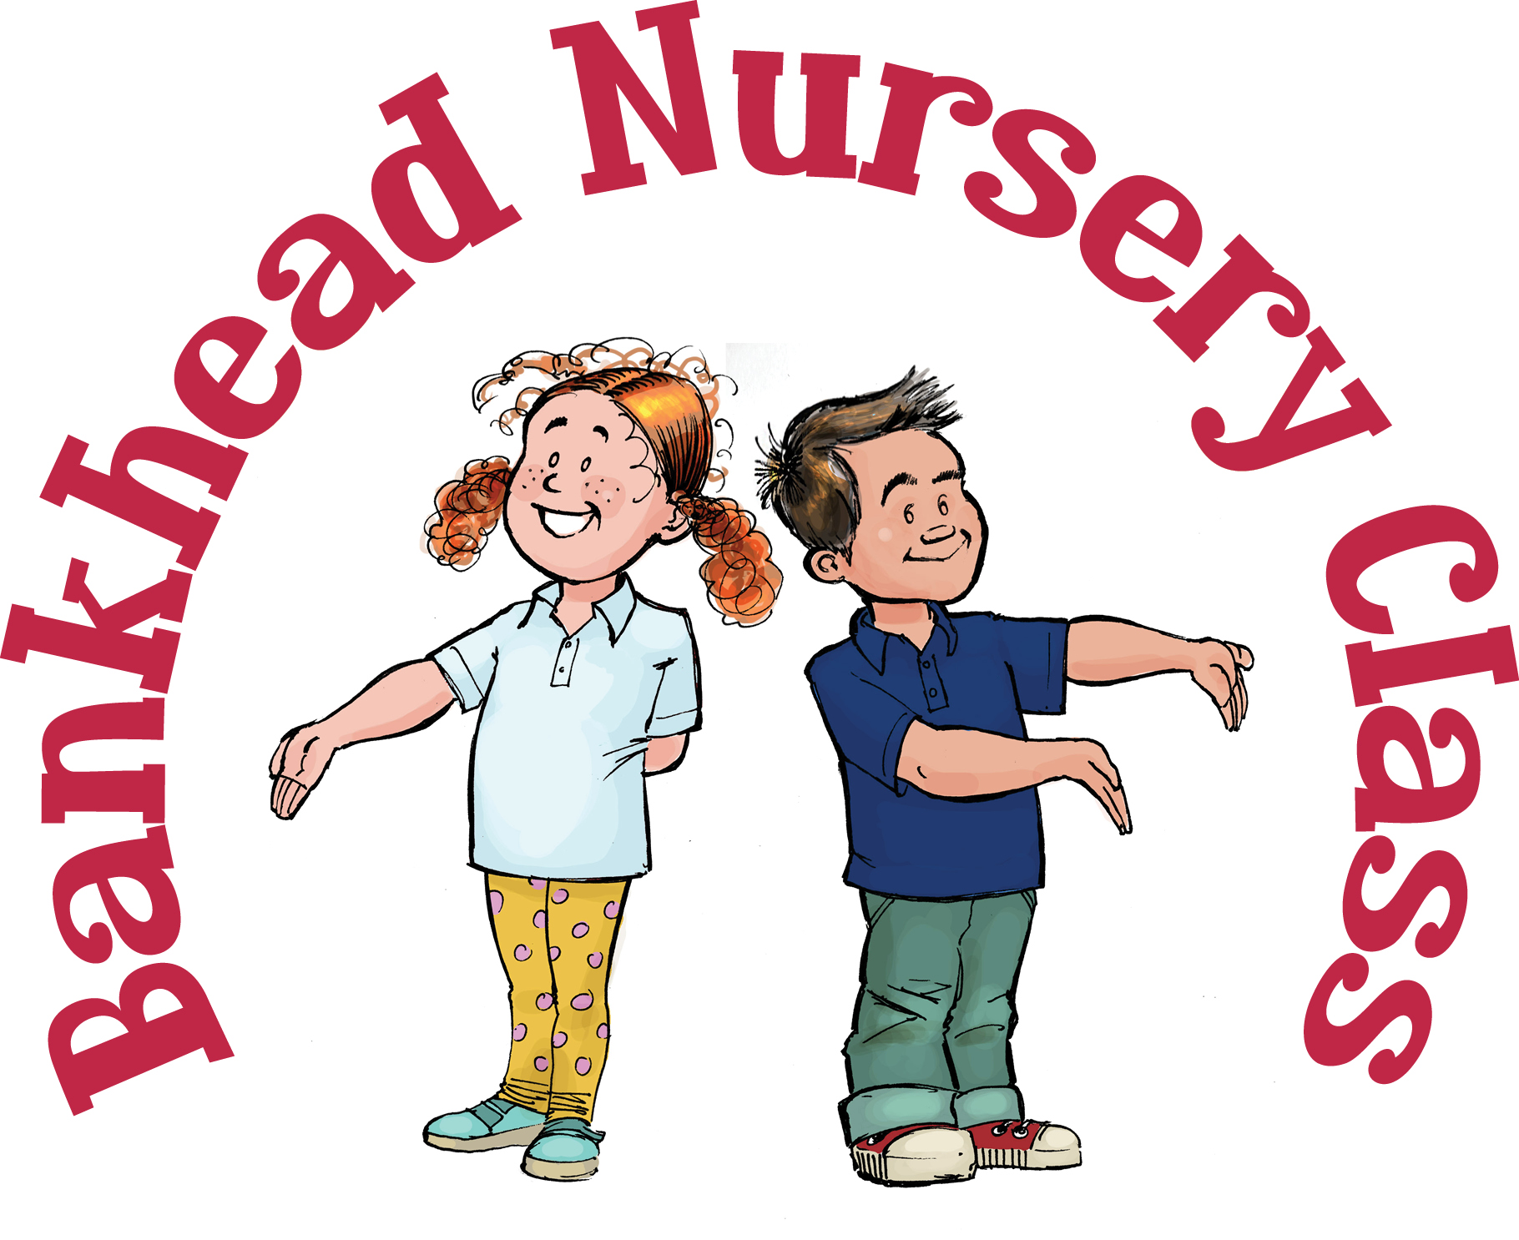



RME

* Play and a game with someone else and remember to take turns and share.
* Learn about different cultures through my World Kitchen. <https://www.bbc.co.uk/cbeebies/shows/my-world-kitchen>
* Talk about how you can care for others and show this kindness e.g. make a card or help to tidy.

Expressive Arts

* Dance and sing along to ‘The Wiggles’ on YouTube.
* Act like a pirate alongside the Swashbucklers <https://www.bbc.co.uk/cbeebies/shows/swashbuckle-online>
* Can you make different sounds using household items? E.g. pots and pans.
* Make pictures using leaves, stones and twigs.

Technology

* Use a range of recyclable materials to create a model.
* Work alongside your child to help to prepare a meal.
* Practise cutting simple shapes or lines using scissors.
* Play a range of games online - [www.topmarks.co.uk](http://www.topmarks.co.uk)

Social Studies

* Learn the name of the town that you live in and your home address.
* Talk about what jobs people do within your town.
* Make a treasure map of your house and draw an x at the spot that you have hidden your toy. Happy hunting!
* Play hide and seek in the garden or your house.

Maths

* Find the following shapes around your home – triangle, square, rectangle and circle e.g. What shape is the clock?
* Identify the numbers 1 to 10 and practise counting objects, e.g. How many pens?
* Look for colours around the room or outdoors.

Literacy

* Read stories together and ask your child to retell them in their own words.
* Sing nursery rhymes e.g. Hickory Dickory Dock.
* Check out CBBC stories <https://www.bbc.co.uk/cbeebies/stories>. The app is also available to download.
* Practise writing your name.
* Draw pictures of your favourite book characters.

Health and Wellbeing

* Try out kids yoga using ‘Cosmic Kids’ on YouTube.
* If you are feeling energetic ‘Jump Start Jonny’ online will get you moving.
* Look in the mirror and discuss your facial expression and talk about different feelings people can have. Draw a self-portrait of how you feel today.

Science

* Go on a senses journey outdoors and ask your child what they can see, hear, touch, smell and taste.
* Gather a variety of objects from around the home and see what floats or sinks.
* Talk about forces e.g. pushing, pulling, and twisting. Test these out e.g. place a car on a homemade ramp.

**Bankhead Nursery Class**

Here are a range of activities you could do at home with your child.