

**Health and Wellbeing**

On Thursday at 8pm, if you’re not already tucked up in bed…remember to clap for our NHS, carers and all key workers!

Send us a picture of you out clapping ☺

**Literacy**

Can you recognise your own name?

Can you find an item in your house that starts with the same letter as your name?

**Numeracy**

Can you recite and recognise numbers 0-10?

*Encourage your child to count stairs as the climb them.*

*Whilst out a walk in your local community point out numbers on doors, buses, bins and registration plates.*

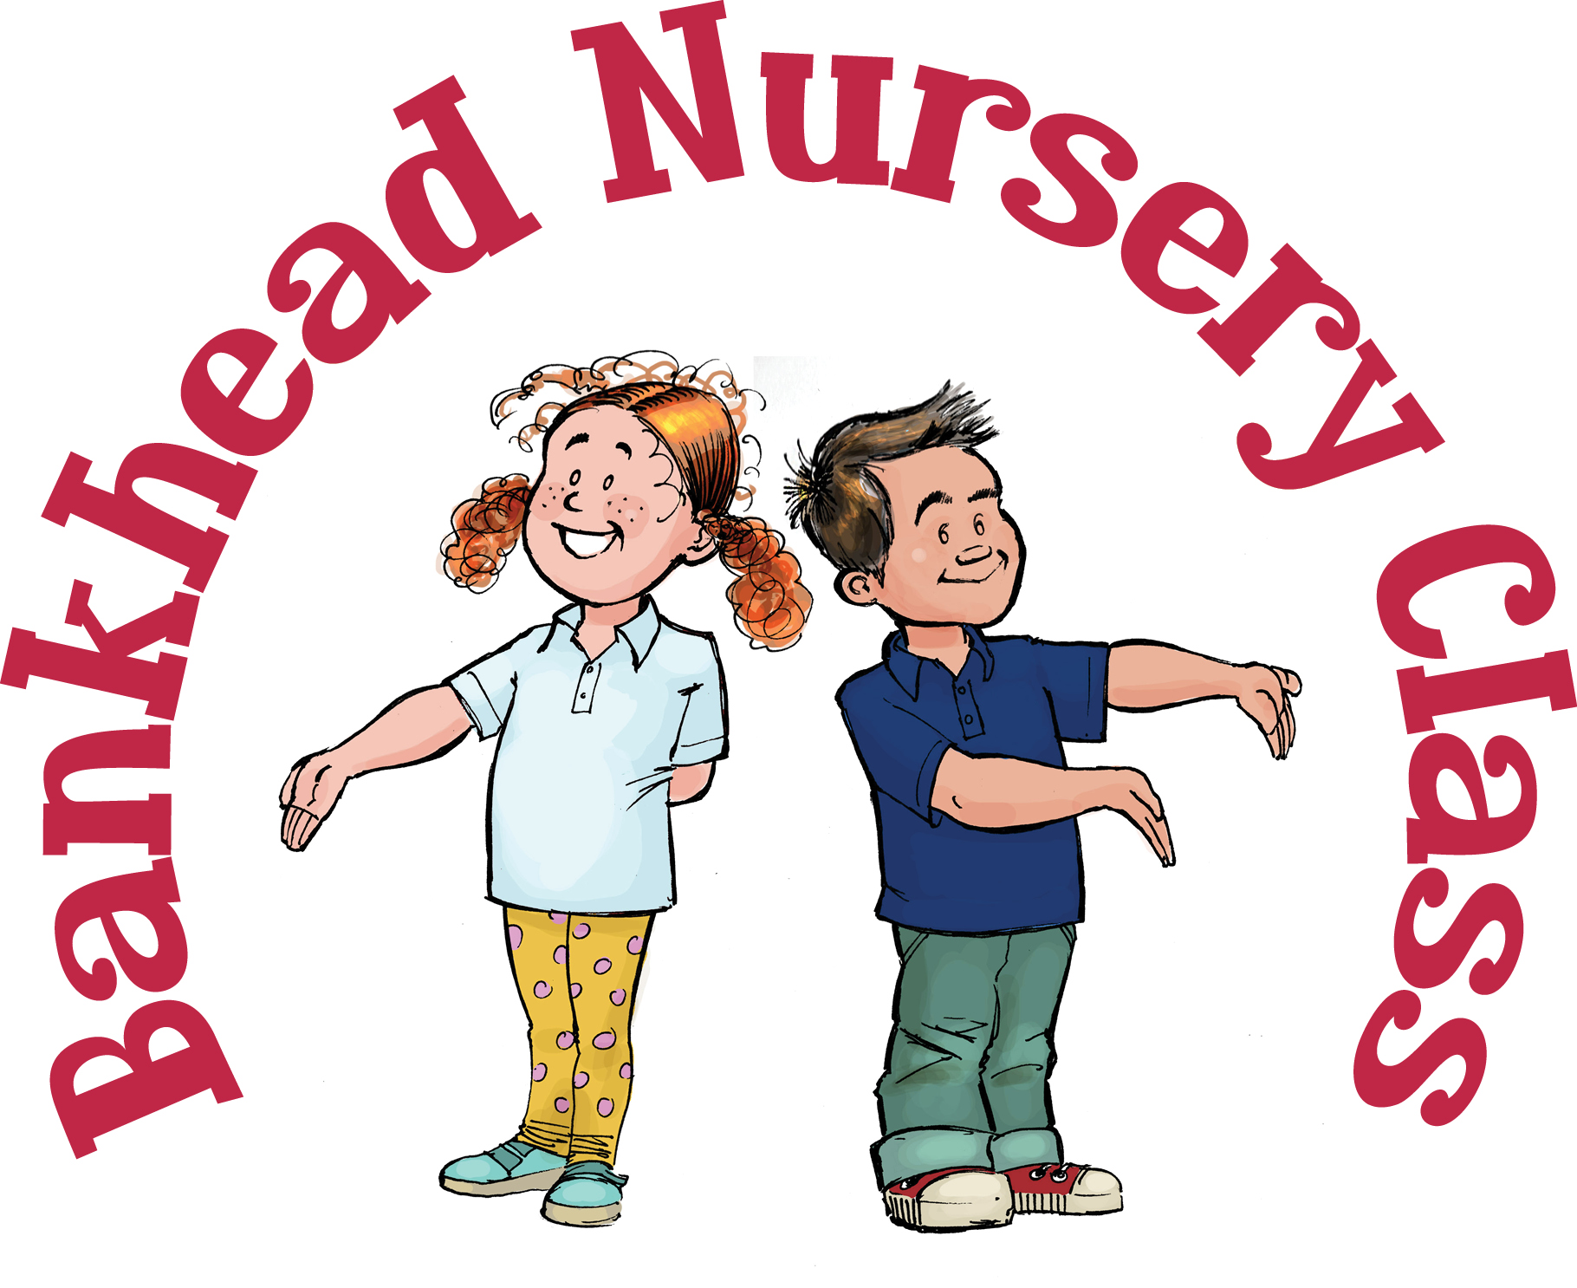







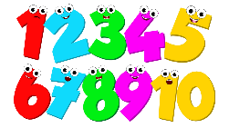

**Bankhead Nursery Class Weekly Plan 4/5/20**

Here are a range of activities you could do at home with your child.

These are all optional and can be adapted for your child and family ☺

**Rhyme time**

**Incy Wincy Spider**

[**https://www.youtube.com/watch?v=YAJynCIsNUg**](https://www.youtube.com/watch?v=YAJynCIsNUg)

**Incy Wincy spider went up the water spout  
Down came the rain and washed the spider out  
Out came the sun and dried up all the rain  
So, Incy Wincy spider went up the water spout again**



**Happy Birthday**



Hisham is turning 4!

**Skill of the week**

Can you help set the table for dinner?

* *Fork to the LEFT*
* *Knife to the RIGHT*

*Talk about your left and right hands.*