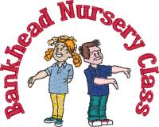
Home Learning activities
Fine Motor Skills
April 2020
Fine motor skills involve the use of the hand, fingers and thumb. They help children perform important tasks like feeding themselves, grasping toys, buttoning and zipping clothes, drawing, writing and more. Before we encourage children to draw or write we can be developing their fine motor skills in other ways. Please find below some ideas for developing your child’s fine motor skills. I’ve tried to collate ideas which include items you may find around the home. Again, these are all ‘suggested activities’, the weather is so beautiful at the moment…even take some of these ideas outdoors! Stay safe and take care, Mrs McGregor x
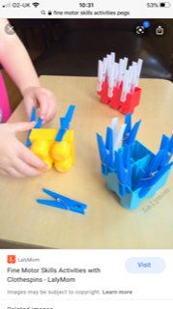
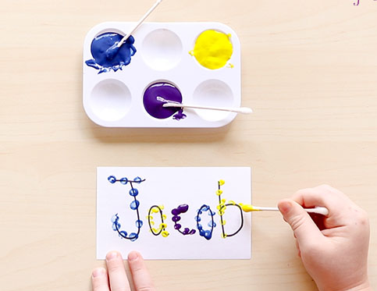

Clip on pegs to the underside of Duplo bricks.
Using a cotton bud, dip in paint and dot over letters of name, children use a ‘pincer’ grip.
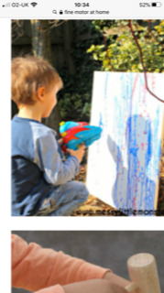
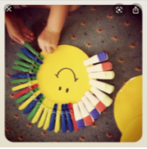

Using a water-gun, or spray bottle…try to spray off chalk or paint marks outdoors.
Clip on pegs to a cardboard circle to make a sun.
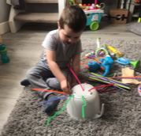
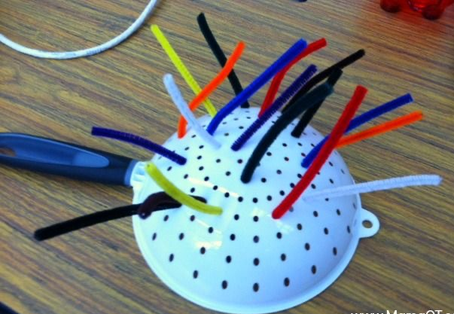

Insert pipe cleaners into the holes of a colander – it makes a crazy hat!

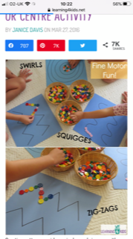
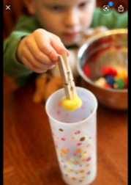
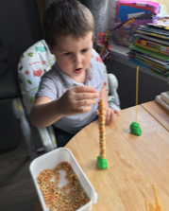
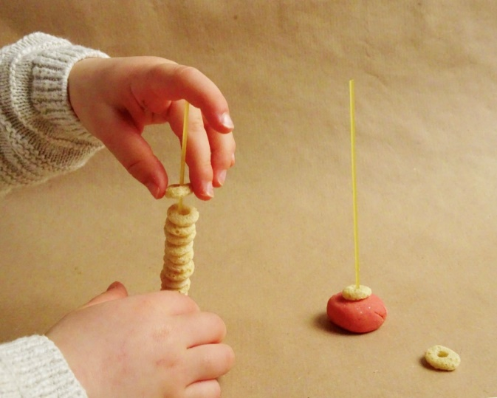
Using a ‘dod’ of playdough with a strand of spaghetti in it, try to loop on Cheerios or any hoop variety cereal…we used Tesco’s own!
Using a peg, grab pompoms and place them into a cup or bowl – you could sort them into colours for a challenge!
Place buttons or pompoms over squiggly or jagged lines.

