Bankhead Primary School

Home Learning Guidance for Parents and Carers
2020/2021

Home Learning at Bankhead – Accessing Google Classrooms
Google Classrooms is our key online teaching tool at Bankhead Primary School. Please follow the steps below to access Google Classrooms for your child.
If using a laptop or PC, the easiest way to access Google Classroom is through your Glow account.
1. Use this website: www.glow.rmunify.com
2. Login using your glow login details, provided by the teacher. Then this page will appear:
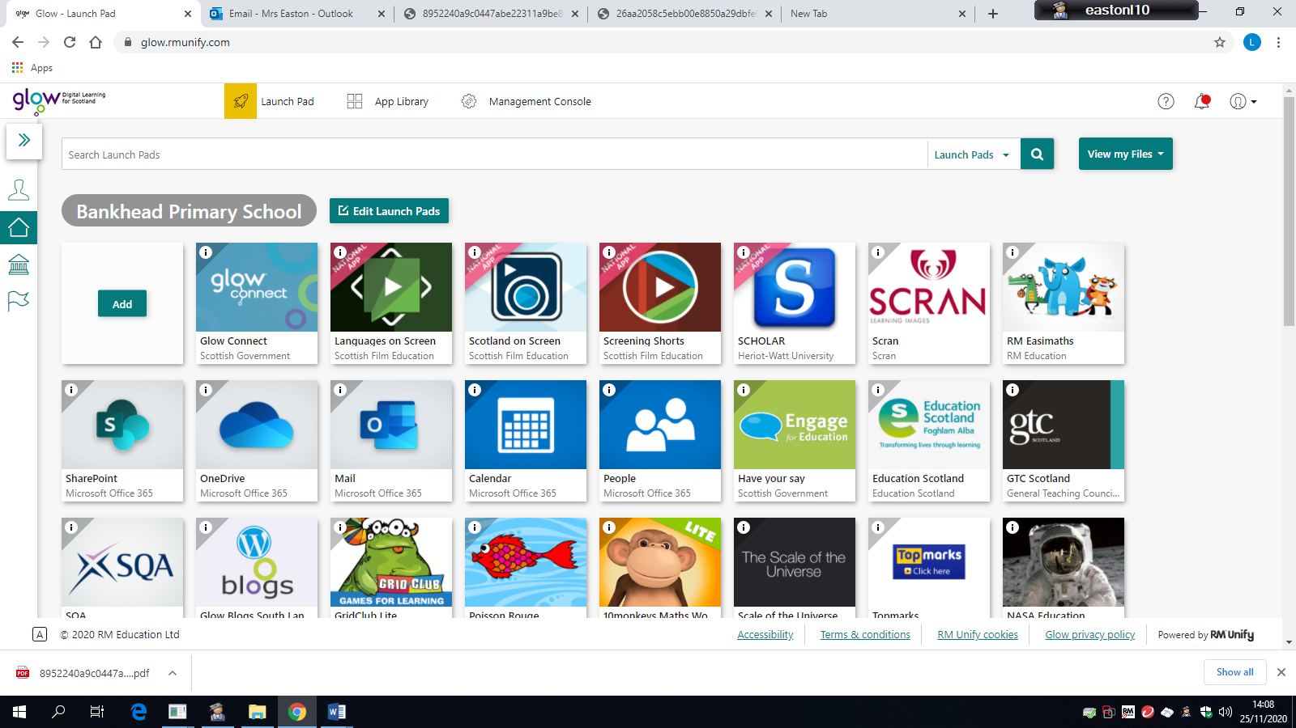
3. Make sure you click on the symbol of the house (highlighted above) and then scroll down to find Google Classroom.
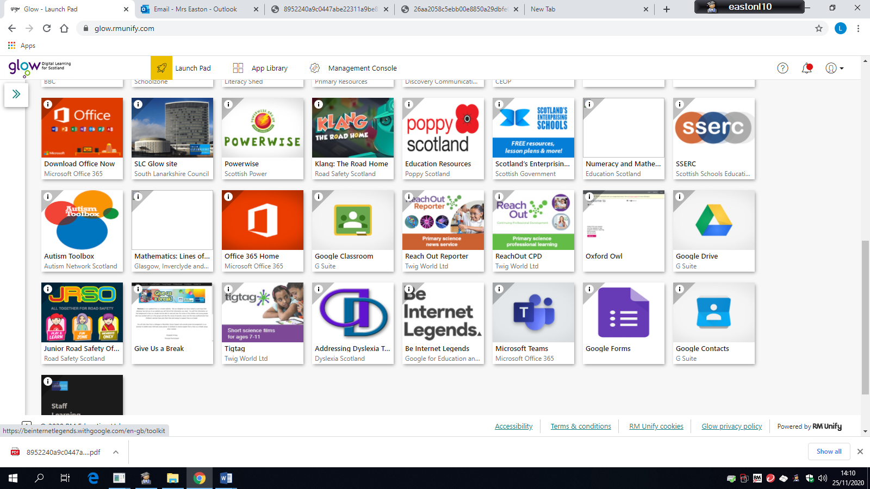
4. When you click Google Classroom, a box like this may appear:
The section highlighted should have your login details, eg. gw14bloggsjoe@sl.glow.scot
You will see the end is slightly different from your email address.
If it is not your login details that appear here, choose add account and login.
You may be redirected to the Glow login page, where you would use your Glow login as usual, not with the altered ending.
You should now have access to your classroom.
If using a tablet or phone, the login process is similar but you can download the app. When you login through the app you login as in step 4. You will need the class code to join via the app, which can be provided by your teacher.

Home Learning at Bankhead
When the school is informed that your child is isolating– if they are too poorly to be at school, they will not be well enough to undertake learning at home. However, if your child is well, they can complete the home learning levels below using the resources listed.
Home Learning Levels | Learning Resources
- Individual and family 14-day isolation | - Early, first or second isolation grids on Google Classrooms (Within the classwork section, under ‘Isolation’)  - Work sent home by class teacher  - Homework on Google Classrooms  - Studyladder, Easimaths, Sumdog or Education City online
2. Whole Class isolation 14 days | - Early, first or second isolation grids day 1 on Google Classrooms  - Class work shared on Google Classrooms  - Studyladder, Easimaths, Sumdog or Education City online
- School isolation 14 days | - Early, first or second isolation grids day 1 on Google Classrooms  - Class work shared on Google Classrooms  - Studyladder, Easimaths, Sumdog or Education City online
- Blended Learning  (Please note: we have no expectation that blended learning is being considered as an option at this time, we just want to ensure that we are prepared for all potential home learning scenarios.) | - 2 days in class  - Plans shared on a Wednesday through Google Classrooms  - 3 days completing work on Google Classrooms

Home Learning Support

We are aware that home learning can be difficult for a variety of reasons, including access to technology, time, support, and space. If you have any general enquiries, please contact: -
The School Office - enquiries@bankhead-pri.s-lanark.sch.uk

If you are experiencing any problems with the work being set, please contact the class teacher via email on Google Classrooms on the first instance. Mrs Easton, DHT will also be available to support general problems: -
Mrs Easton – gw11eastonlaura01@glow.sch.uk

If you are experiencing any ICT issues, please contact our ICT
Co-ordinator, Mrs Urquhart (Monday – Wednesday): -
ICT Co-ordinator - theict@bankhead-pri.s-lanark.sch.uk

If you require support for learning for your child, please contact Mrs Yardley, DHT: -
Mrs Yardley - gw07yardleyjulie@glow.sch.uk

