COVID-19 Health and Well Being Parental Questionnaire Response
11th May 2020
Question 1:

Yes – 63% No – 37%
School Response
Through the introduction of our community ‘Wellbeing Wednesday’ we hope to support parents/carers with mental, emotional, social and physical wellbeing. The school also offers wellbeing phone calls, please contact the school if you would like to speak to a member of SMT.
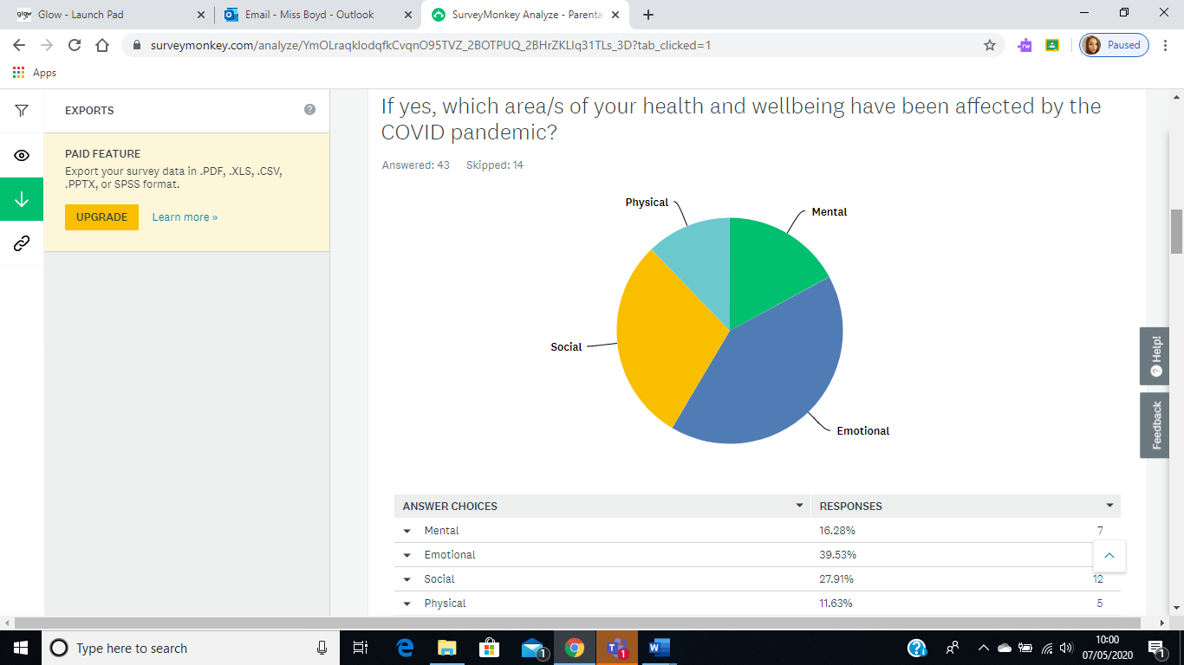
Question 2:

Mental – 17% Emotional = 40% Social – 28% Physical – 12%
Comments:
- All areas above, missing family and friends who would usually be able to offer support
- Feeling more stressed
- All areas have been impacted in some way and some days more than others. At the minute we're doing ok, largely because of a continuing and strong church community. But physically it's hard to be motivated to drag two reluctant children out for a walk. Rushing to and from school every day was great for forcing us to be active!
- Emotionally and physically. I suffer from hypothyroidism.
- All areas affected in some way
- Social aspect – missing it a lot

School Response
To support your health and wellbeing the school will introduce a ‘Wellbeing Wednesday’ for parents/carers with a focus on mental, emotional, social and physical wellbeing.

Question 3:

Yes – 47% N0 – 53%
School Response
To support your child’s health and wellbeing the school will introduce whole school weekly lessons with a focus on mental, emotional, social and physical wellbeing.
Question 4:

Mental – 12% Emotional – 24% Social – 33% Physical – 12%
Comments:
- Children are missing relatives although behaviour has improved between siblings
- Missing grandparents and friends
- Outbursts and hard to calm him back down
- No effects
- Coped well
- Missing friends
- Daughter doesn’t seem to bothered
- Child overwhelmed, not sleeping well
- Affected more than one area
- Social and emotional
School Response
As a whole school we will deliver lessons and provide support to your child for each of the four areas in health and wellbeing. Lessons will be posted onto Google Classrooms and Learning Journals. We will work in collaboration with the parent council to deliver virtual social events for your child.

Question 5:

Yes – 16% No – 84%
Comments:
- Mental health for the kids
- We've been in regular contact with our church family, a great way of supporting our mental, emotional, social and spiritual health.
- Social Work
- Visit doctor recently to do blood test to increase medication dosage
- Work contacts
School Response
The school has collated a list of local and national agencies that provide health and wellbeing support for pupils and parents, this will be shared with all parents/carers.

Question 6:

Health and Well Being Links – 34%
Activities through Google Classrooms and Learning Journals – 36%
Personalised Phone Calls – 4%
All of the above – 27%
School Response
The school will provide all of the above forms of support and as a family you can decide which activities you wish to participate in to meet your health and wellbeing needs.
Question 7:

Daily – 2% Few times a week – 17% Weekly – 67% Monthly – 15%
School Response
We have now planned whole school weekly health and wellbeing lessons delivered on a Monday by Mrs Donald and on a Wednesday by Miss Boyd. Class teachers will also plan individual class lessons based on the needs of their children.
Question 8:

Yes – 88% No – 12%
School Response
We have planned a wide range of activities throughout the week to support the mental, emotional, physical and social well-being of both our pupils and parents/carers. These activities are optional.

