Thank you to the Friends of Bankhead

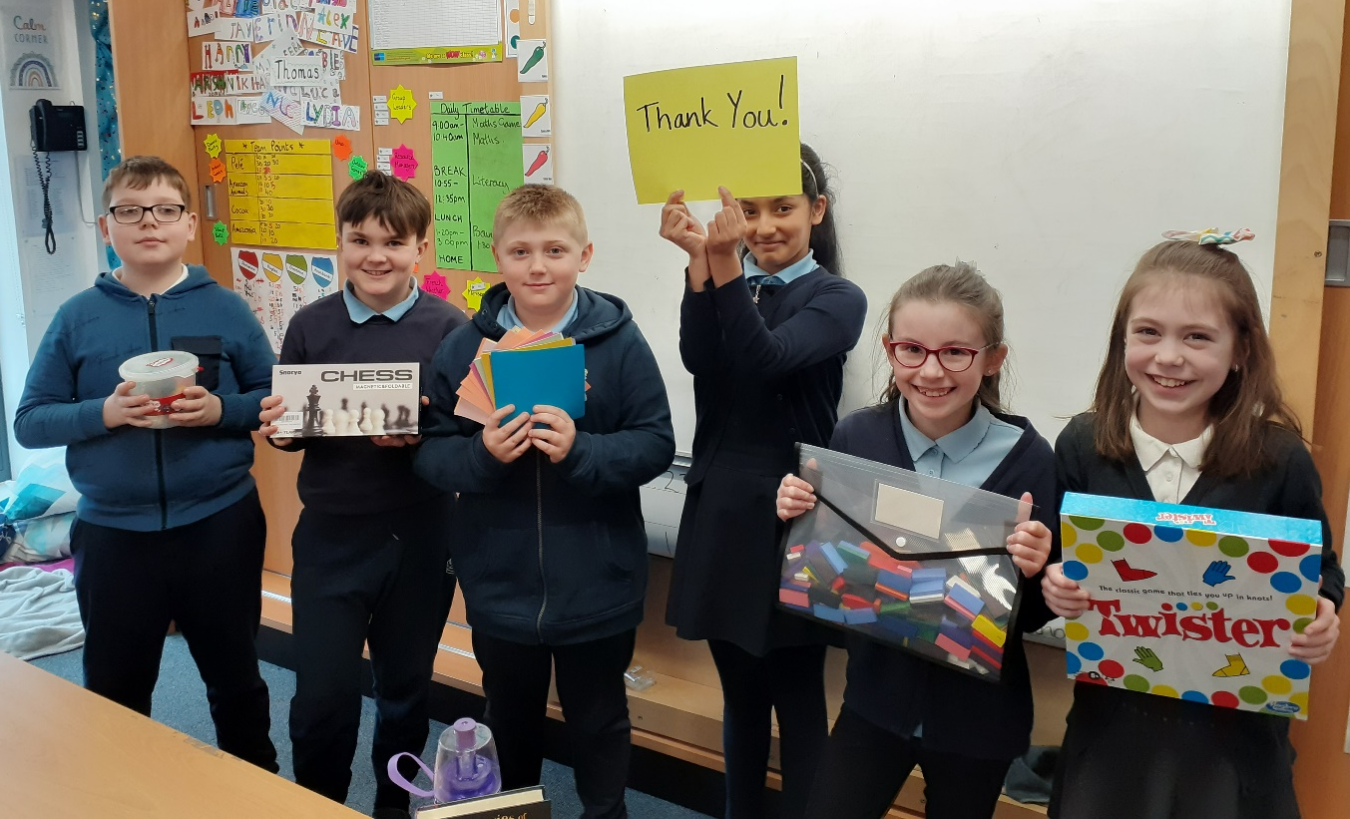
For our amazing gifts! We are enjoying, chess, modelling clay, origami paper, dominos and twister!
Thank you from Room 7

