Bankhead Primary – Pre Loved Uniforms
Has your child out grown their school uniform?
Do you need to replenish any items of school uniform before the summer?
Then we have many pre loved items that are avaliable for collection from the school.

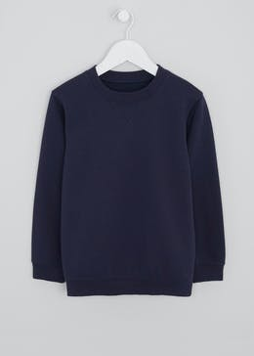
Where – Outside the School Community Wing
When - Tuesday 30th March
Times - 9am to 10am or 2pm to 3pm
