Your child has been issued with their Glow login details. This will allow your child to access email and many other resources that can support their learning, including Google Classroom.
You can help your child access Glow using the following steps:
Using Google or any other search engine – search Glow sign in
Click on: Glow – Sign in – RM Unify
sts.platform.rmunify.com › account › signin › glow

The Glow sign in page looks like this:

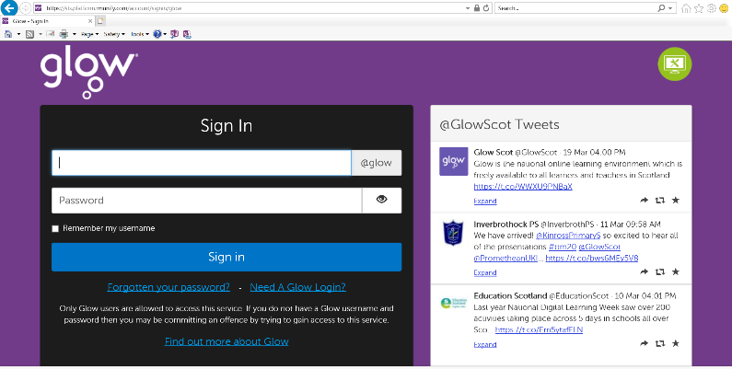

To log in the children only need to add the first part of their email address – the rest will be auto completed. E.g
gw14doejohn
and then enter their password, which should be 4 characters, beginning with one letter and then 3 numbers. The password does not require capital letters. E.g. - r067

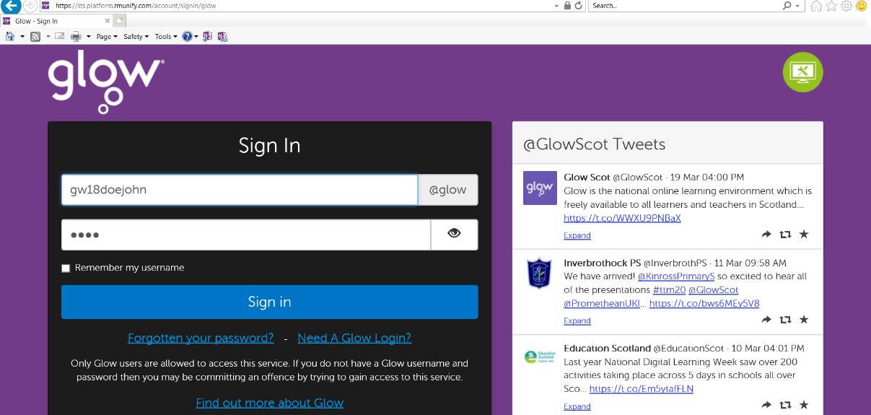
To log into Google Classroom follow the steps above.
Once you log on your screen may look like this:
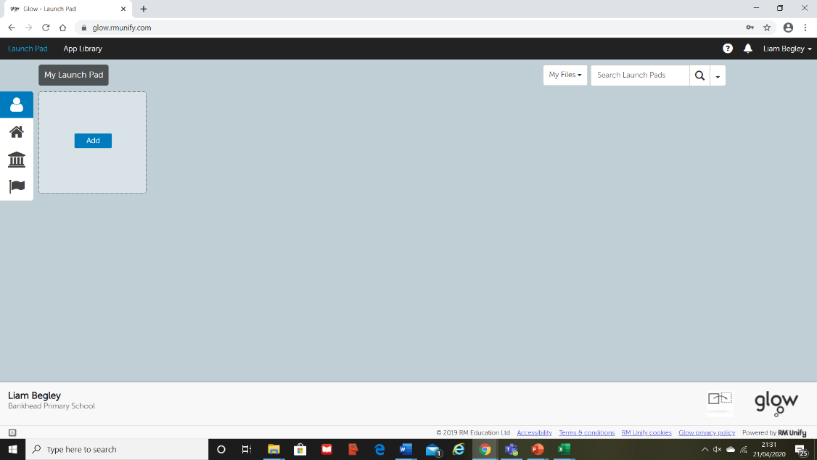

If so, you need to click on the house icon, to the left-hand side of the page. (See the arrow above)
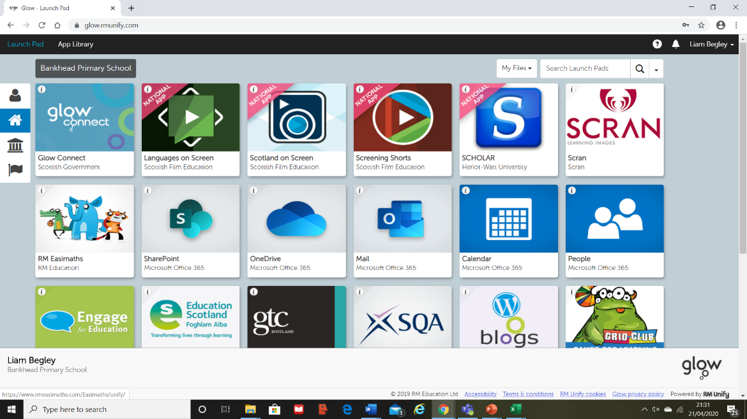
Once you click on the arrow this opens up Bankhead’s Launchpad.

Scroll down to the bottom of this page and the Google Classroom tile can be found here.
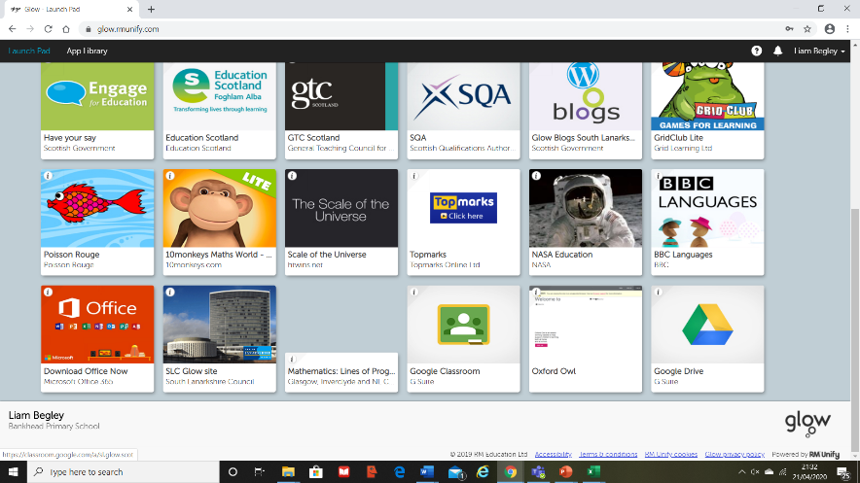
Click on the tile:

When you click on the Google Classroom tile, your screen may look like this:
(The email address for Google Classrooms is slightly different, it ends with @sl.glow.scot – don’t worry about this and click continue)
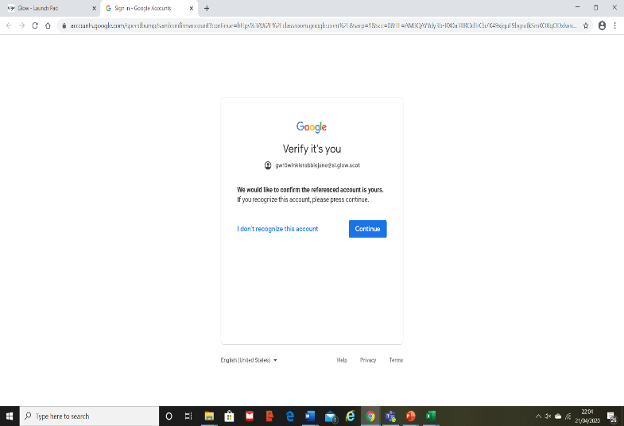

Click continue and a second screen opens up, click continue again.
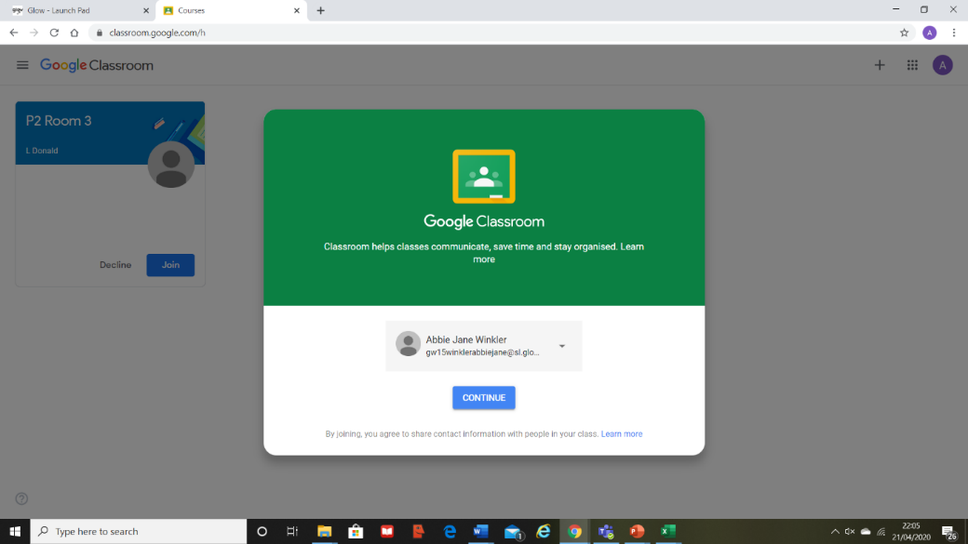

You will then be asked whether you are a student or teacher. Click on student and then click JOIN
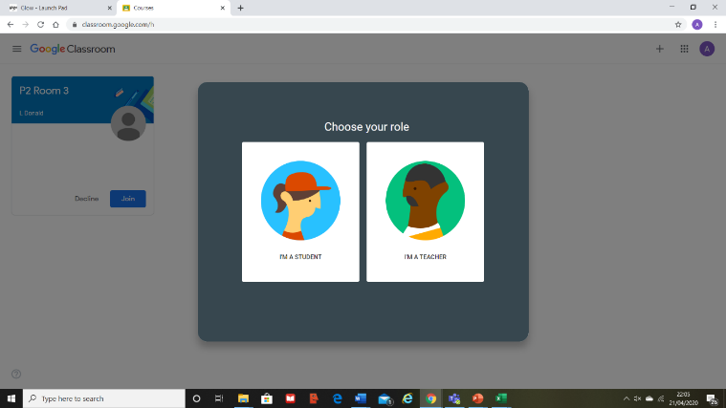
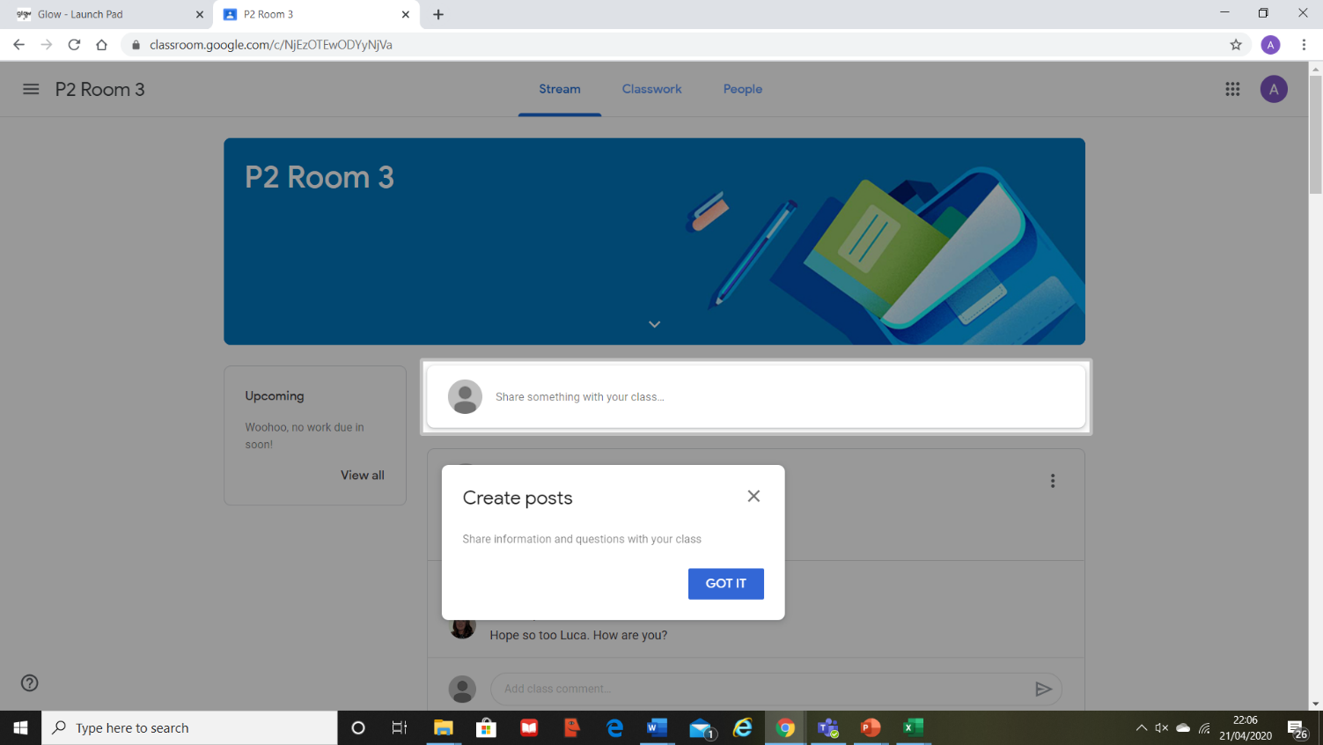
Once you have joined the Google Classroom you will see a page entitled Stream. This is where you can post comments and see the teacher’s posts.

Next to the STREAM tab you will see a classwork tab and this is where you will find documents such as worksheets or videos or tasks that the teacher has set.

Every time you wish to log onto your Google Classroom you just need to log into Glow and then click on the Google Classroom tile.

Hopefully this guide will allow you access Google Classrooms choose activities that your child could do.
If you continue to encounter difficulties then please contact us on:
theict@bankhead-pri.s-lanark.sch.uk

