**Planning for School Recovery at**

**Bankhead Primary School and Nursery Class**

The purpose of this leaﬂet is to give an overview of our Recovery Plan in order to ensure that all parents and carers are fully

aware of the school’s priorities.

**What is a School Recovery Plan and why do we have one?**

Each year we produce an Improvement Plan. The plan is informed by the information gathered through the school’s self‐evaluation procedures. These include focussed dialogue sessions with pupils, staﬀ, parents and

carers. However, due to the COVID 19 pandemic, we have planned for recovery for the session 2020/2021.

Furthermore, monitoring by promoted staﬀ of children’s work and

classroom practice, analysis of attainment data and the results of audits carried out focussing

on aspects of the work of the school such as the  quality of the curriculum. When devising the

plan, the school also takes into account current national and local guidance and initiatives. The

overall purpose of the plan is to drive forward improvements in order to ensure the highest

quality experiences for our pupils.

**How do we implement the School Recovery Plan?**

Teams of staﬀ focus on taking forward particular targets within the plan.

The Senior Management Team continually monitor progress made in meeting the targets

identiﬁed and all staﬀ are involved in auditing progress to date at various points throughout the school year.

This year we have 2 main targets on our Recovery Plan and various key tasks within each of these targets.  Our targets for 2020/2021 are:

1. **Promote the positive health and wellbeing of children and young people, parents/carers and staff.**

* Whole school parent/carer health and wellbeing survey to identify mental, social, emotional and physical well-being concerns.
* Pre and Post Boxalls for all children to identify strengths and wellbeing needs post school closure.
* Using Healthy Schools document. Advice and resources for settings and families.
* Make the skills for learning in a school environment explicit to our pupils.
* Use the strength of the NHS as a catalyst to talk about our nation’s strength and resolve and celebrate achievements.
* To update the school Bereavement Policy taking into consideration the impact that COVID 19 has had on the community. To provide the Staying Stronger change and loss programme to parents and Give us a Break programme to children.
* To focus on the mental, emotional, social and physical wellbeing of children through NSPCC, Think you Know, Young Minds, Paediatric Mental Health Association, Barnardos.
* Create ‘safe spaces’ for children to talk about their experiences through lockdown.
* To provide training for all staff on SLC Education Resources Attachment Strategy to build a culture of positive relationships.
* Supporting Post-Lockdown Education using the 6 Principles of Nurture.
* To embed the ICE pack and introduce the Emotions Works Recovery Programme.
* Plan curriculum activities throughout the day/week linked to the 5 ways to wellbeing: *Connect, Take Notice, Keep Learning, Keep Active and Give.* Upper School - Connected and Compassionate. Lower School – Circle Framework. Nursery – A to Z.
* To further develop outdoor education to provide children with a safe space to learn.
* Unicef Rights Respecting Schools - ‘Return to School: A Child Rights-Based Approach to Planning and Delivery.

**2. Planning for Equity**

* Collate data reflecting learners’ school closure experiences using both formative and summative tests. (June/August)
* Draw up a closure experience profile for the whole school.
* Using a range of quantitative and qualitative measures, pupils’ current (August/September) status in wellbeing, attainment, engagement and participation will be established.
* Attainment data gathered.
* Staff to gather data using a variety of the measures above and SMT to collate and analyse.
* Post lockdown school profile compiled by SLT using data gathered from above measures.
* Staff engage in dialogue to consider possible approaches to closing attainment gap, with consideration given to measuring impact throughout.



* Consideration given to partnerships that will best support pupils.
* Comprehensive planning will be in place for supporting additional support needs at home and in school, including provision of resources and materials.
* Regular and rigorous tracking of pupil progress within interventions.
* Continuous recording of progress and evaluations of interventions.
* Cost of the School Day (CoSD) will be updated by SLT early in the session. Any charges that will reduce the CoSD will be eliminated.
* Paper learning packs to be issued to pupils with no internet access.
* Staff to have any event involving finance approved and authorised by SLT.
* Every effort to be made to ensure fundraising events/trips etc. are kept to minimum costs.

.…………………………………………..

Through regular newsletters, school app and communication on the school website and twitter account, we will keep you up to date with developments and progress in addressing these targets.

A full copy of the School Recovery Plan is available on our school website. <http://www.bankhead-pri.s-lanark.sch.uk/>

If you require any further information please contact the school oﬃce on 0141 647 6967 or [enquiries@bankhead-pri.s-lanark.sch.uk](mailto:enquiries@bankhead-pri.s-lanark.sch.uk).

…………………………………………..

***Our Nursery and School Vision***

*Working and Learning in partnership to ensure all our children are safe, included and reaching their potential.*

***Motto***

*Bankhead Will Soar*

***Values***

*Success, Opportunity, Active, Respect*

[](https://www.google.co.uk/url?sa=i&rct=j&q=&esrc=s&source=images&cd=&cad=rja&uact=8&ved=2ahUKEwio6e2gwOXcAhUBT8AKHZUcCMoQjRx6BAgBEAU&url=http://outletplayresource.co.uk/&psig=AOvVaw2r5HXuKIylWSKMRtXnHMWg&ust=1534094046995218)

**Bankhead Primary School and Nursery Class**

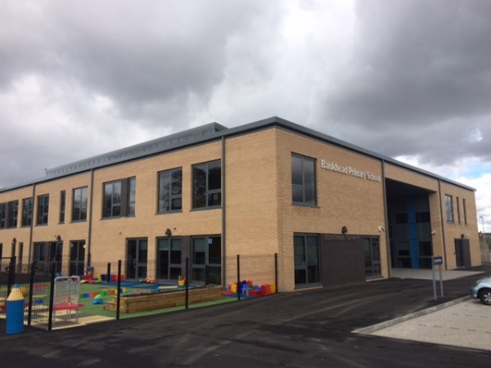

**School Recovery Plan 2020/2021**

*Information for Parents and Carers*

