Have a Brilliant Summer from Luna and Miss MacVey

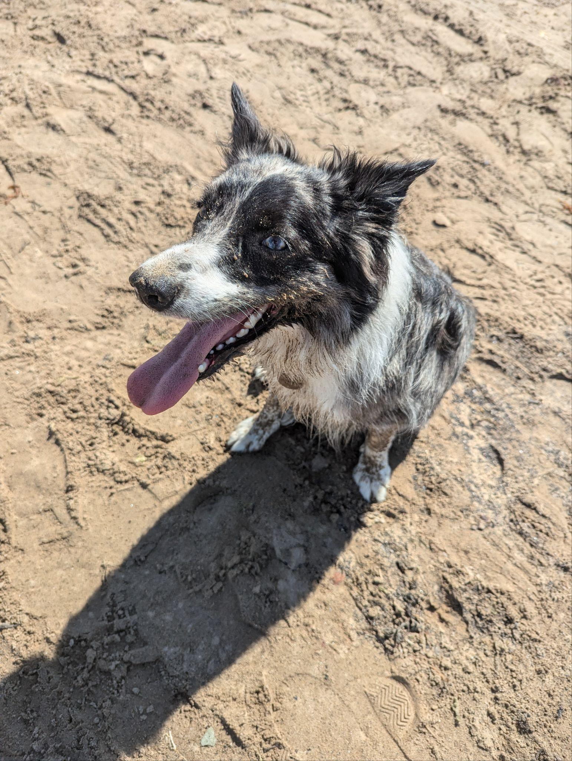

It was a pleasure to teach you this year. 