Your child has been issued with their Glow login details. This will allow your child to access email and many other resources that can support their learning, including Google Classroom.
You can help your child access Glow using the following steps:
Using Google or any other search engine – search Glow sign in
Click on: Glow – Sign in – RM Unify
sts.platform.rmunify.com › account › signin › glow

The Glow sign in page look like this:

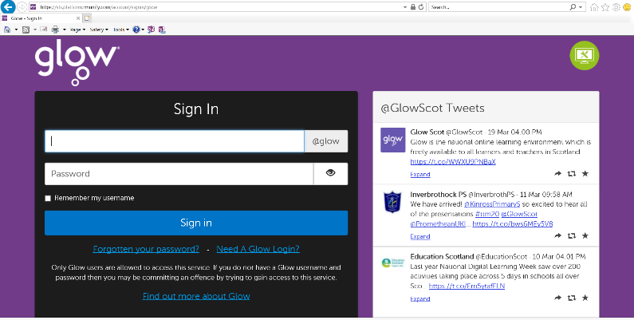

To log in the children only need to add the first part of their email address – the rest will be auto completed. E.g
gw14doejohn
and then enter their password, which should be 4 characters, beginning with one letter and then 3 numbers. The password does not require capital letters. E.g. - r067

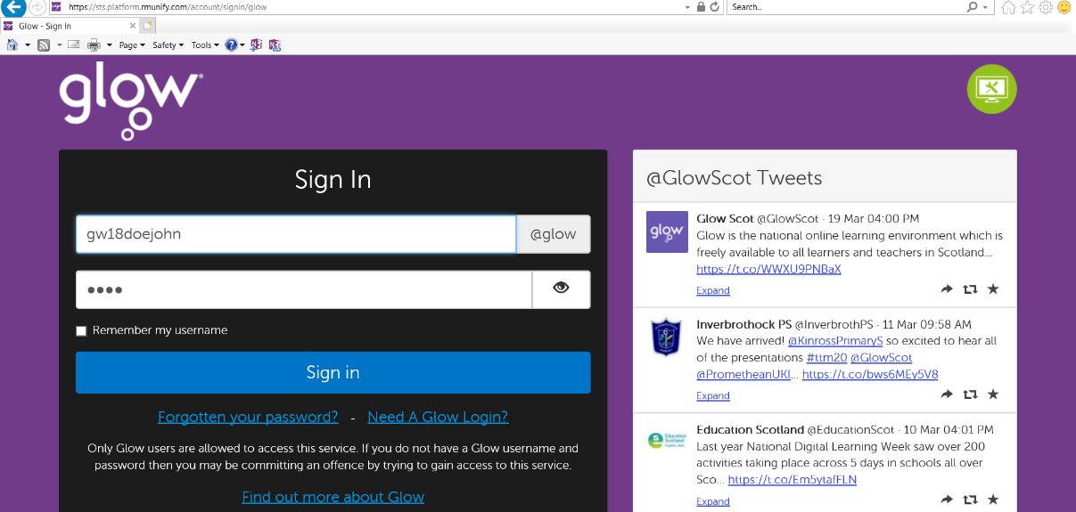
If you encounter any difficulties please contact:
theict@bankhead-pri.s-lanark.sch.uk

