Book Week Scotland and Anti-Bullying Week

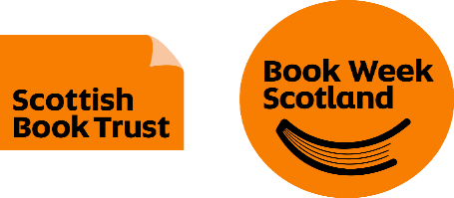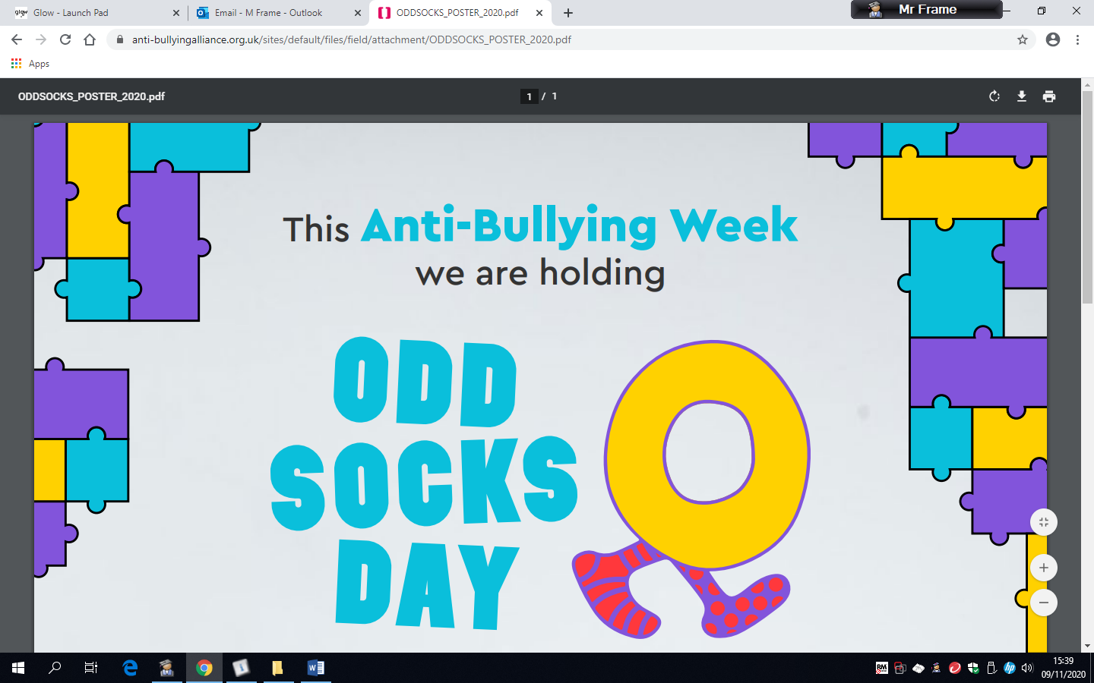

Tuesday 10th November 2020

Dear Parent/Carer,
Book Week Scotland will be celebrated in Bothwell Primary School from Tuesday 17th November until Friday 20th November. It is also Anti-Bullying Week. The P7 Ambassadors were involved in deciding what activities should happen during Book Week Scotland.

Our activities planned are:
- Every day- DEAR (Drop Everything And Read) time in classes
- ‘Bring Your Own Book’- from Tuesday to Friday
- ‘Reading aloud’ – some P7 pupils will read virtually to classes

P1 will receive their Book Bug bag and Primary 2 and 3 will receive their Read, Write, Count bags.

As next week is also Anti-Bullying Week, we will be focusing on this in our learning about Health and Wellbeing. On Friday 20th November we will have ‘Odd Socks Day’ - All you need to do is wear odd socks! It's a great way to celebrate what makes us all unique in Anti-Bullying Week!

We are all looking forward to next week.

Thank you for your anticipated support.

Yours sincerely,

Mr M Frame Mrs M Montgomery
Acting Depute Head Teacher Acting Principal Teacher
and the P7 Ambassadors

