 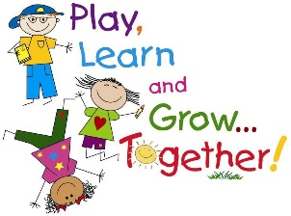

**STEM**

STEM is Science, Technology, Engineering and Maths…. or in other words, FUN! Children have a natural sense of curiosity and wonder about the world around them, they are inquisitive and enquiring. These activities are designed to encourage children to ask questions ….what will happen if? .....how can I make it work? .....why did it do that? ………how can I change it? This is called cognitive learning and encourages using problem-solving skills, challenging and creative thinking and a ‘have a go’ attitude…. skills needed for lifelong learning.

1. Marshmallows and spaghetti: what can you build? How can you make it strong enough? What shapes can you make? What happens if you use mini marshmallows? Would it work with cooked spaghetti? What else could you use? Would pieces of apple and cocktail sticks work?

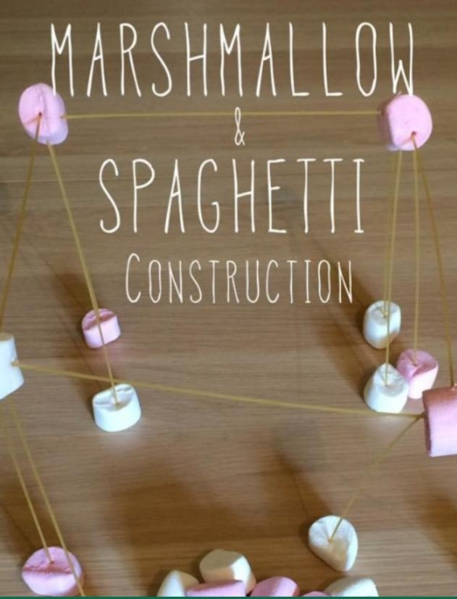

1. Build a bird’s nest: what materials do you need to make a bird’s nest? Where will you find these? How much will you need? How big does it need to be? What shape will it be? Why do birds build nests? Where do they build them? What do birds use to build their nests if they don’t have hands?

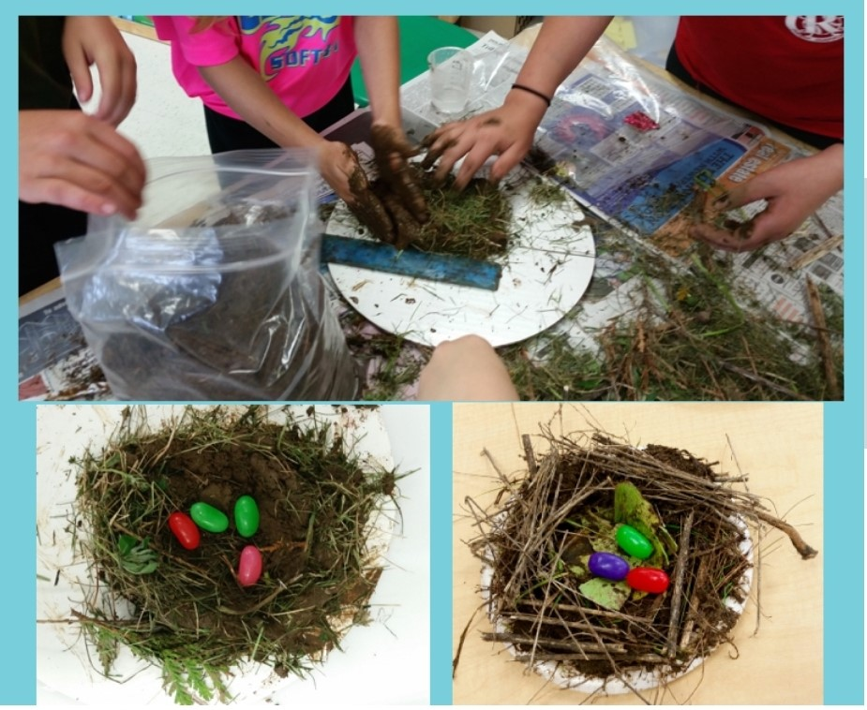

1. Glow in the dark skittles: Re-use some plastic bottles of the same size, fill with water and pop in glow sticks. Then use a ball to knock down as many as you can. Great family fun!

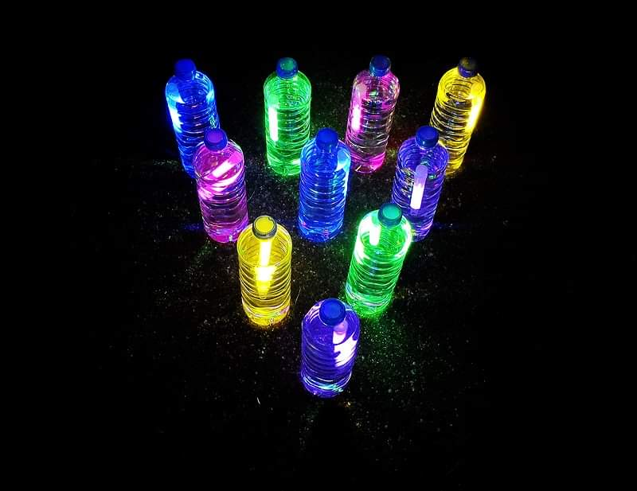

Here are some other ideas to try…………..

