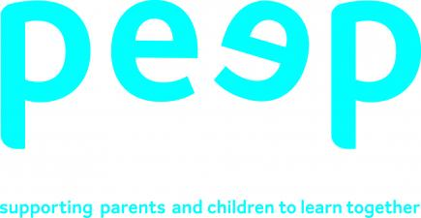

Next week is Maths Week Scotland, so our PEEP activities look at ways of supporting children to learn about numbers. There is a big difference between knowing the names of numbers, using number names in play, and understanding that numbers represent quantity. Counting is a tricky concept to grasp which takes time and lots of practice. Young children first need to learn that numbers and letters are different. Young children may be able to recite numbers in order, as part of a song or chant – however, this does not necessarily mean that they are able to count. Saying number names in the ‘wrong’ order is very common when young children begin to learn about numbers, number names and counting.

Singing number songs, chanting number rhymes, playing number games and sharing numbers in stories are all good ways to learn the names of numbers in order. They can also help children learn the difference between reciting numbers and counting.

Children who do not have English as their first language, may know the names of numbers in their mother tongue and are beginning to develop their understanding of numbers for counting at the same time as they are learning the names of numbers, e.g. ‘One, two, three‘ etc. (number names) in English. This will help to support the development of both languages. Parents can help by counting out loud and singing songs and rhymes in the different languages.

Here are some simple ways you can help your child to understand that numbers have meaning:

1. Count the steps as you climb up and down the stairs
2. Counting the number of objects in a picture book – ‘I can see two dogs… look… one dog, two dogs!’
3. Jumping off a low wall – ‘One, two, three…. jump!’
4. Getting into or out of bed, the bath or a highchair – ‘One, two, three… in you go!/out you come!’
5. Laying the table or preparing meals – ‘One plate for me and one plate for you’, ‘That’s one sausage and two sausages’
6. As a label or name – e.g. the number on a bus, or a number 8 on a football shirt, the numbers on a door or car registration plate
7. Find numbers on the TV remote

Children learn to recite the names of numbers when they hear them again and again – often in stories, songs and rhymes. Using props really helps children to develop their understanding of how numbers can be used for counting, touching things helps them to remember.

Here are some songs to sing together:

1. Baa baa black sheep….use 3 balls of wool as the 3 bags full
2. 5 currant buns….. use scrunched up paper as the buns, even better if you can make real ones!
3. 10 green bottles
4. 10 fat sausages sizzling in a pan…..make sausages from playdough
5. 5 little ducks….use plastic ducks
6. Songs you can use your fingers to count:

* 5 little peas in a pea pod
* 5 little speckled frogs
* 5 cheeky monkeys

Children need to practice counting 1 item at a time to help them learn that number names have meaning and tell us how many we have of something. We call this 1:1 correspondence.

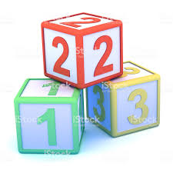Lay out 10 Lego bricks, or cars, trains, beads (anything will do) and ask your child to count how many there are. Watch to see how they do this. Do they touch/ point to them one at a time and count 1, 2, 3, etc . For example, do they count the first 3 then say 4, 5 for the next brick? Point to each brick slowly with your child so they are able to see how to count accurately.

As children develop their understanding of numbers they will begin to realise that numbers can be used to add, subtract, measure, tell the time, etc. If your child is ready to practice this, here are some ideas to support them:

1. If there are 4 of you eating dinner, give your child 3 plates to hand out. Ask them “How many more do we need?”
2. Make a simple routine timetable to show when it is time for breakfast, nursery, bath, bedtime, etc. this will help your child to recognise numbers

Follow these links for more great ideas to help your child with their understanding of numbers and counting

Maths Week Scotland https://www.mathsweek.scot/

Numtums introduce number recognition through songs and repetition <https://www.bbc.co.uk/cbeebies/curations/numtums-numbers>

Numberblocks use songs to introduce understanding of numbers as quantity <https://www.bbc.co.uk/cbeebies/shows/numberblocks>