 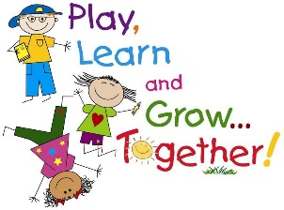

**40 days of fun**

For our final PEEP activity for this academic year, we have put together a list of activities for you to try for every day of the holiday. The activities will support lots of learning, such as following instructions, reading and writing, counting, measuring, shapes and colours, communication, concentration and perseverance, and lots more. But most of all they are fun and we hope you enjoy them ☺

1. Make a butterfly feeder: the best way to attract butterflies to your garden is to make them a feast! Follow this link to find details on how to make your own feeder. Look out for the butterflies coming into your garden; if you’re lucky you might see lots of different kinds! <https://thelandtrust.org.uk/wp-content/uploads/2016/01/How-to-Butterfly-Feeder.pdf>
2. Make a nature bracelet: All you need for this simple craft is tape! Wrap a piece of masking tape around your child's wrist sticky side up, and head out for a nature walk. As you explore, have your child find different items to attach to the tape to make a bracelet. Different flowers, leaves, and even grass all make great additions!
3. 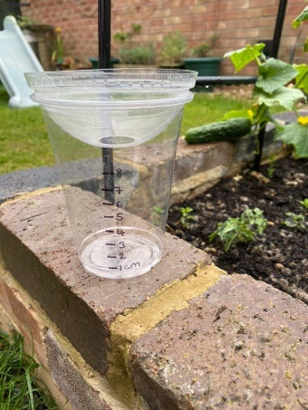Make a rain gauge: an easy way to measure how much rain fell in your garden. Keep a journal to find out which day during the holiday had the most rain
4. 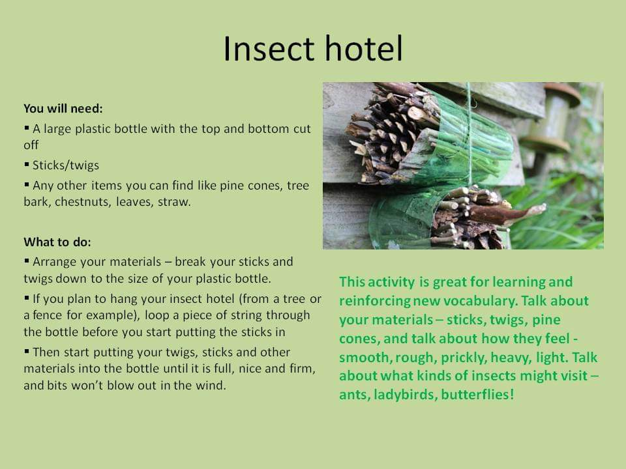Make a bug house: build a cosy home for bugs. Leave it for a few days to let them move in, and then investigate which bugs you have made a home for.
5. Nature scavenger hunt: Work with your child to create a list of natural objects you can find outside during the summertime (such as a bird feather, wildflowers, and a green leaf.) After you make your list, grab a paper bag and set out to find each item. You can even turn it into a game for multiple children — the first one to find every item wins!
6. Make some fruit kebabs: choose your favourite fruit (strawberries, bananas, grapes, apple, pear, kiwi, blueberries, pineapple, mango) help to cut up and wash the fruit and then push the pieces onto a long skewer. Yummy!
7. Build a terrarium: build your own self-supporting ecosystem and watch it come to life! Follow this link to find out how to do it <https://www.familyeducation.com/fun/nature-activities/build-terrarium>
8. Make a bird feeder: make a feeder to attract the birds to your garden by threading popcorn, berries, raisins, fruit and anything else you think birds would like to eat onto a strong piece of string and hang it up in your garden.
9. Magnetic seashells: turn you seashells into fridge magnets. Decorate the shells however you want, attach a small magnet or magnet strip to the back, and use your new magnets to display your art work on the fridge.
10. 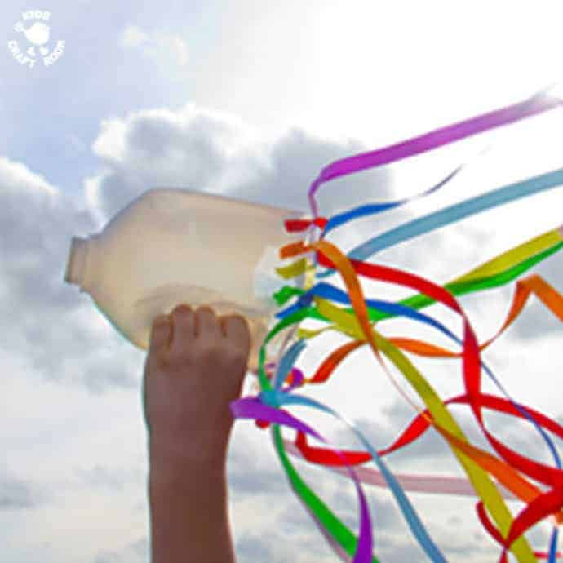Make a wind sock: use an old, washed out milk jug to make a wind sock. Cut off the bottom, just below the handle, cut some holes around the bottom and thread some coloured ribbon through these to make a streamer. Now run around holding the bottle as high as you can and watch as the wind blows through the bottle and makes the streamers dance!
11. Fizzy eggs: this is a great science experiment using baking soda and vinegar. Children will be fascinated by the chemical processes. Follow the link to find out what to do <https://www.pre-kpages.com/dinosaur-eggs-fizzy-science-experiment/>
12. Water painting: a great activity for outside. You will need water and brushes. Try different sizes from small paintbrushes to large sweeping brushes. Notice the different marks you can make. You can chalk some numbers, letters, patterns on the ground first and then ‘paint’ them out.
13. Make a dried food picture: use dried lentils, pasta, rice, herbs, seeds, etc to make a picture
14. 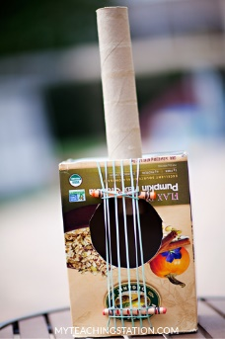Make a guitar: use an old cardboard box, kitchen roll tube, sting or elastic bands to make your own guitar
15. Play Kim’s game: this is a great game to practice memory skills. Follow this link if you’re not sure of the rules <http://www.helpmykidlearn.ie/activities/5-7/detail/kims-game#:~:text=Ask%20your%20child%20to%20look,tray%20as%20they%20get%20better.>
16. Go on an ‘I spy walk’: make a list of things you might see on a walk and then tick them off as you go. Here are some ideas:

* Something blue
* A post box
* A number 3
* A letter C
* A yellow flower
* Something square
* A cat
* A zebra crossing

1. Have a family garden party picnic: put up some bunting, make some food and drink labels, layout a blanket and enjoy some family time in the sun.
2. Have a sunflower growing competition: plant some sunflower seeds in a pot, label it with your name and care for it with light and water. Whose sunflower will grow to be the tallest?
3. Have a water fight: the best way to cool down on a hot day!
4. Nature weaving: you can use a wire cooling rack, a fence, chicken wire, or piece of card with string. Collect some natural objects and thread these through to make a picture or pattern.
5. Make a monster: Turn a colander or sieve upside down and use pipe cleaners, feathers, spaghetti, wool, ribbon, string, leaves, flowers, etc to push through the holes
6. Build a robot: you could use recycling materials, Lego, Duplo, Kinex. Think about the different shapes you might need and how you will stick them together.
7. Build a den: this can be both an inside and outside activity. You could throw a blanket over a washing line, or a sheet over some chairs; you could make a den under the table, or behind the sofa.
8. Ice writing: add some food colouring to water and freeze in ice cube trays. Once frozen, you can use these to write or draw a picture.
9. Supertato: make a Supertato model using a potato and material. You might choose to make your model into a Ninja Turtle, or Mr/Mrs Potato Head….the choice is yours.
10. Play a board game: board games are great for building attention and concentration skills, as well as learning about rules and turn taking. Try Snakes and Ladders, Frustration, The Shopping List Game
11. Let’s go shopping: you could make your own shop in your home or garden, add some price labels to the items in your shop. You could make some mud pies or flower soup to sell.
12. 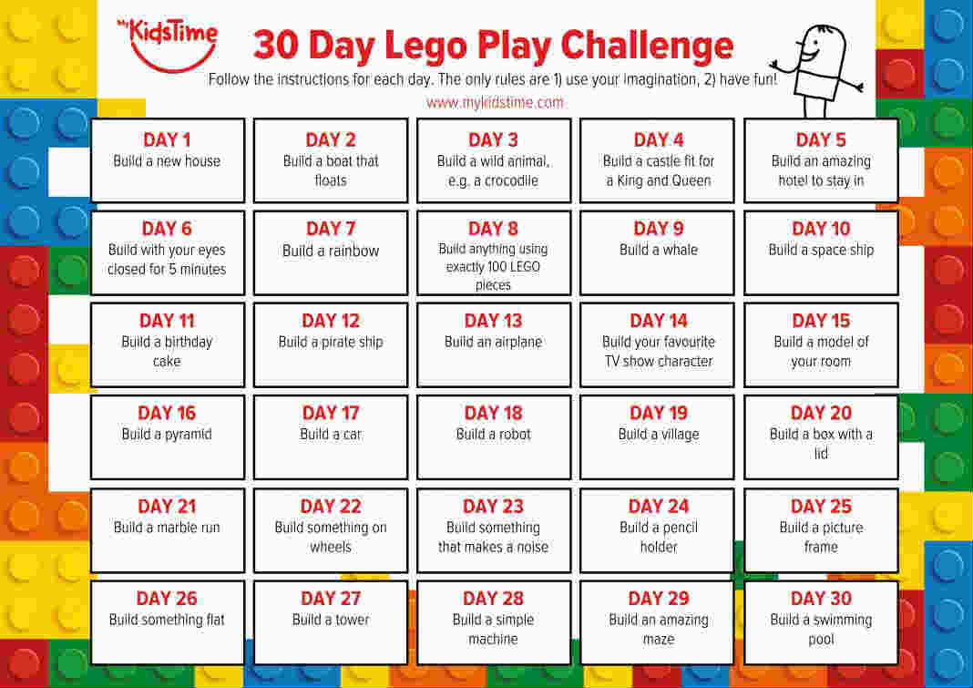Lego challenge: try a Lego challenge and make something different every day

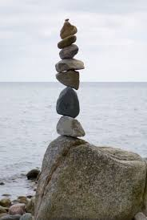

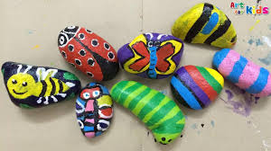

1. Rock art: Collect some rocks of all different colours, sizes and shapes. You can use them to build towers or make art.
2. Car wash: help to wash your family car or you could wash your bike or scooter, your toy cars
3. Bake cookies: a great activity for practising maths skills, and tasty too!
4. Dinosaur fossils: making the salt dough for this activity is another great measuring activity, as well as an opportunity to talk about science and history! Follow this link for a step-by-step picture guide on what to do <https://www.littlepassports.com/blog/craft-diy/make-dinosaur-fossils-using-salt-dough/>

If you don’t have any dinosaurs, or your child’s interests lie in something else, just change the dinosaurs for other small objects.

1. Tinker tray: this activity is great for little hands and provides lots of fascination and curiosity. Collect a range of different objects (list below for ideas) and allow your child time to investigate them. Bags or egg boxes provide opportunities for children to sort and group the items.

* Washers, screws, bolts, wing nuts, etc
* Cotton reels, bottle tops, buttons, etc
* Fir cones, conkers, flower heads, etc
* Kitchen or toilet roll tubes, ribbon, string, wool, etc

1. Make a volcano: a fascinating science activity using ordinary household items. You can make this a simple activity just watching the chemical reaction, or get creative and build Mount Vesuvius….the choice is yours! This link from the Natural History Museum shows you how to make a volcano as well as giving you information about them <https://www.nhm.ac.uk/discover/how-to-make-a-volcano.html?gclid=Cj0KCQjw3Nv3BRC8ARIsAPh8hgJnYhVh78iDUiX2EU0EbyZwgTqE8OfkqB3JQm1swYPb9DnW-qEDDSIaAu8pEALw_wcB>
2. Make supersoft playdough: this recipe is a twist on the usual playdough and gives a nice, soft consistency. You will need 2 cups of cornflour, 1 cup of hair conditioner, food colouring. Add the food colouring to the hair conditioner and mix together. Add the cornflour 1 spoon at a time, gradually mixing together until you form a soft dough.
3. 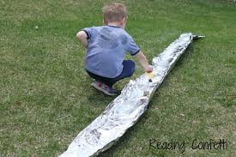Silver river: build a river from tin foil and add water. Try making some boats from bottle tops, or float leaves, daisies, petals, grass down your river.
4. Make a rocket: This is a super fun activity but you will need an outdoor open space because the rocket will really BLAST OFF! Follow this link for simple instructions <https://www.youtube.com/watch?v=NJlUwAqZXjk>
5. Make a lava lamp: another wonderful science activity for children. This link will take you to the instructions <https://www.youtube.com/watch?v=NJlUwAqZXjk>
6. Squirt gun painting: make your own paint with food colouring and water, add to a spray bottle and now you can make your own squirty pictures.
7. Make a wommery: this project will help children learn about how worms ‘recycle’ plant waste and feed the soil. The link from BBC gives you step-by-step instructions: <http://www.bbc.co.uk/gardening/gardening_with_children/homegrownprojects_watchworms.shtml>