 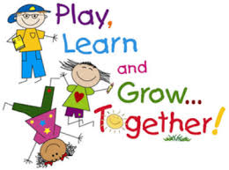

**Feelings and emotions**

During our first weeks at nursery, we have been supporting children to recognise and be able to name their feelings and emotions. We know that when children are able to tell us how they feel, they are more resilient, self-confident and ready to have a go at new experiences. Children who are self-confident are more likely to be curious, enjoy exploring their world and have a strong desire to learn. Here are some activities for you to try at home, to support your child to learn about their emotions.

1. Emotions pairs game: help your child to draw some faces with different emotions onto some card or paper, making sure there are 2 of each one. As you play the game, your child will learn to take turns, practice their memory skills, and begin to recognise how different emotions show on our faces.

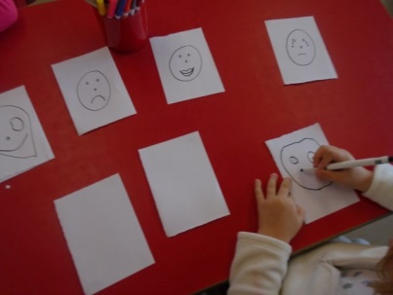 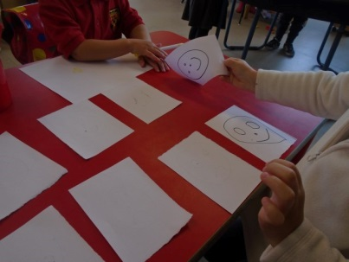

1. Funny faces: help your child to cut out eyes, noses, mouths, hair, etc from magazines or newspaper. Use these to make pictures of funny faces. Encourage your child to look carefully at the face they have made and talk about if they look happy or sad, excited or angry, tired or scared, etc. Stick them into a homemade book, and encourage your child to talk about what makes them feel happy, sad, etc. Write what your child says under the different pictures.
2. Food faces: help your child to make some faces from rice cakes; use different fruit or veg to make the facial features, eg tomatoes, cucumber, peppers, etc. Ask your child why their face is happy, or sad, etc.

We made faces at nursery using loose parts 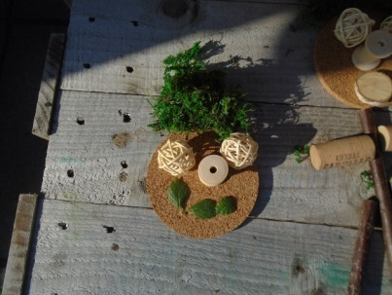

1. Mr Potato head: help your child to make a Mr Potato Head using a potato, toothpicks or matchsticks, raisins, grapes, etc. Talk to your child about what makes Mr Potato Head feel happy, sad, angry, etc. You could use an apple, carrot, or orange instead.
2. If you’re happy and you know it: sing the song but add different emotions to the verses…..

If you’re happy and you know it, clap your hands…..

If you’re angry and you know it, stamp your feet….

If you’re tired and you know it, stretch your arms……

If you’re sad and you know it, wipe your eyes….

More ideas:

* Check out the CBeebies website for more activities and tips to support your child’s feelings and emotions <https://www.bbc.co.uk/cbeebies/search?q=emotions>
* Listen to some stories about feelings and emotions for example, *How do you feel?* By Anthony Browne <https://www.youtube.com/watch?v=kILR7wfi-X4>
* Make some emotion balloons: draw different emotions onto balloons and fill with flour, lentils, sugar, salt, etc. They don’t need to be very big. Tie off the ends and allow your child to squeeze them. This not only helps to reinforce their learning about feelings, but also builds the muscles in their hands
* Make some playdough and use this to make different faces. You could use the playdough as the face and add loose parts as eyes, nose, mouths, etc. or you could roll the playdough into different shapes to make the eyes, nose, mouth, etc.