Mrs McKeown’s spring nature hunt
I went outside in my garden and found all of these wonderful things. Why don’t you see if you can find some of them too? You might see other amazing signs of spring and you can take a photo or draw a picture of it. Have fun and stay safe
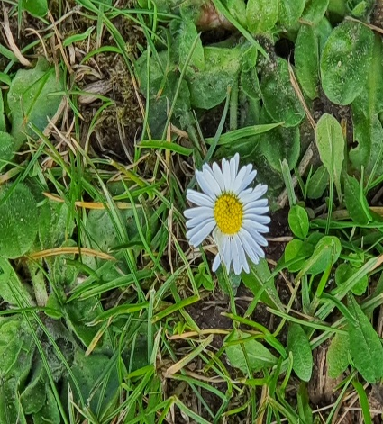  daisy | 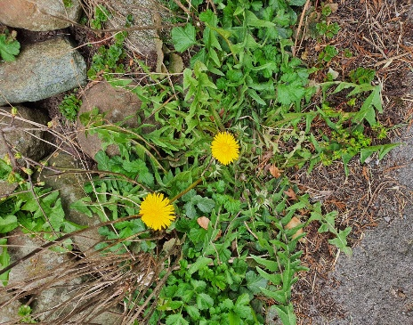  dandelion
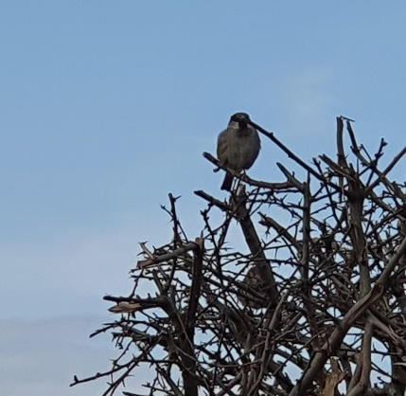  bird | 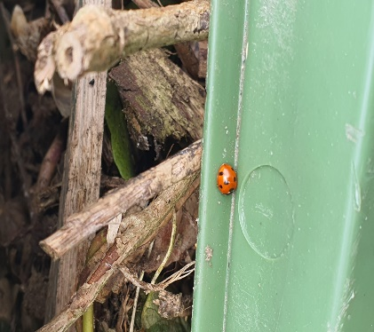  ladybird
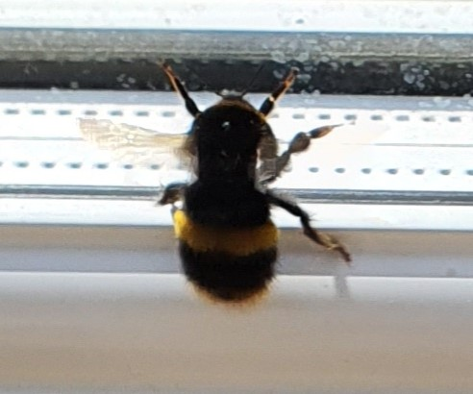  bee | 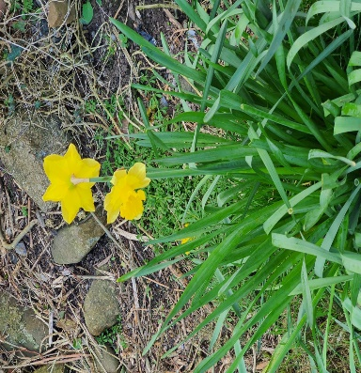  daffodils  A daisy
I found a…………. | I found a……

