**Talking, listening, questioning**

This week we will be looking at how to support your child’s understanding of ‘when’. Understanding when things happen, in a sequence of events, can be a tricky concept for some children to master, and they need lots of practice. Here are some ideas you can try:

1. Take some pictures of daily routines in your home using your smartphone or camera. Ask your child “When do you…..?”

* If you can, print these off and ask your child to put them in the correct order.
* If you don’t have access to a printer, look at the photos on your phone with your child.

Some ideas of daily routines you might choose are:

waking up, getting dressed, having breakfast, playing in the garden, eating lunch, having a bath or shower, reading a story, going to bed

1. Collect a bag of items, e.g. a toothbrush, a towel, a cup, a spoon, a hairbrush, a pen, a washing up bottle, etc. ‘Hide’ these in a large bag and take turns with your child to pull an item out. Ask your child “When do we use this?” Encourage them to ask you the same question when it is your turn.
2. After you have read a story to your child, ask them about it, e.g. “When did Jack get the magic beans?” or “When the Giant shouted, ‘Fee, Fi, Fo Fum’, what did Jack do?”
3. Cook or bake with your child using a simple recipe. Ask your child “When do we…….?” e.g. add eggs, sugar. Why not try this banana bread recipe?

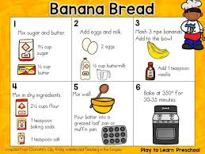

**What is my child learning?**

These activities will help your child to understand that ‘when’ means something is happening. It will help them to recognize patterns and understand the world around them. This is an important skill that will go on to help your child learn to tell the time and even how to read sequences of letters (words).