**Preparing your child to return to nursery**

We are busy preparing nursery ready for when your child can return in August. We have missed all the children very much and we are very excited to see them back safe and well. We wanted to share some thoughts on how you can help your child think about and prepare for return to nursery after such a long time away.

It could be that your child doesn’t remember very much about nursery, and much of it may look and feel different when they return.

Start talking to your child about what they remember from their time at nursery before lock-down and what they are looking forward to when they come back.



Encourage and praise me when I try to do things for myself, such as putting on my own coat and shoes and washing my hands properly.





Talk to me about staying at nursery on my own.

Talk about the friends I might see when I go back.

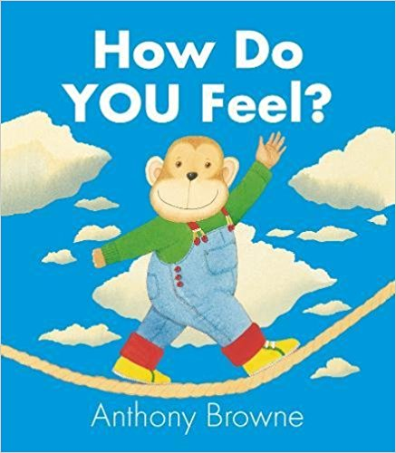Help me learn to recognise my different emotions so I can tell my key worker if I feel a bit sad or frustrated.

We could read books together about feelings, play games and try some Mindfulness activities.

Talk about things that make me feel happy and confident.

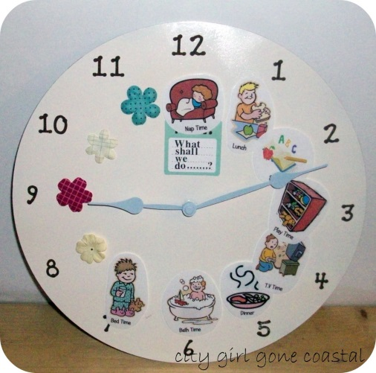

Help me to follow a good daily routine so I have lots of time to play, eat healthy food and get a good sleep at night.

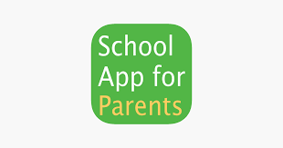Help me to look for activities my nursery has shared on the app and school website.

These will help me be ready for going back to nursery.

Let’s try and remember our Nursery Values

**Walk:** look where you’re going and use your walking feet, keep running for outside

**Talk**: use a quiet voice for inside and save your loud voice for outdoors; ask for help; use good manners; use kind words

**Share:** take turns with toys; join in with activities; play with others, sharing ideas

**Care:** be kind to others; look after your toys; tell someone if you feel sad; practice your self-help skills

**Listen:** use listening ears; follow instructions; listen to others in your conversations

Although this guide is designed for children returning to Nursery, it will also help those children who are returning and starting school in P1.