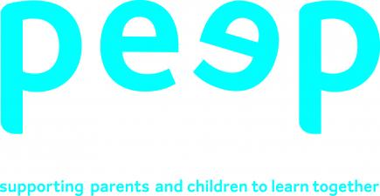 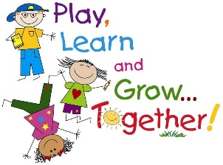

**Loose parts play**

What are loose parts?

Loose parts are just about anything your child can find around your home that they can use safely to create, design, build, investigate, organise, sort, match…..the possibilities are endless.

You can use the photos to give you some ideas of the kinds of things you can use, but here are a few suggestions:

Buttons, coins, bottle tops, pegs, cutlery, screws, bolts, toilet rolls, pebbles, cotton reels, curtain rings, tins, blocks, feathers, shells, leaves, sticks, flowers, scarves, ribbons, shoe laces….

How does loose parts play help my child’s learning?

Loose parts allow your child to use their imagination and be creative in their play with none of the restrictions that bought toys often have. Children will often be engaged in this type of play for longer periods of time as it builds on their interests and sense of discovery. Children learn, through their play, to develop attention and concentration skills, they learn to be problem-solvers and be critical thinkers. You might notice how your child sorts items by shape, colour, size, or counts each item they have, working out how many more they need for their design. Your child might make up a story as they play, developing their communication and language skills. If you provide mark making items too, your child will begin to develop their writing skills. As your child picks up and transports different sized items they are developing both their fine and gross motor skills; that is the small movements using their fingers and hands as well as the big movements in moving larger and heavier items.

There is so much hidden learning through this powerful and meaningful play activity, so we not give it a go? Children love loose parts play because they can lose themselves in a world of imagination and invention.

