 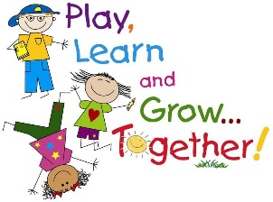

**Get Active Challenge**

We know that keeping active is important for our health and wellbeing. You might have found this tricky to do during lockdown, although our young children probably haven’t! Here are some ideas you might like to try to channel their energy into something more productive ☺

1. Challenge your child to complete a Toddle Around the Garden….. a bit like Captain Tom! How many laps do they think they can do? How will they do it….run, walk, hop, skip?
2. Go on a safari. Hide some small world animals (or pictures if you don’t’ have any) around your garden and challenge your child to find them all. You could make it tricky by asking them to find 3 cats, 4 pigs, 5 tiny dinosaurs, etc
3. Bird watch. Make some binoculars from toilet roll tubes….you can decorate them, and tie some string around them so you can hang them around your neck. Now go for a walk, and look out for birds. Make a list of the ones you see, or tick them off on this picture. What else did you spot?

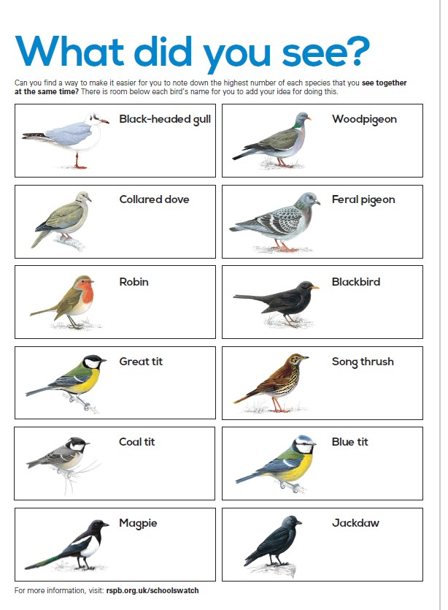

1. Nature hunt. Go for a walk and collect lots of different natural objects. Try to make sure there are lots of different things. When you get home, use what you have collected to make some land art. Here are some ideas to inspire you.

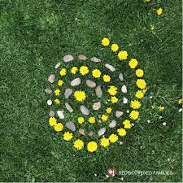 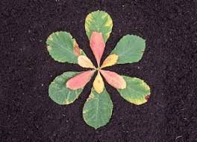

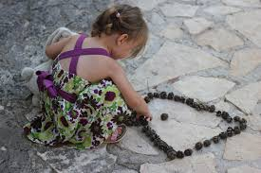 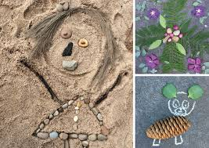

1. Puddle jump. You will need to make your own puddles while we have some lovely sunny weather. Pour water onto the garden to make big and small puddles. Can you jump from one to the other? What do you think will happen to the puddles on a sunny day?

We have shared some ideas from the Barnado’s Toddle, an annual event to raise money to help vulnerable children in the UK. If you would like to find more information, please follow this link <https://www.barnardos.org.uk/bigtoddle>