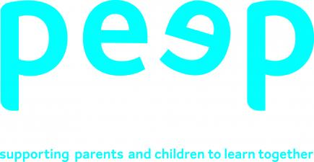 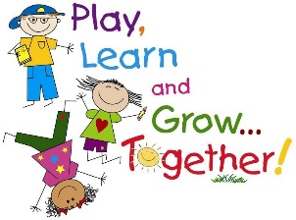

**Song bags**

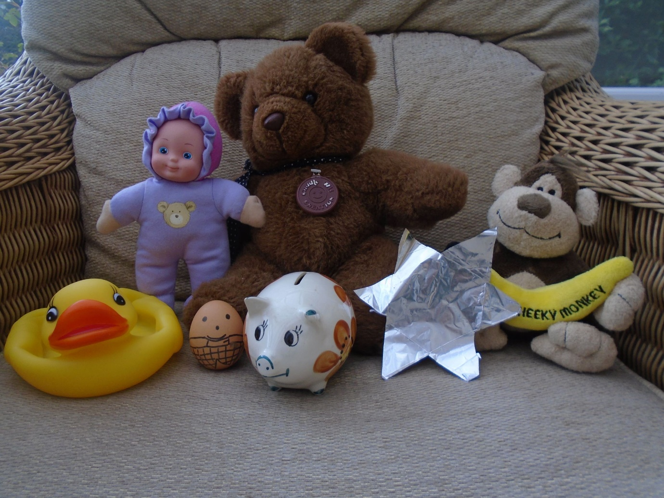

What is a song bag?

A collection of props which relate to a familiar song or rhyme are hidden inside a bag.

Ask your child to pull one object out of the bag at a time.

Ask him/her what they think the song/ rhyme might be.

**PAUSE AND WAIT**! Don’t be tempted to answer for him/her. Give time for him/her to think about their answer. Remember that some children take a bit longer to think about an answer. And they might give a different suggestion to the one you had thought of!

How do I make a song bag?

It couldn’t be easier! Have a look through things you have around the house, and through your child’s toy box. Pick props you can link to familiar songs and put them in a bag, big enough to hide all the props from view. They don’t need to be elaborate or expensive, they can be home made, or pictures cut out from magazines. The idea is to excite and interest your child to join in with you in singing.

Have a look at the photo. Can you guess what songs these props relate to?

What are the benefits of using a song bag?

Children love the mystery of what might be hidden in the bag. You can introduce and support skills such as taking turns, following rules and waiting. Using a song bag makes singing nursery rhymes and songs more exciting and fun, so your child will engage with you for a longer period of time.

Why are nursery rhymes important?

Nursery rhymes and songs help children develop communication and language skills. The repetitive pattern and rhythm of rhymes support children’s development of memory, listening and forming speech sounds.

Children love the opportunity to act out a song, for example, Wheels on the bus, as it meets their need to be active. Physical participation encourages children to develop fine and gross motor skills, as well as balance, coordination and to follow simple instructions.

Counting songs, for example, 5 little ducks, give children a fun and interesting way to play with and learn about numbers.

If a child knows, by heart, 8 different rhymes by the time they reach 4 years old, they will be among the best readers by the age of 8.