**Learning through play at home**

It is important for you to carry on with your learning while you are away from nursery during lockdown. These activities are a fun way for you to practice some of your skills. Try and do one activity every day. You can ask an adult to help you if you find some of the activities tricky, but have a go yourself first ☺ We will send new activities for you to try every week, until you are able to come back to nursery safely. Remember to send photos or video through the Evidence Me app to share what you have been learning at home.

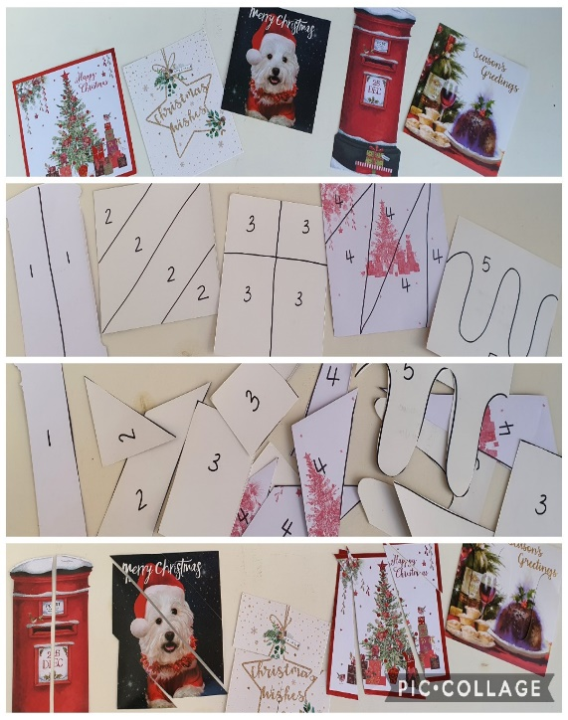**Activity 1**

Use some old Christmas cards to make a jigsaw.

* Draw lines on the back of your cards
* Write a number in each section on every card, this is so you can sort them out once you’ve cut them up
* Take your time and cut carefully along the lines
* Sort out your pieces so that card number 1 is together, card number 2, etc
* Put the pieces back together to make the picture

I am learning….

TO USE SCISSORS: Remember to hold your scissors correctly: thumb in the top hole and 2 fingers in the bottom. Straight lines are easier to cut along; you can make it more challenging by drawing zigzag or curvy lines

MATHS: to recognise and name numbers (the more cards you do the more numbers you will use); to sort and match; to recognise and name shapes

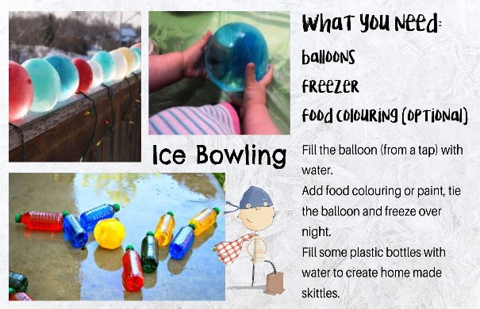**Activity 2**

I am learning….

SCIENCE: about how temperature changes affect water

MATHS: to count how many bottles I knock down

COORDINATION: to roll or throw with accuracy

SHARING: to take turns when I play with someone else

**Activity 3**

Read a story together: choose a favourite book to read or listen to one from the Book Trust. The Hairy Maclary story can be found here: <https://www.booktrust.org.uk/books-and-reading/have-some-fun/storybooks-and-games/hairy-maclary/>

I am learning…..

LISTENING & TALKING: the rhyming language in this book helps me to pay attention and remember new words; to recognise rhyming words; to talk about the differences between the dogs

**Activity 4**

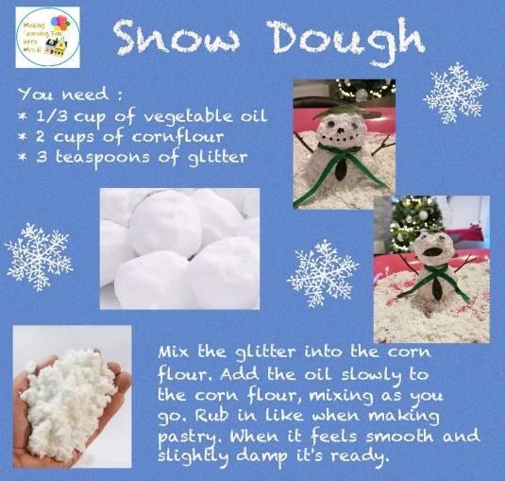I am learning……

MATHS: to use numbers for measure and quantity

SCIENCE: to notice changes in materials

FINE MOTOR SKILLS: to use the muscles in my hands to mix, rub, roll, squash, push, etc

CREATIVITY: to use my imagination to plan, design and create

LANGUAGE: new words to describe

**Activity 5**  


Go for a safe, scavenger walk….how many of the items on the list can you find?

I am learning…..

HEALTH AND WELL-BEING: by being active I am looking after my body

MATHS: to use numbers for counting; to use data handling to record my findings

COMMUNICATION: to talk about the world around me