Word doc

**Topic on Tuesday** - 19th May 2020

Good morning pet lovers. I thought we could start with a bit of fun. What would your mythical pet be? Click on the link and play the game! 😉

<https://www.youtube.com/watch?v=e1JhM9g-9RQ>

**TASK**: Well, now you have found out which mythical pet you would have, I don’t see why we can’t add this into your pet project. Here are a few suggestions:

* 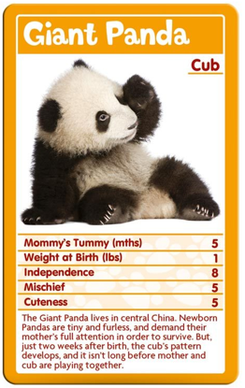**Top trump card** – from the quiz, you are given some information about this pet but as these are mythical creatures, you can make up your own information too.
* **Fact card** – like the ones we get with National Geographic or free in a cereal box! Once again you could use the information from the quiz.

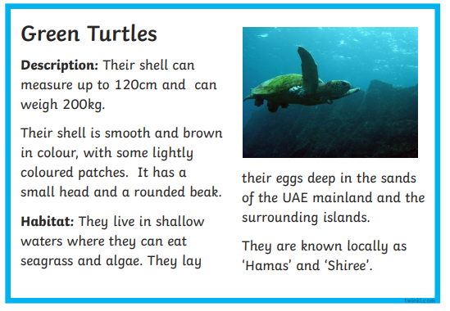

**Or**:

* Maybe a Wordle?
* Maybe just a mind map with your mythical pet drawn in the middle?
* Maybe draw a large picture of your mythical pet and bullet point the information inside?
* Own idea.

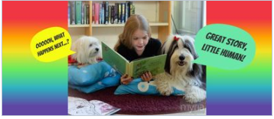

**TASK**: SeeSaw task. Where possible read to your pet or a pet toy. I am missing hearing you read, so I am looking forward to listening to your reading to hear how your reading aloud has developed. Thank you. 😊

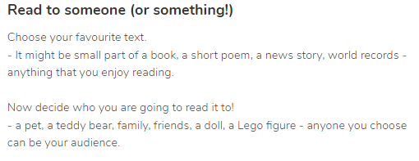

**TASK**: New Learning: Pie charts.

Pie charts are a type of graph in which a circle is divided into segments; each segment represent a proportion of the whole. Here is a picture of one. Do not worry that some of the fractions have a different denominator, (bottom number). For this task, you do not need to know why.

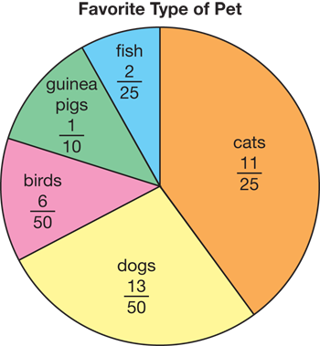Here is a link to a short clip which will be prudent, (sensible) to watch before engaging with the task. Being ‘pet related’, once completed, this task will look good in your project. 😊

<https://www.youtube.com/watch?v=V_5rtiQzQQA>

|  |
| --- |
| Now open the PDF relating to this task and *wow* me with your data handling and knowledge of fraction skills! 😊 |

**TASK - part (a):** Healthcare Signs of illness. Another part of your project should focus on signs of your pet not being in good health.

I do **NOT** expect you to write out or type a long list as shown in the box below, (unless you wish to), just research signs of ill health for your type of pet and then copy the information onto a word document or take a photograph. Alternatively, you could produce something as simple as this:

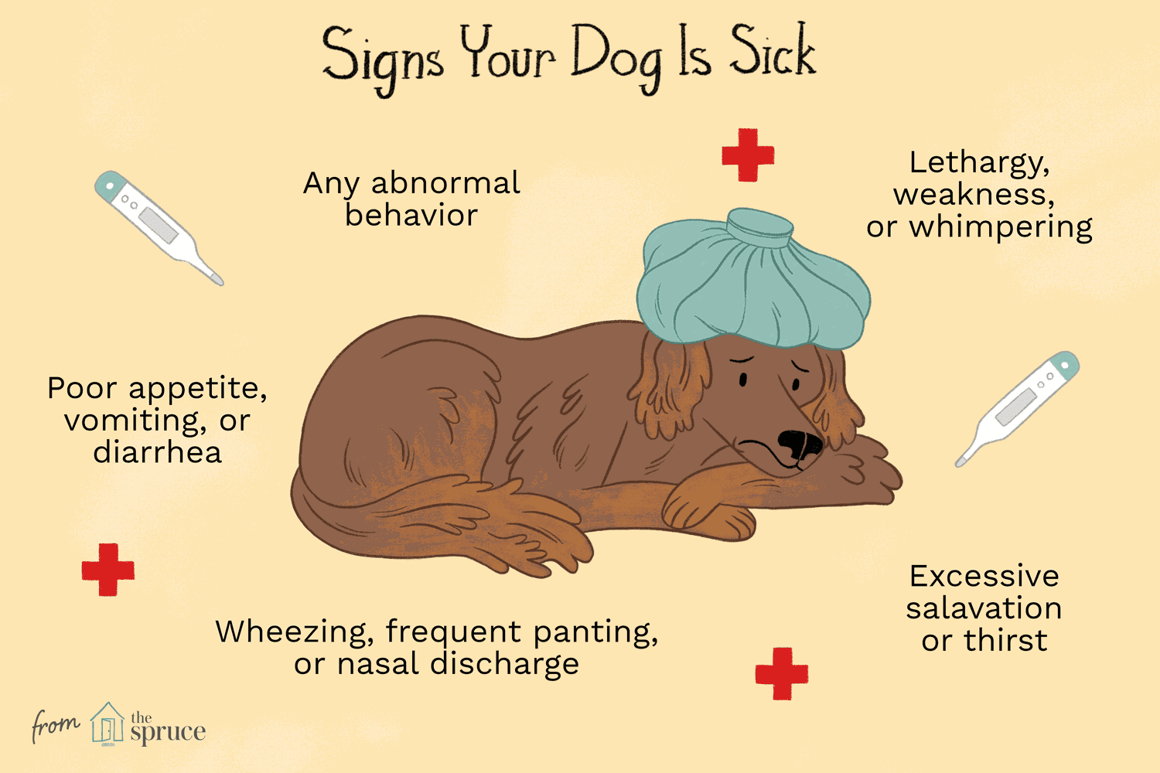

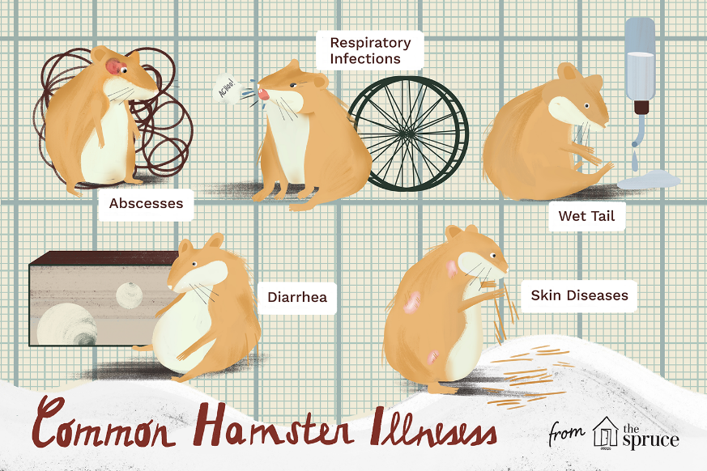

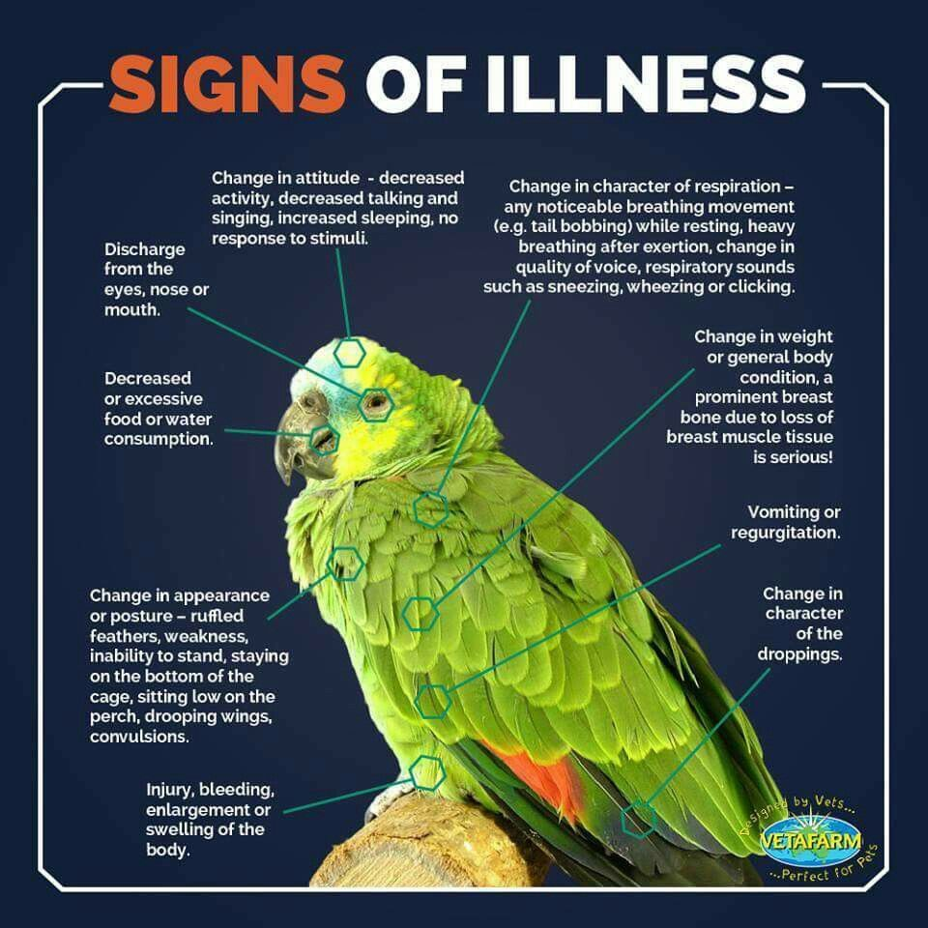

|  |
| --- |
| Observe your rabbit regularly; if you notice any of the following it might indicate a health problem and you should contact your local vet to arrange a consultation:  ■ Lethargy  ■ Diarrhoea or a significant change in the size/number of droppings  ■ Weak hind limbs, swollen joints or lameness  ■ Hair loss, flaky or crusting skin or excessive scratching  ■ Not eating or drinking  ■ Dull eye colour or coat  ■ Squealing when urinating or blood in the urine  ■ Dirty, uneven or broken teeth  ■ Drooling or tooth-grinding  ■ Discharges from the eyes or nose  ■ Breathing difficulties  ■ Lumps  ■ Swelling of the abdomen  ■ Wounds or sores on the feet |

**TASK - part (b):** As our pets cannot talk, it is up to us as responsible pet owners to look after them as best we can. It is a good idea to keep a note of your Vet handy.

Here is mine: **Can you make one showing your Vet’s details?** The one I have does not show their opening times. Perhaps, you could include these details on yours? If you do not have a pet, either research a Practice on your computer/laptop/iPad or make one up.



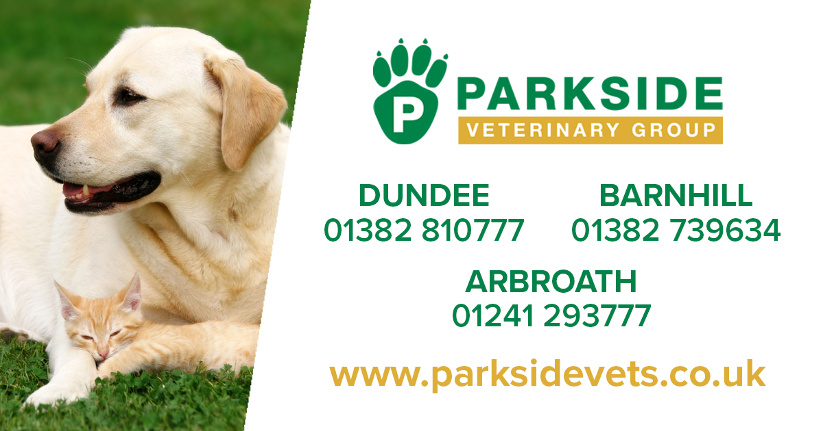

**TASK**: Can you put together a contents page? At this stage I do not think it would be wise to number the pages because we will have more inserts to add into the various sections. In fact, you don’t even have to number the pages; you could colour code the different sections. Here are some examples to look at but grab any book and see what their contents page looks like.

|  |  |
| --- | --- |
|  | Introduction ……………………..  Choosing the right dog…….  History of spaniels ………….  Preparing for you spaniel … |

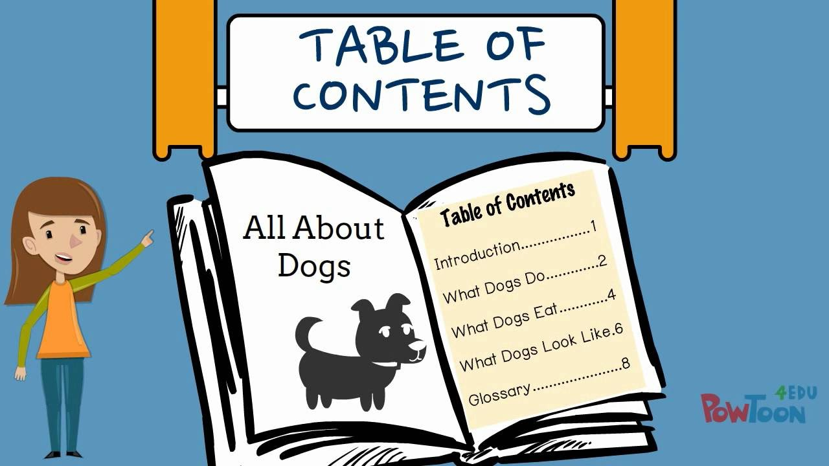

|  |
| --- |
| Remember, these are just suggestions. Maybe, you could do one or two today and another one tomorrow for Writing on Wednesday? In fact, you can do any of the tasks, sent to you on any day, at any time! Also, you can cover your learning in whatever way you wish. Just keep challenging yourself and be the best version of YOU!  😊 |