Numeracy 19.6.20

Fun Friday Maths! Work through as many of these as you can. If you are finding them too tricky you can practise areas of maths you are struggling with by using sum dog, number gym or Top marks!

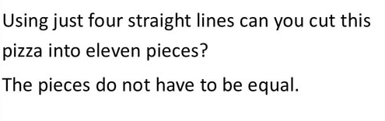



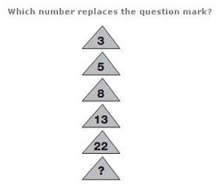

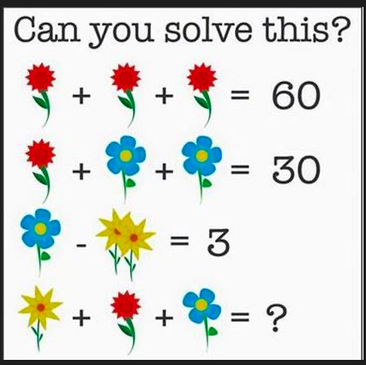

When you have your answer can you tell me what each flower is worth?

