15.6.20 Numeracy Task

Here are some mental maths and problem-solving starters to begin your week!

I would like you to give them all a go. If some are too difficult this is ok – it allows you to become aware of your next steps in numeracy.

When you have completed this you can use hit the button or any other online tool you enjoy using to practise your times tables.

Good Luck!

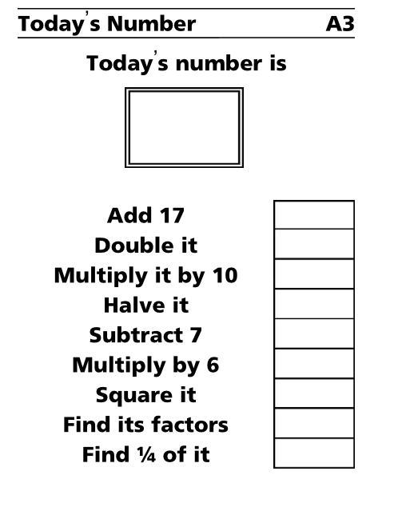
3

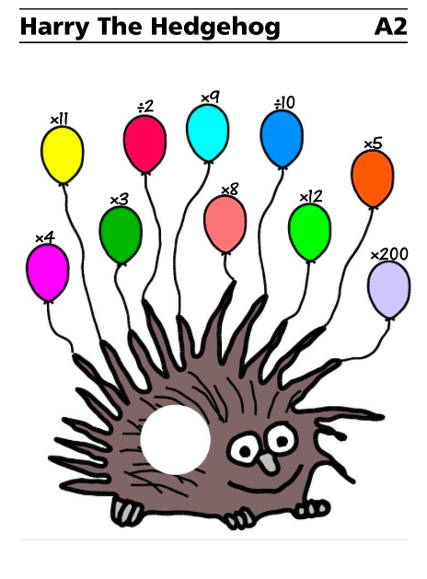
4

