Answers to today’s questions.
Renewable Energy | Non-renewable Energy
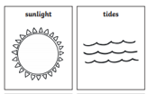  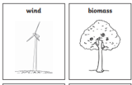  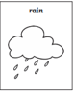 | 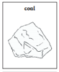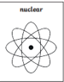  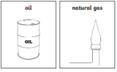

-----------------------------------------------------------------------------------------------------------------------------------------------
Put 0.74 in the correct place value columns.
Th  Thousands | H  Hundreds | T  Tens | O  Ones |  | 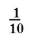  tenths | 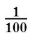  hundredths
 |  |  | 0 |  | 7 | 4

-------------------------------------------------------------------------------------------------------------------------------------------
Glaciers have thinned by an average of over 10 m since 1980.
10 m = how many centimetres? Answer: 1,000 cm
There are 100 centimetres in one metre (remember ‘cent’ relates to 100). So, we need to times (multiply) 100 cm by 10 m. We can do this quite a few ways. Repeating addition 100 + 100 + 100 + 100 and so on until we have added 10 lots of 100! Some of us may have just multiplied 100 x 10 and so of us will have taken a different journey. It does not matter how you worked it out, as long as you have understood your thinking.

