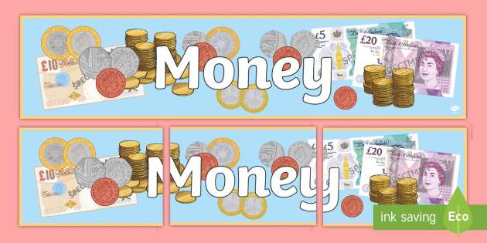

You have been asked to plan a birthday party. You have £100 to spend. You need to keep within your budget. There are several items you must get and a couple of rules you must follow. They are listed below. If you can buy all these items and have money left over, you can choose to spend it on other items for the party.

The Rules:

There are 14 people invited to the party, you need to cater for all of them.

You cannot make up the prices for the items. You can check how much an item costs by looking online or asking someone to help you figure it out.

You must write down how much each item cost on your list so that you can work out a total and then check if you are due any change.

The items you must buy are:

A birthday cake of your choice

Party decorations – must include 20 balloons, bunting and party hats

A birthday present of your choice

Food for the party – ingredients to make two types of sandwiches, a selection of crisps and drinks

Party bags – you can have whatever you like in the party bags, but you must have at least three items, remember to include the price of the bags.

Prizes for party games – there will be four party games of your choice, you need prizes for four winners and runners up prizes.

**If you wish to make this challenge harder, you can add the following items to your list:**

Party invitations – you need at least 14 for all the guests.

The balloons need to be filled with helium; you will need to buy the helium to fill them yourself.

As well as the food listed above, you need to buy pizzas, strawberries and two types of vegetables for veggie sticks.

**If you would like to make this challenge easier, then select only three of the required items to work with.**