**Fun on Friday** – 15th May 2020

**Brain teaser answer:** The river was frozen!

Let the picture speak for itself!

I’m ready, are you? 😉

So, today is ‘Fun Friday but wait a minute, I hear you say, we thought today was a STEM day. Well, children, every day is a STEM day, just like every day is a literacy day … Do you know that STEM is part of our everything in our lives? Science is everywhere in the world around us. Technology is continuously expanding into every aspect of our lives. Engineering is the basic designs of roads, bridges and so the list could go on but engineering also tackles the challenges of changing global weather and environmentally-friendly changes to our home. Mathematics is in every occupation, every activity we do in our lives. Important? I should say so. Therefore, all tasks today will be STEM related! 😊



**TASK**: Computational thinking is about learning to solve problems, with or without a computer. This link takes you to a site called Barefoot and they have put together a whole package of home learning opportunities. On their homepage you find lots of choices – each one has an age recommendation but this is just a guide. Looking forward to seeing what challenge you smashed! <https://www.barefootcomputing.org/homelearning>

|  |
| --- |
| **All I wish you to do is tell me the name of the activity, who took part, what you found challenging and what you did not like, if anything. Then give it a star rating out of ten. As most of the activities will be using algorithms, let’s see if you can follow mine! 😉** |

**TASK**: Thank you to the readers out there who did yesterday’s task. 😊 Remember that word you had to set aside for today? Well, the time has now come to look it out! Using the coding sheet uploaded as a PDF, spell out the word and complete the corresponding activity! For those who did not do yesterday’s task, just follow these instructions.

|  |
| --- |
| **Spell out your full name and complete the activity for each letter. For a greater challenge include your middle name or maybe do each twice. Get all the family involved, including pets – well, perhaps not the fish!** |

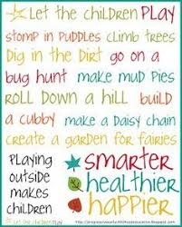**TASK**: I think this one is self-explanatory … have fun!

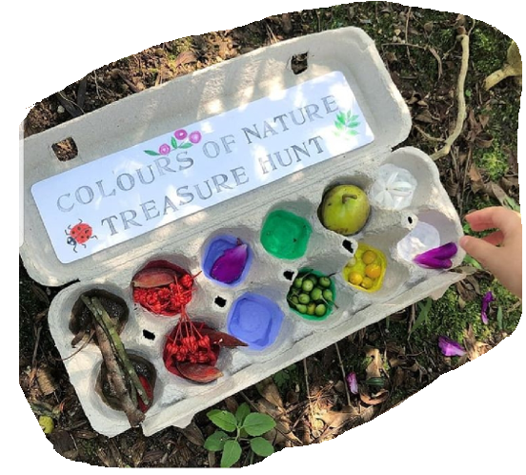

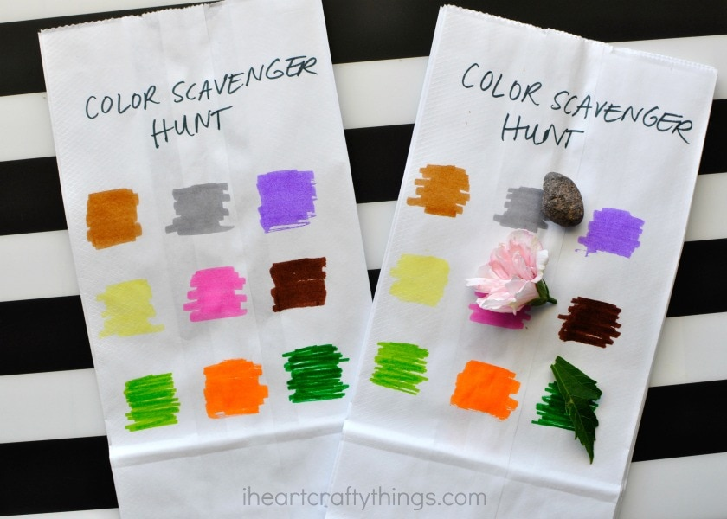

Take a photo and share your finds.

How close can you match the colours?

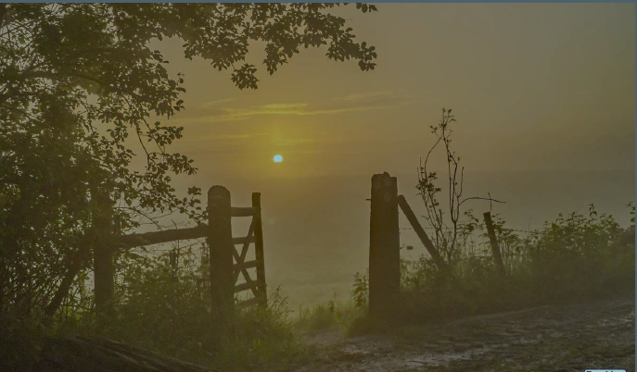

**TASK**: I know Oakley and Jay both wrote stories about the *Open Gate* and very good stories they were too but what I did not give you was the last page; kept it back especially for today. 😉

Well, here it is …

|  |
| --- |
| **Investigate: Design a gate that cannot be left open. How would the mechanism work?** |

|  |
| --- |
| **MEET SOMEITY**: THE **TOKYO 2020 PARALYMPIC MASCOT**  The **Tokyo 2020 Paralympic mascot's** name is Someity, (pronounced soh-may-tee) which comes from someiyoshino, a popular cherry blossom variety, and additionally echoes the English phrase “so mighty”. |

**TASK**: As you know I am very passionate about all sports and through Emma I have had the honour to have been a special guest at some fabulous World Championships and the like. I have also been extremely lucky to have met, in person, a few of these exceptional men and women. As you are aware, I should have been going to the Tokyo Paralympic Games and I had, already, been gifted their mascot, Someity.

If we had been in school, then we’d all have been involved in this competition:

**Design a ParalympicGB Mascot Competition**

**and in fact, the deadline would have been and gone. However, due to present circumstances, they have extended the deadline and so I am hoping YOU ALL have a go at this competition.**

The deadline to submit your mascot is **31 May 2020** and mascots can be designed using any medium **(e.g. hand drawn, computer-aided design or modelled in 3D)**

**Everything you need to start you off on the right track can be found by following this link. You have just over two weeks to produce the winning mascot and I am here to help. It would give me so much pleasure, if at least a few of you entered.**

<https://www.wassp.co.uk/about-us/news/87-get-set-home-learning-quizzes-an-competition>

**If you are keen, then know I will be encouraging you to research thoroughly, plan properly and give it your very best effort. Below are your Steps for Success. Good luck!**

|  |
| --- |
| **Remember your mascot should**:  • represent a physical or sensory impairment in some way  • celebrate Paralympic athletes and the *Paralympic Values  • champion ParalympicsGB at future Summer and Winter Games  • have a great name! |

*Paralympic Values: ***determination, equality, inspiration and courage***

Emma has also sent a couple of links which she thought you may enjoy. No questions this week; just enjoy and be …

*inspired* …

Home exercise: <https://youtu.be/A1duMhdw7l8>

Shooting with a vision impairment:  <https://youtu.be/1q2AAGCZcv4>

Athletics feature: <https://youtu.be/rJB8tuuE7Jg>

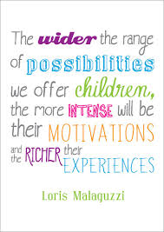

Thank you once again for all support and being there. See you next week … keep safe; keep smiling.

With love,

Mrs. Logan X

and now …

