
12.6.20 Literacy Task
You will find your tasks on the next page.
If you are finding these too challenging, you can use the poster and the video links on the next page to write a summary of what the poster is portraying and what the video’s explain.
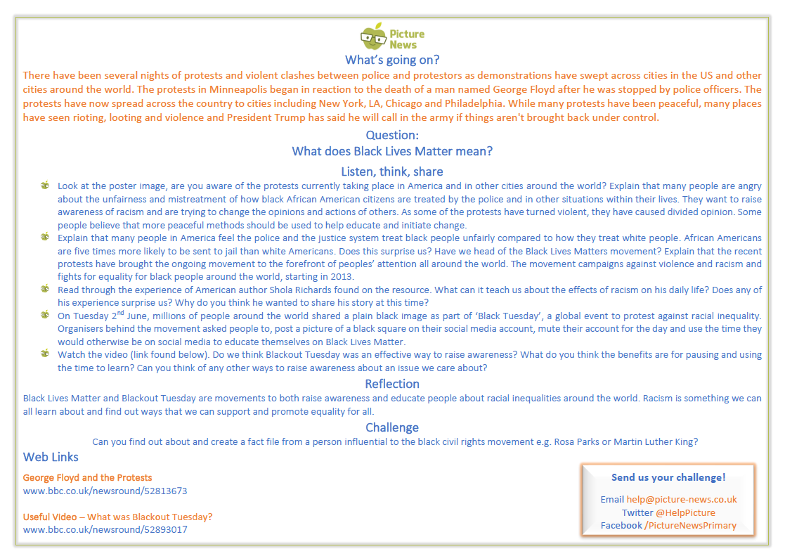
12.6.20 Literacy Task
For the ‘listen, think, share’ part – use a family member to discuss with!
If you are struggling to read this on here I’ve uploaded the PDF form as well.

