Word doc.

**Literacy Learning for Thursday** – 14th May 2020

Today, no preamble, just straight into literacy. 😊

TASK: I would like you to get your reading book and a piece of paper and writing tool. Now read for at least 15 minutes. During this time, jot down any words you do not know the meaning of. If you know the definition of all the vocabulary, jot down words you like. (If after reading for ten minutes you have a long list of unknown vocabulary, then may I suggest the book you are reading is a little too challenging for you at the moment.)

Follow-on TASK: Look up unknown vocabulary or ask someone to explain their meaning or use the internet – hopefully this will then support your understanding of the text. Next, keep aside just one word – you will need this word for a fun activity **tomorrow**. 😊

TASK: Copy this quote about pets in your very best cursive handwriting. You could do something like the example below. If you did, it would be another page for your Pet Project. Just a suggestion. 😊 ‘Somethings just fill your heart without trying’.

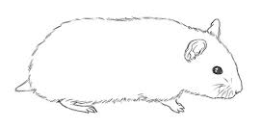

Somethings just fill your heart without trying.

TASK: If you are quite confident with the young of different animals, why don’t you challenge yourself and cover over the word bank? Maybe just use the word bank to check spelling once you have completed the crossword. This will also be shared in PDF form.

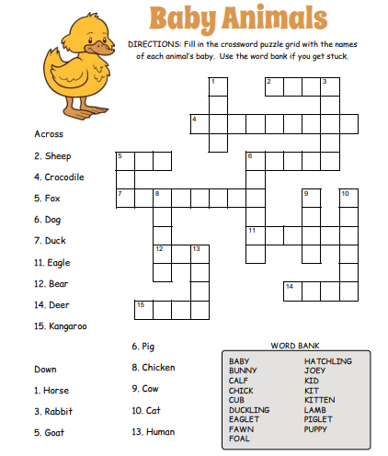

TASK: A little while ago I sent you ‘**Pet Care of a Rabbit’** passage to read. I then asked you to write a number of questions for the passage. Well, thanks to Casey, Katie and Zak, here is today’s comprehension.

|  |
| --- |
| REMEMBER to answer in full sentences! |

**Chili challenge \***

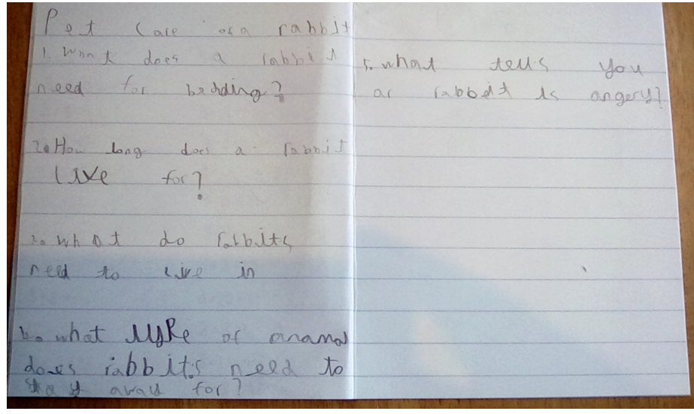

1. What does a rabbit need for bedding?
2. How long does a rabbit live for?
3. What do rabbits need to live in?
4. What type of animal do rabbits need to stay away from?
5. What tells you a rabbit is angry?

**Chili challenge \*\***

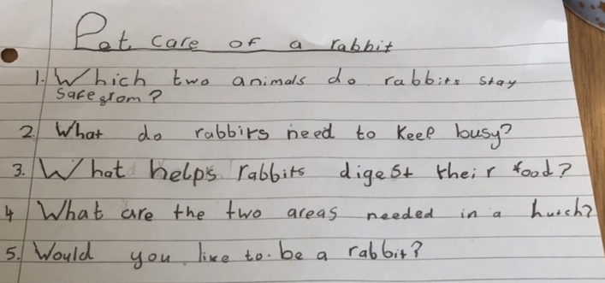

**Chili challenge \*\*\***

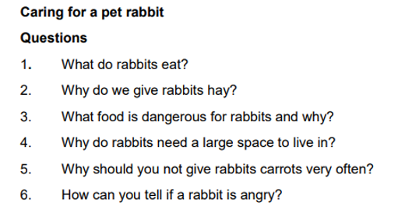

|  |
| --- |
| TASK: Editing task going live on SeeSaw at 10 am! It would be wonderful if learners could try this one. It will be an excellent exercise to improve your editing skills; much needed when self or peer assessing! 😊 |

--------------------------------------------------------------------------------------------------------------------------------------------------------

## TASK: New learning* Home learning focus:

To understand how to use paragraphs correctly in your writing.

This lesson includes:

* one video to help you to understand how to use paragraphs
* three activities

Here is the link to BBC Bitesize. <https://www.bbc.co.uk/bitesize/articles/zv4j7nb>

As you have just read above, there is one video clip and three activities. All I am inviting you to do is watch the clip and read the information which follows. It is your choice if you wish to complete an activity BUT please, do not do all three or if you do just share ONE with me through SeeSaw. Many thanks. 😊