Word Document

**Topic Tuesday** – 5th May 2020 Remember; the following tasks are just suggestions for you to engage with or not. Also, topic tasks can be adapted to reflect your own creativity. I just want you to enjoy your learning, whilst hopefully, building in some challenge for progress. 😊

-----------------------------------------------------------------------------------------------------

**Joke**: Q: When does a horse talk? **A: Whinney wants to!**

**Riddle**: Bob at the butcher shop is 2 metres tall and wears size 11 shoes. What does he weigh? **Meat! Bob works at the butcher shop, so he weighs meat for a living.**

**Answer to yesterday’s brain teaser:** I do hope some of you had a go at this. 😊

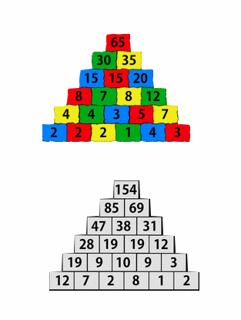

-----------------------------------------------------------------------------------------------------

**TASK**: This is a game. Make up the die, decide how many times you are going to roll it, record your results in a tally chart and then graph the results. (Template found on PDF for die and graph but of course, you can make your own graph).

Tally chart could look something like this:

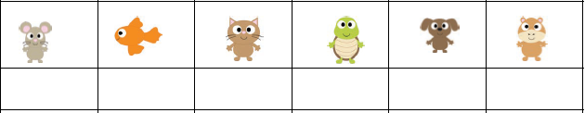

|  |
| --- |
| **Remember, your graph will need an appropriate title and labels for x and y axis. We have covered data handling, so this should be no problem. 😊** |

**TASK**: Although I have copied this task out below, if it is easier to access online, here is the link. I like this challenge; gets you thinking. Have fun! 😊 <https://nrich.maths.org/247>

**The Pet Graph**

Tim's class collected information about all their pets. They have six different kinds of pets between them.

This is the block graph they are making to show how many of each pet the class has altogether.

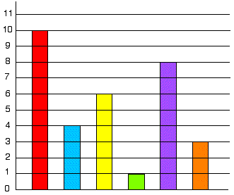

The children have not yet put in the animal names under each column. Can you do this for them using the information below?

There are two less cats than dogs.  
Only one child has a parrot at home.  
The number of fish added to the number of gerbils is equal to the number of dogs.  
There are twice as many fish as hamsters.  
There are half the number of gerbils as there are cats.

-----------------------------------------------------------------------------------------------------

As you know Emma works for the IPC and yesterday, she sent me some links to clips she thought I may like to use with my class.

Today I have chosen this one <https://youtu.be/xT1Vyrtjq7s> as it links to an area of our maths and pets learning!

Watch it carefully and then answer this question: What did you see floating in the pool?

**Topic – Pets**

Now remember, you do not need to have a pet to be able to produce a pet project successfully. Perhaps you do not have one now but have had one in the past so, you will be able to draw on that experience.

Ok pet owners. You did your research, you decided what type of pet would fit into your family life, you built or bought the right accommodation and you have got everything in place. You didn’t go overboard before you brought your new pet home but you did make sure you had the essentials.

Depending on the type of pet you chose, these would have included such things like a pet carrier, somewhere to sleep (a bed for cats and dogs, a cage for small furries, an aquarium for fish or a vivarium for reptiles, coop for hens, stable for pony, goat, sheep etc.), litter trays, bedding, feeding bowls, water bottles, toys, the correct food and registered your pet with a vet.

So, your lovely pet is now very much part of your family but you know it is important to keep an eye how your pet is growing but more importantly its weight.

**TASK**: With help, measure and weigh your pet. This is important information and so, needs to be recorded. This will be another insert for your project, so make it as neat and attractive as possible.

|  |
| --- |
| If you have not got a pet and are putting together a project based on a pet you would like, then you will have to do a bit of research to find out average measurements and weight for your chosen pet. I have a site that will help you find this information but anyone is welcome to use it. It is a good site to visit. <https://www.pfma.org.uk/pet-size-o-meter>  (Information from the PFMA: It's really difficult for owners to check if their pet is overweight and it's a touchy subject!  We have developed Pet Size-O-Meters (user friendly versions of Body Condition Score Charts).  So far, we have developed them for [dogs](https://www.pfma.org.uk/dog-pet-size-o-meter/), [cats](https://www.pfma.org.uk/cat-size-o-meter/), [rabbits](https://www.pfma.org.uk/rabbit-size-o-meter/),[birds](https://www.pfma.org.uk/bird-size-o-meter/) and [guinea pigs](https://www.pfma.org.uk/guinea-pig-size-o-meter/).  You can scroll through our selection, click to download for free and print at home |

**TASK**: Make your own ‘Pet Care Daily Calendar’. You can either follow this link to download your own or make your own based on the examples shown below. The second example is for a dog; you just change ‘dog’ for your type of pet! (I will also send out the PDFs)

<https://www.seussville.com/activity/pet-care-daily-calendar/>

Example 1:

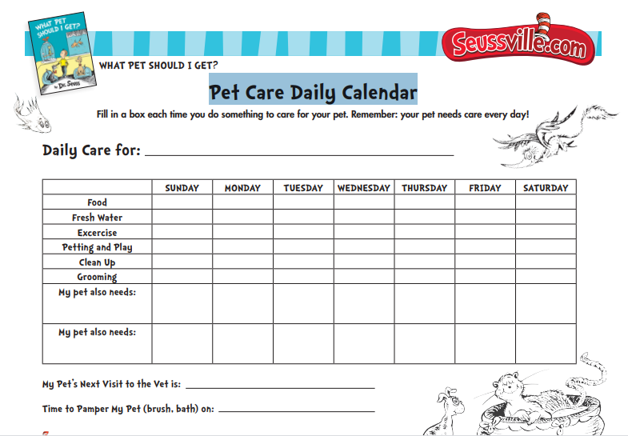

Example 2:

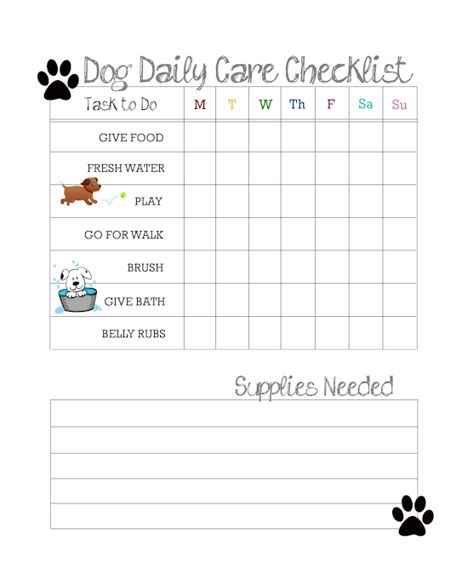

**TASK**: Draw your pet either free hand or use this link, ‘how to draw pets’ to help you.

<http://www.yedraw.com/animals-pets.html#.XrBUYqhKjIU>

However, if you put your pet into Google you will probably find a better site to help you.

Alternatively, print of a template of your pet. Then transform it into a collage.

|  |
| --- |
| Collage *noun*  a piece of art made by sticking various different materials such as pieces fabric, paper or craft materials on to a backing. |

Below are a few examples. Be as creative as you wish but no colouring in!

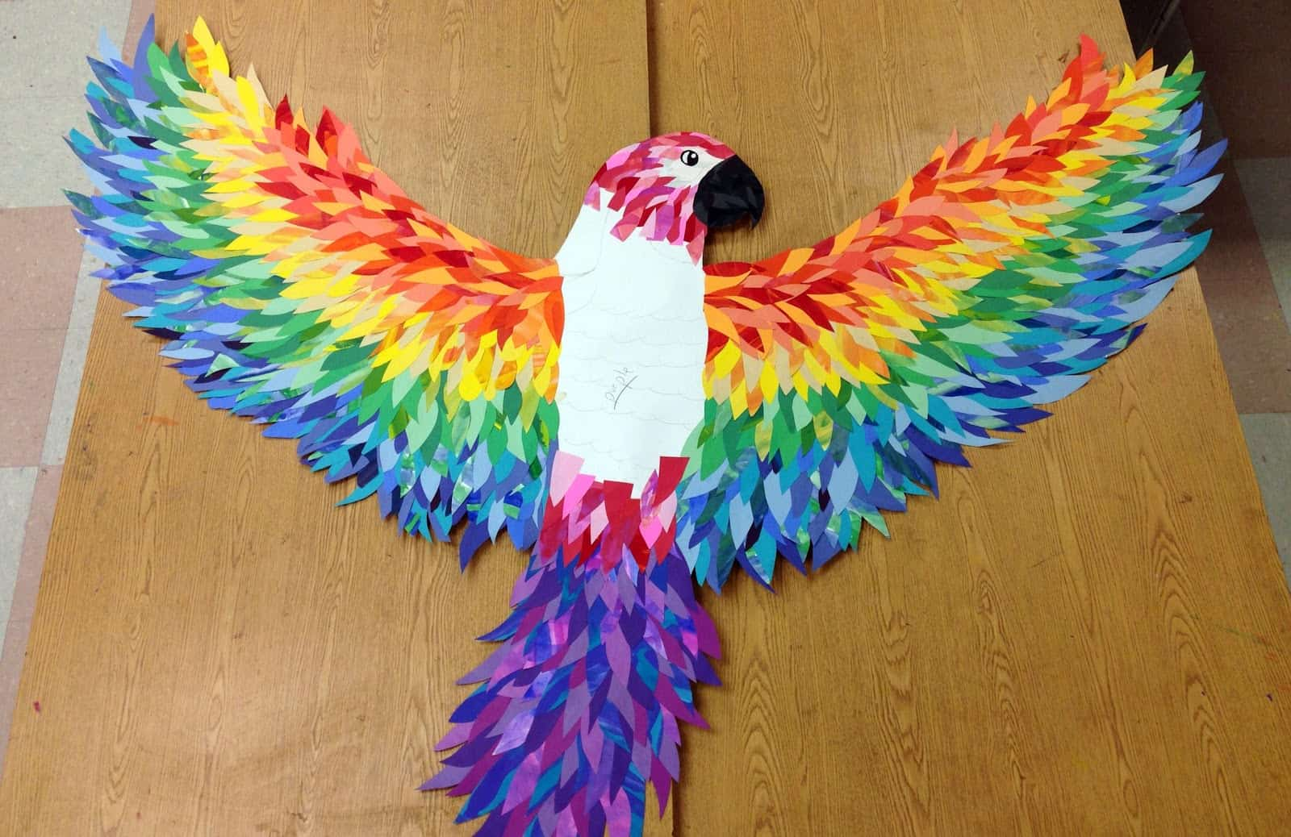

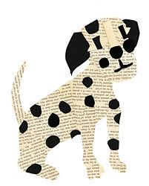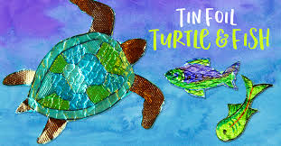

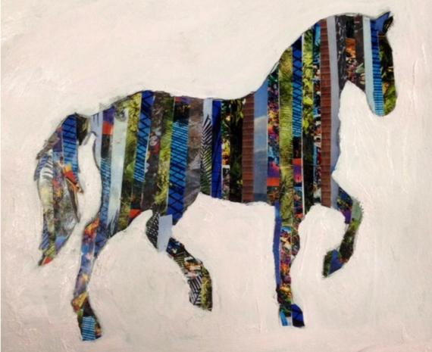

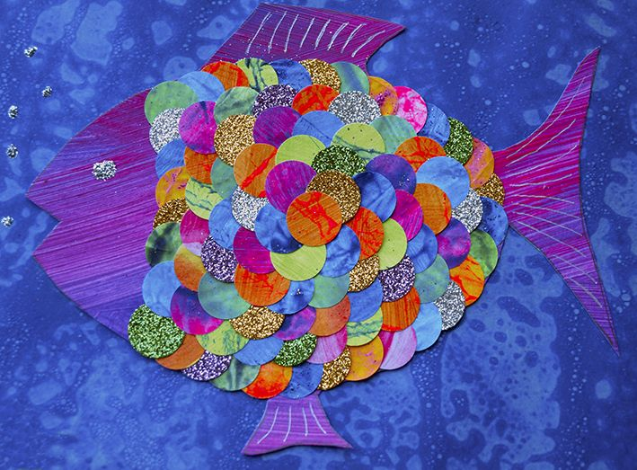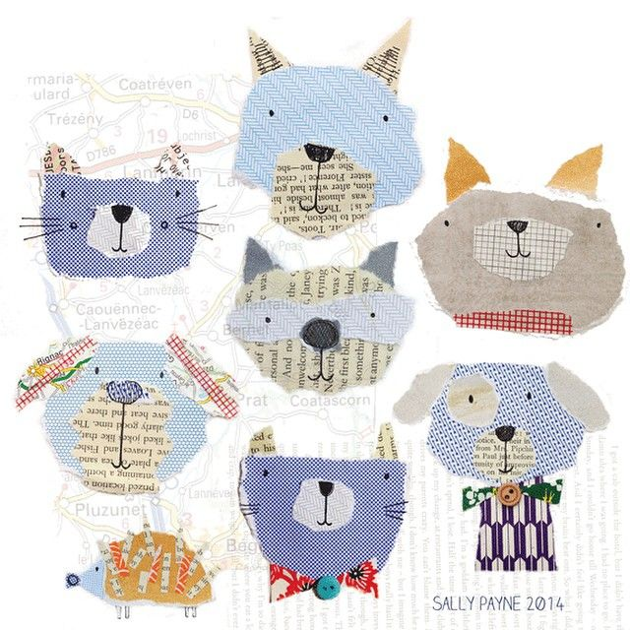

|  |
| --- |
| Lastly, check out this site:    <https://www.scouts.org.uk/cubs/activity-badges/>  and click on Animal Carer and read what you will have to do to earn this badge. If you supply the evidence that you have completely all the badge requires, then I will ensure you are awarded with a badge. Whilst you are on this site, why not check out the other badges and see what else you could achieve. Why not? Sounds awesome to me! |

Happy learning! 😉