How would you describe an elephant to someone who has never seen one?

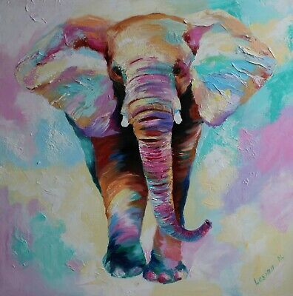

Write about the world’s first hiccup!

Write directions for eating an ice-cream.

What are the advantages and disadvantages of having an octopus as a lifeguard?

What would happen if it always snowed?

Why do people climb Mount Everest?

What would happen if sweets were free?

If a frog could talk, what questions would you ask it?

If a tree fell in a forest, and no one was there to hear it, would it make a sound?

Write a conversation that might be going on between five toes in a sock!

Why do we have fingernails?

Imagine you are yesterday’s newspaper, what is going to happen to you?

Why are there thorns on a rose?

