Topic Tuesday – 28th April 2020.

### Joke: Q. Why are fish so good at watching their weight? Because they have lots of scales.

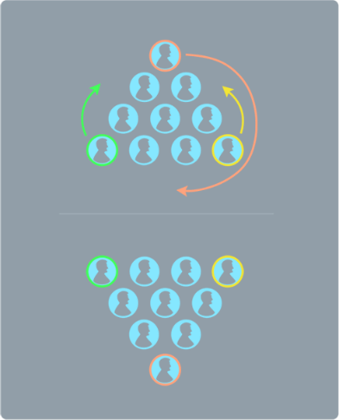

Answer to yesterday’s challenge:

**Today’s challenge:**

There were 3 Owners - John, Sally and Chloe  
Each person had a Pet - Hamster, Cat and Dog  
And each pet was bought in a certain month - August, March and October.

Can you work out which pet belongs to which owner and when the pet was bought?  
Clues -  
1. The owner that owns the hamster did not buy it in March.  
2. Sally did not buy her hamster in October.  
3. The owner bought his dog in March.

**Answer tomorrow.**

Now I know that today is Topic Tuesday but I could not let a rich opportunity to engage with some real live maths. So here are your number challenges which I hope you all have a go at. **Remember to use your tool box of strategies!**

1. **26 challenge**: how many different number bonds can you make for the number 26 if you use running and walking as the two variants? On the next page there is an example how you could show your thinking.

|  |  |
| --- | --- |
| **run** | **walk** |
| 26 | 0 |
| 25 | 1 |

1. **Challenge total challenge**: As a collective Families Team you raised £41. How many pennies is this?
2. **26K challenge**:

* How many metres in 26 km?
* 26 km is the same as how many miles? (Rounded to the nearest whole mile.)
* **Extension challenge**: Some did a 2.6 km challenge – what is the 0.6?

1. **Distance challenge**:

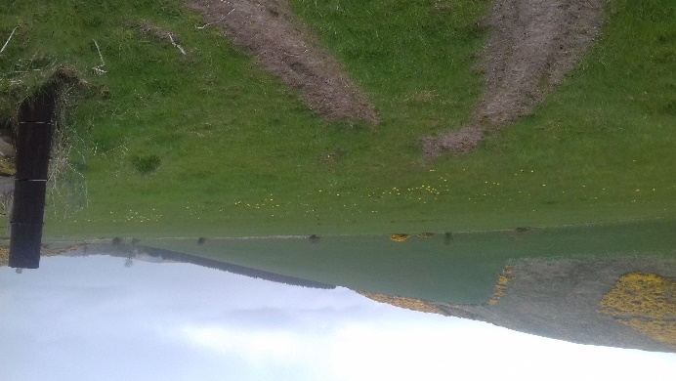 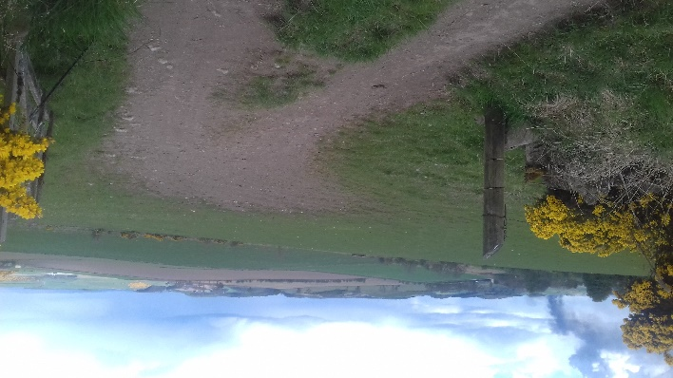

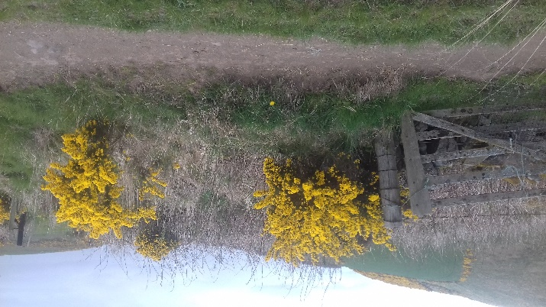For my 26 km run I used our neighbour’s fields. I found two adjacent fields joined by open gateways. I ran round both fields and called this one complete circuit/lap. Each field has a perimeter of 1 km. Also, each field is square-shaped. Using this information, answer the following questions. Thank you.

(This photo just shows how the two fields

are connected.)

1. How many laps did I run before I had covered 26 km?
2. Approximately, what does one side of a field measure?
3. **EXTENSION CHALLENGE**: Show your answer to number 2 in as many different ways as you can think of.
4. Money challenge: At 3 pm today the total raised for the 2 and 6 challenge was £**6,225,075.33**

**How much is this figure?**

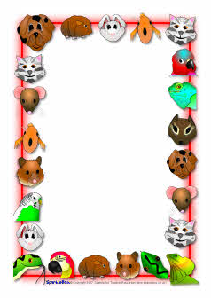

**Topic Task**: What do you have to think about, (consider), before getting a pet? Make a list, (written or typed) and illustrate each point. This is going to be another page in your project so make it your best work. Here is an example to help you get started.

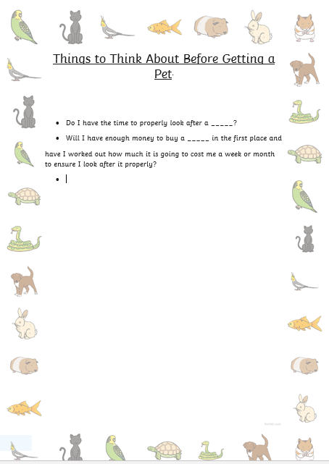

Where it says ‘will I have enough money …?’, I am meaning your family. It was just an example to get your mind going along the correct line of thinking.

Now, think about what your pet needs to keep it fit and healthy. Share your list however you wish: poster, leaflet, mind-map, lift-up-flaps to fit your Lapbook, wordle or your own

This is an example of a wordle for friendships.

Remember, make it your very best work, as going to be part of your project. Just take your time; there is absolutely, no need to rush. Thank you. 😊

**Topic Task**: Follow the links to see if any are going to be of help for your project. You might some good ideas from checking them out! Enjoy. 😊

<https://www.youngvetsclub.com/looking-after-your-pet?gclid=EAIaIQobChMIg--lutaI6QIVwrTtCh1nUgH1EAAYASAAEgJZcfD_BwE>

<https://www.ducksters.com/animals.php>

<https://www.pdsa.org.uk/get-involved/kids-corner>

<https://www.bbc.co.uk/newsround/47953276>