**Maths on Monday** – 18th May 2020

|  |
| --- |
| **Good morning, please remember these tasks are to help, support and guide not to overwhelm. They can be completed in whichever order best suits or just left for another day or not. 😊** |

**Please read with great care, the text in the blue box; it contains very important instructions for you to follow.**

|  |
| --- |
| **Today, when you have completed a learning task, go into SeeSaw and:**   * **send me a message stating the task you have completed** * **say What Went Well.** * **if the learning task has an answer sheet, wait until you receive it, then mark your work.** * **go into SeeSaw and send me a message telling me what your Next Steps will be.**   **Of course, you can share anything you like because as you know, I always look at your posts with great interest and usually with tea and biscuits to hand. 😊** |

**TASK**: Today we are going to be looking at fractions. If possible, try to engage with this task because there will be follow-on tasks later on in the week. It would be great too, if you can work through this task with an older member of your family. That way, if you have questions as you go along, they can be answered.

Now you have a choice. You can access your learning/revision about fractions through Bitesize: <https://www.bbc.co.uk/bitesize/articles/zd8mt39>

**OR** **Mathsantics**.

**OR** both … this is all about YOU as a learner so, choose what is going to work best for you. Fractions are very much a part of life; getting to grips now will be incredibly beneficial. 😊

If you choose the Mathantics, watch the two YouTube clips as shown below. If you are confident using fractions and would like to develop your understanding, then go to [www.mathantics.com](http://www.mathantics.com) and watch one of the clips further down the list from the box below. (The clips are in a particular order to support your grasp of fractions.)

**Fractions are parts** - <https://www.youtube.com/watch?v=CA9XLJpQp3c>

**Working with parts** - <https://www.youtube.com/watch?v=qDc_-GTipBk>

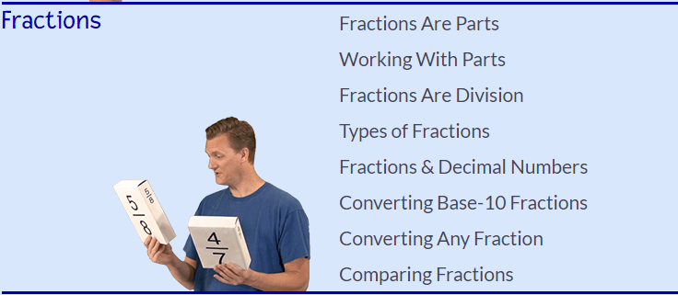

For those of you who find it easier to learn through games, follow this link

<https://www.topmarks.co.uk/Search.aspx?q=fractions>

but choose wisely. Games that pose no challenge, rarely support progress. Each game indicates an appropriate age; be guided by this but it does not mean you cannot choose a game from a different age range. 😊

|  |
| --- |
| **At 12 noon today, you will receive 3 SeeSaw fraction activities. They are differentiated, so chose the one which best suits your level of confidence. Remember my very first instruction? If not scroll back to the first page to remind yourself. 😊** |

**TASK**: Roll a task: Brain Break. This is one is for everyone. 😊

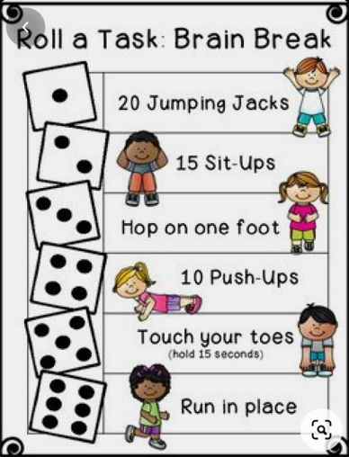

**TASK**: Daily Challenge – see PDF sent via App. and SeeSaw. This one is for all the family. 😊

**TASK**: **The Mystery of the Super Snack**. As some of you have asked for a more challenging Mystery to crack, here it is (well, see PDF!). Do not worry, there is something for everyone! If not too confident, YET, in a number of areas linked to maths then this one is for you: **The Mystery of the Squashed Fruit.**

|  |
| --- |
| **Feel free to complete both BUT just share the culprit’s name in SeeSaw and What you think Went Well. Wait for the answer sheet, mark and post up your Next Steps – thank you. 😊** |

**TASK**: You have all heard of and played hopscotch but here is a fun twist to the same game – one that you to enjoy and let out a little steam too. This game ‘**Hands and Feet Hopscotch**’ looks like a mix of Twister and Hopscotch and involves a lot of quick movement, using hands and feet and jumping.

This game teaches a lot of patience and requires a great deal of presence of mind. It also increases concentration, is great for hand and feet coordination and is a great physical activity. It can be easily played indoors, requires little space and is very easy to set up too. The beauty of this game is that you can make it more complicated for older children, or simple for younger ones. Best of all, this game is super fun for adults too. 😉

**What you need:**

* Print outs or hands (both left and right) and feet (both left and right) – each one in a separate sheet – 5-6 copies of each set of 4 prints. You can try the game and print as many as you need depending on the age of the child and the challenge level.
* If printing is not possible, you can even draw or trace out your palms and feet on each A4 sheet of paper. Just make sure you have enough copies.
* If you are playing outdoors or on a chalk-friendly flooring, you can just draw them on the floor.

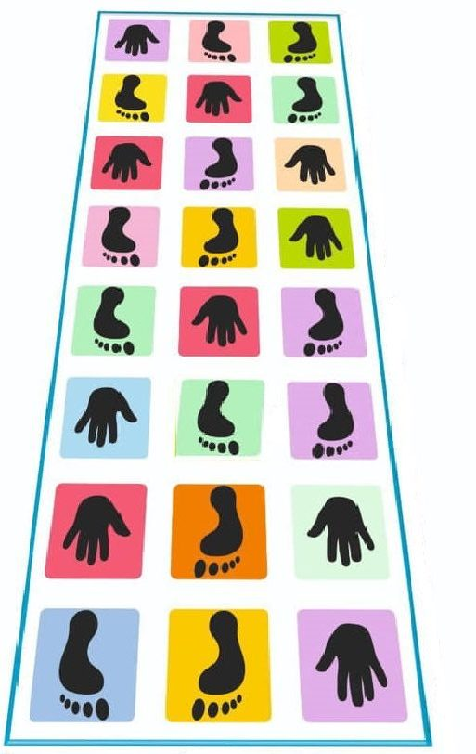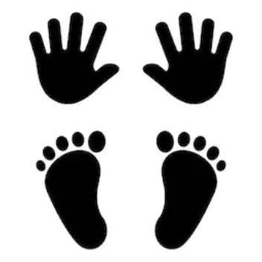

# How to Play:

* You can set up any number of rows, but each row should have 3 squares.
* Each square will have one hand or foot (either drawn or printed sheet of paper). Place the sheets of paper out in rows and use tape to adhere them to the floor.
* Mix up the hands and feet, just like in the Twister game. For little children keep two feet in the code but if your children are older, it’s fun to have one foot and two hands in the three-box row. Also, the younger the group of children the shorter you will need to make the game.
* The players need to jump on the prints following what they show. **So, keep left foot on left footprints, right foot on right print, left palm on left-hand print and so on.**
* The children will love just jumping but you can also time it to see who completes the course the fastest and how accurately they jump without falling down.
* It is a good idea to have a referee!

Have fun but play nicely! I tell you now, I would not be very good; my skills of coordination need honing!

Watch this Hopscotch using hands and feet video so, you have an idea what it looks like! <https://www.youtube.com/watch?v=lwbKAfnmV7U>

***Good luck and have fun!***

Competition time!

Now is your chance to design a Macron training jersey for your Scotland teams!

We’re asking Scotland fans to get creative and design a training jersey for the Scotland teams, which could be made by Macron. Give us your best ideas for a jersey that will be worn around the globe when Scotland 7s, Women and Men prepare for international rugby matches in the 2021/22 season. All you need to know can be found by following this link.

<https://www.scottishrugby.org/fanzone/design-a-macron-jersey-for-your-scotland-teams>