Which will fall the quickest?

Take a look at the two pictures and predict which one you think will fall the quickest. Why do you think that?

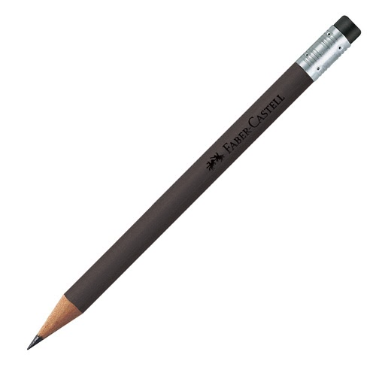  Pencil | OR | 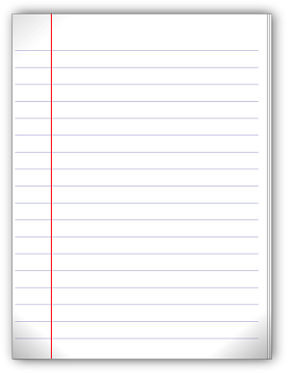  Flat sheet of paper
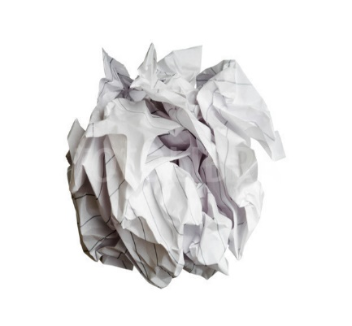  Balled sheet of paper | OR | Flat sheet of paper
Balled sheet of paper | OR |   Tubed piece of paper
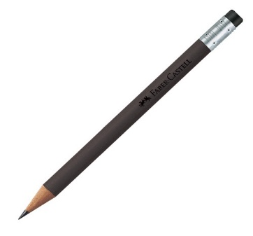  Pencil | OR | Tubed piece of paper

