Mental Maths Thursday

Hi P5,
Your Mental Maths Challenge for today is practising multiplying by 10, 100 and 1000. Below is a colouring worksheet to help you with this challenge. If you would rather practise by doing something else, that’s fine . Remember to share your ideas if they are different!

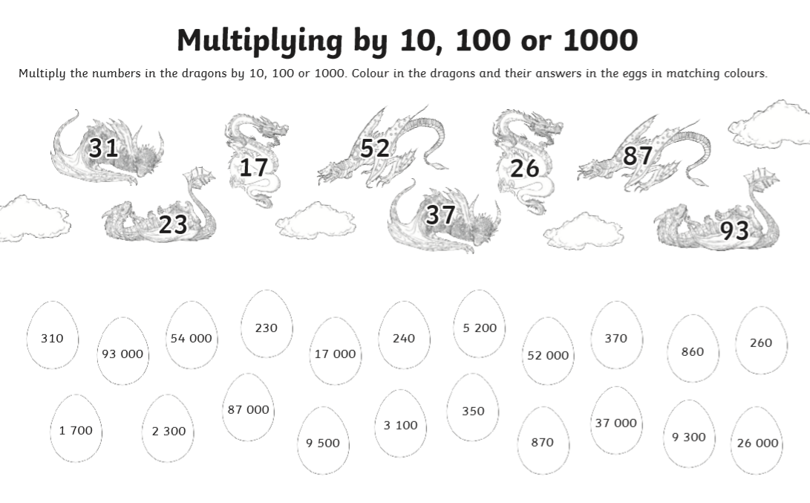
If you are not able to print off the picture, you could always draw your own dragons and then draw the correct egg answers around them.

