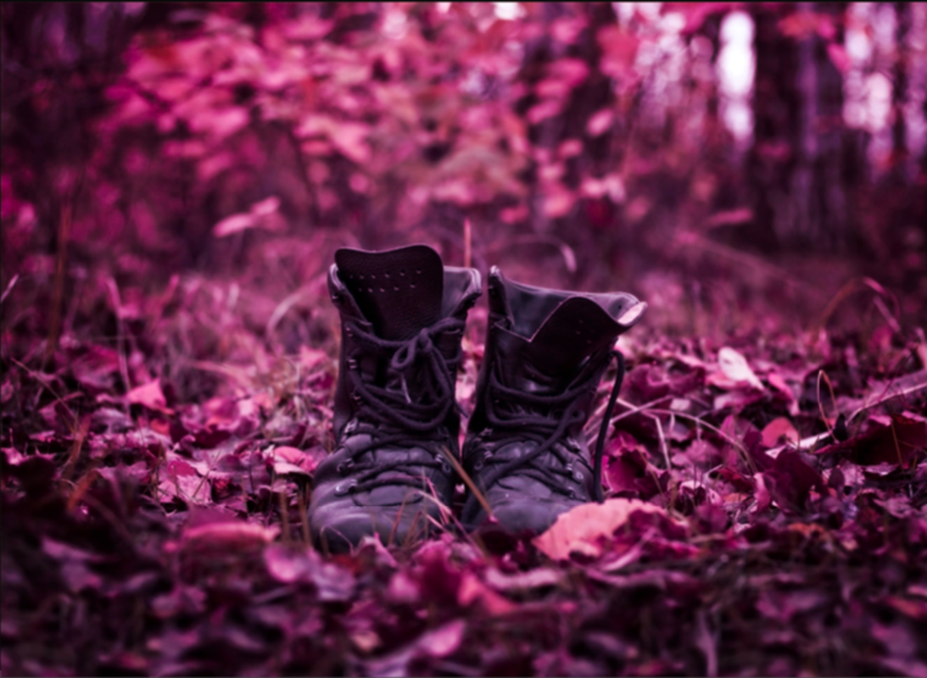

**Story starter!**

All was silent in the forest. Not a breath of wind could be felt or heard.

A blanket of crisp, crimson leaves lay on the forest floor, and a faint earthy smell wafted through the tall, bare-branched trees.

The serenity of the scene was gradually broken as the empty boots began to come to life. The soft, brown leather seemed to flex, as if something had slipped inside them. The leaves rustled and crunched beneath them, as one of the boots miraculously took a step forward…

## Task 1

## Question time! (remember to answer in full sentences)

What does ‘serenity’ mean?

Why do the trees have bare branches?

What has broken the silence of the forest?

What do you think is happening with the boots?

How did the boots get there in the first place?

What will happen next, now that the boots have started moving?

**Task 2**

**Sick Sentences**

These sentences are ‘sick’ and need help to get better. You all did some up-levelling last week so let’s get more practise and WOW me with some amazing connectives and ambitious vocabulary!

1. It was quiet in the forest.
2. The floor was covered in leaves.
3. There were an empty pair of boots. They were brown.

## Task 3

## Sentence challenge!

## <https://www.youtube.com/watch?v=noBFVxBTV7Q>

Can you write a rhetorical question about the scene in the forest? Use this YouTube clip to help you however this task is trickier than the others! If you want to come back to it at the end you can do so ☺.

Why___________________________?

What __________________________?

When __________________________?

## Task 4

## Perfect picture!

Can you draw a picture of what it is that you think has caused these boots to move?

**Task 5**

**Continue...**

Can you continue the story by adding one more paragraph? Make sure you continue to use ambitious vocabulary, creative openers and a range of connectives!