**Monday, 8th June 2020**

**Thought for Today …**



**Literacy:**

|  |
| --- |
| Sometime today, watch Newsround and read for at least 10 minutes. 😊 |

**TASK: Handwriting Practice:** Your choice. Practise writing the letters you find more of a challenge or write ten words all with the correct letter size. I have sent you all a handwriting mat. **PDF 😊**

**Do one spelling task today and one tomorrow …**

**TASK (a): Spelling – application of spelling rule:**

Make a list of 10 nouns you can find around the house. Can you write their plurals? E.g. curtain – curtains dish – dishes **😊**

**OR**

**TASK (b): Spelling – application of sounds and syllables:**

Crossword**. PDF 😊**

**Brain Break of your choice**

**TASK: KAL:**

Write as many synonyms you can think of for the word…

**TASK (a): VCOP Skills – application.**

Can you improve this sentence? **Remember to use the 5 Ws or perhaps the 5 Ws and the 1 H.**

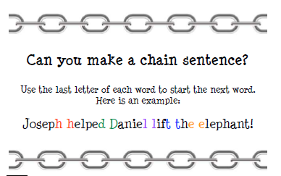

**TASK (b):**

* I wonder who in Primary 4 will produce the best sentence? It will definitely be someone who has thought about it and was prepared to up-levelled their sentence at least once! 😊

**Mid-morning breaktime. 😊.**

**Numeracy:**

**TASK: Time: Consolidation: follow-on from last week.**

|  |
| --- |
| We are learning to write fractions of hours as hours and minutes |

I have uploaded Exercise 2 as a **PDF**. On the PDF is this time wall – use it to help you! 😊

**TASK: Application of skills:**

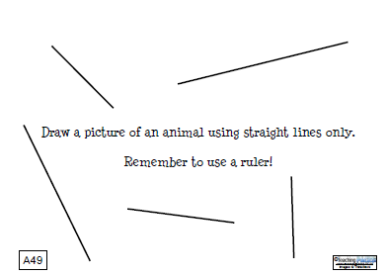

|  |
| --- |
| **Challenge**: Can you work out its perimeter? If you draw it onto squared paper, can you work out its surface area? I have sent you some 1 cm squared paper. **PDF** |

**Brain Break of your choice**

**TASK: Application of skills:**

**Education City** – Chili Challenge **. Have fun and remember all I said last week about ‘*steps for success’*. 😊





Enjoy … see you tomorrow! 😊